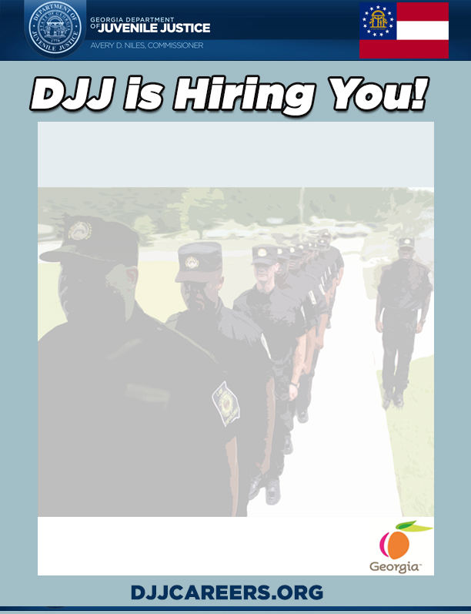

**WHEN: Wednesday , September 19, 2018**

**WHERE: Georgia Department of Labor ( Statesboro Career Center)**

**62 Packinghouse Road**

**Statesboro, Ga. 30458**

**TIME: 10:00AM – 1:00PM**

**ATTIRE: Business Professional**

**WHAT TO BRING**

**To ensure eligibility for entrance and interviewing you MUST bring the following:**

1. **Valid Georgia Driver’s License**
2. **Proof of High School Diploma or GED**
3. **Test Scores (ACT, SAT, Compass, or Accuplacer) or Proof of 4-year degree from an accredited college or university**
4. **DD214 long form with indicated discharge (Military Personnel Only)**
5. **POST Certification (if applicable)**
6. **Naturalization forms if non- US citizen**

**This event is open to the public**

**\*Professional dress for onsite interviews is required; current law enforcement and Military personnel may come in uniform\***

**HIRING EVENT**

**Juvenile Correctional Officers**