SY 14 - 15 Wellness Program
Goal One: National School Lunch Week
Goal Two: Spring Health Fair

Goal 1: National School Lunch Week
“Get in the Game with School Lunch!”

Georgia Preparatory Academy Wellness Program
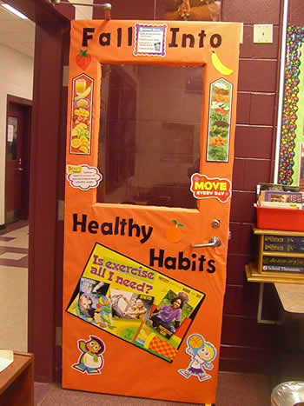
Georgia Preparatory Academy Schools celebrated National School Lunch Week across the state, helping students to “Get in the Game with School Lunch!” The program was the first goal of the Georgia Preparatory Academy Wellness Program and was a great success! Youth participated in a weeklong series of activities celebrating sports, exercise, and nutritious foods and lunches. Some of the many activities to take place around Georgia include:
• Viewing a sports’ themed movie while enjoying healthy snacks
• Guest servers on the lunch line, including teachers, recreation leaders, and community members
• Youth and staff decorating the lunch room and multi-purpose room
• Flag football and cornhole tournaments
• Creating posters showcasing their favorites sports and teams
• Zumba class
• And many more!
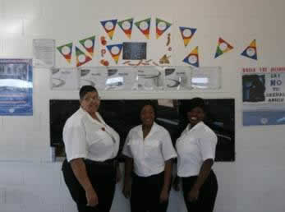
These events allowed youth to learn about the importance of physical activity and a nutritious diet while participating in art projects, sports tournaments, and exercise classes. Not only did youth enjoy fun activities, they also enjoyed stimulating conversations about sports and heath with staff. One Wellness Ambassador reports, “Most of all, the events helped build a working and mentoring relationship amongst the staff and youth.” Another reports, “This event truly let the youth express their interest in sports. It evoked discussions between youths and staff relating to sports teams and different players that usually do not occur.”
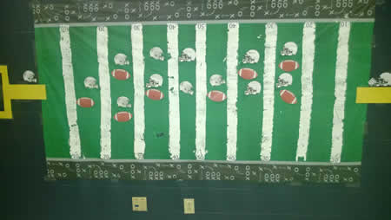
Overall, National School Lunch Week was a great kick-off to the SY 14-15 Wellness Program. High youth participation, a morale boosting and learning atmosphere, and abundant staff involvement helped youth learn about the benefits and importance of physical activity and a healthy diet.
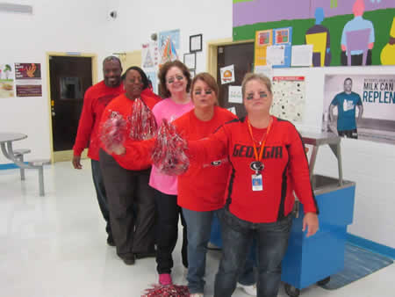
We look forward to celebrating National School Lunch Week next year!

