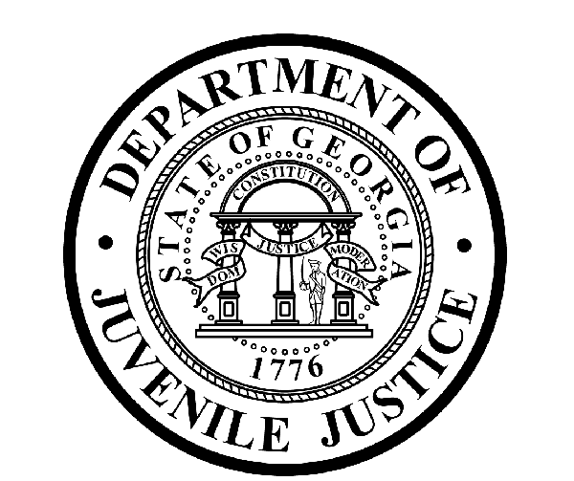

Avery D. Niles, CommissionerDepartment of Juvenile Justice

Jim Shuler, Director3408 Covington Highway ▪ Decatur, Georgia ▪ 30032-1513
Office of CommunicationsTelephone: (404) 508-7147 ▪ Fax: (404) 508-7341
FOR IMMEDIATE RELEASE CONTACT:
Matt Montgomery
February 19, 2014 DJJ Communications
(404) 508-7142 MatthewMontgomery@djj.state.ga.us

DJJ CANNED FOOD DRIVE BENEFITS GEORGIA COMMUNITIES
“Restock the Shelves 14” Campaign Extended Through March

(ATLANTA – GA) The Department of Juvenile Justice’s statewide canned food drive collection campaign benefitting local food banks across Georgia has had a successful start in February and is expanding its initial goals. Named “Restock the Shelves ‘14”, the DJJ employee food collection project has exceeded its original collection expectations and been extended by DJJ Commissioner Avery Niles into the month of March.

“I am proud of the immediate and generous response of DJJ employees to help collect food and toiletry items for our communities,” Commissioner Niles said. “The collection and donation of these items will help local food banks provide meals and other necessities to the nearly 1-in-5 Georgians who are unsure of where their meals will come from this season.”

A personal initiative of Commissioner Avery Niles, “Restock the Shelves ‘14” was envisioned as a way for DJJ to give back to local communities by helping those less fortunate than themselves. “Restock the Shelves ‘14” allows Department of Juvenile Justice employees to assist local food banks replenish their supplies following the busy holiday and winter seasons. All donated items will stay in the area where collected to maximize the benefit in the community.

The early success of “Restock the Shelves” along with the excitement of DJJ employees has helped to grow the program in unexpected and positive ways. “Restock the Shelves” has added donation boxes in the community and received individual collection help from the local area Boy and Girl Scouts, local school systems, and community providers. In addition, youth in the care of DJJ also have participated through donations to court services offices around the state.

(MORE MORE MORE)

(PAGE TWO)

“Restock the Shelves ’14” already has received over 4,000 donated food and health items during the first two weeks of the campaign. The extension of the program through March was done in part to expand upon the enthusiasm of both DJJ employees and local communities as well as to help meet the additional challenges brought forth by the recent winter storms across Georgia.

The Department of Juvenile Justice has partnered with the following food banks across Georgia to collect canned food and toiletry items through March:

- ATHENS - Food Bank of Northeast Georgia - Tina Laseter - 706-354-8191
- VALDOSTA - Second Harvest of South Georgia - Doug Griner - 229-244-2678 ext 202
- SAVANNAH - America's Second Harvest of Coastal Georgia - Russ Toler - 912-721-1791
- AUGUSTA - Golden Harvest Food Bank - Carrie Jones - 706-736-1199 ext 217
- COLUMBUS - Feeding the Valley Food Bank - David Shemwell - 706-561-4755 ext 17
- MACON - Middle Georgia Community Food Bank - Mike Morrison - 478-742-3958
- GAINESVILLE- Georgia Mountain Food Bank - Stephanie Lucas - 770-534-4111
- ATLANTA - Atlanta Community Food Bank - Elizabeth Haskell - 678-553-5954

Among the most needed items for donation are canned meats, canned fruits and fruit juice, canned meals, canned beans, canned soups, stews, and pasta. Other items welcomed include peanut butter, macaroni and cheese, whole grain cereals, paper products, diapers, and toiletries.

For additional information about “Restock the Shelves 14”, visit the DJJ website at http://www.djjnewsandviews.org/restocktheshelves.

(END RELEASE)

BELOW IS A PHOTOGRAPH OF DJJ COMMISSIONER AVERY NILES IN FRONT OF ONE OF THE COLLECTION BARRELS FOR “RESTOCK THE SHELVES ‘14”. THE PHOTO MAY BE USED IN ALL PUBLICATIONS AS NEEDED.


