Avery D. Niles, Commissioner Department of Juvenile Justice
Office of Communications 3408 Covington Highway Decatur, Georgia 30032-1513
Telephone: (404) 508-7147 Fax: (404) 508-7341
For Immediate Release Contact: Glenn Allen
DJJ Communications May 27, 2019
(404) 508-5119
publicaffairs@djj.state.ga.us

Georgia Department of Juvenile Justice Celebrates Academic Achievement
Decatur, GA – The Georgia Department of Juvenile Justice (DJJ) held its annual spring high school commencement ceremony for youth attending the Georgia Preparatory Academy on Friday, May 24th, in Forsyth, Georgia. DJJ Commissioner Avery D. Niles presented 18 High School Diplomas, 26 General Equivalency Degrees (GED), and 32 Technical Certificates of Credit to qualifying students.
“Our mission is to turn around the lives of these young people and give them the tools they need to succeed," said Commissioner Niles. "Education is a key indicator of a youth’s future success and I am proud of them for working so hard to reach their goal."
The Department of Juvenile Justice is the 181st school district in Georgia. Within the school system, there is a middle and high school called Georgia Preparatory Academy and a GED program called Pathway to Success. Georgia Preparatory Academy and Pathway to Success are located at 29 campuses within DJJ’s Regional Youth Detention Centers, Youth Development Campuses, and Education Transition Centers across Georgia.
DJJ operates the Georgia Preparatory Academy with a curriculum that meets the education standards set forth by the Georgia Department of Education for all public schools. Since Commissioner Niles’ appointment in 2012, 164 High School Diplomas, 446 GED Diplomas and 172 Technical Certificates of Credit have been issued to students under his care.

--continue--

DJJ Celebrates Academic Achievements
Page 2

“The journey before these students will have both valleys and mountains, alike; some days the journey will be a simple stroll, while others it will be a rigorous climb,” said State Senator Chuck Payne who served as the keynote speaker. “The key is to always measure your long-term progress by a single step at a time.”
Following graduation, each student who remains in DJJ custody at a secure facility is enrolled in the Connections Graduate Program (CGP), which is designed to prepare the youth for college or a career. CGP instructors specialize in educational and employability development.
Students participating in last week’s commencement ceremonies are currently in custody at DJJ secure facilities in Fulton, Richmond, Laurens, Dodge, Hall, Bibb, Baldwin, Rockdale, Sumter, Terrell, and Ware counties.

# # #
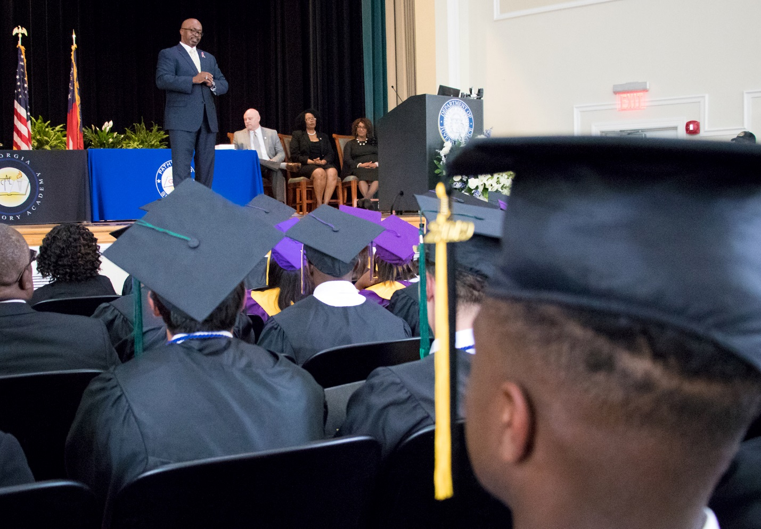
Photo attribution to the Georgia Department of Juvenile Justice

