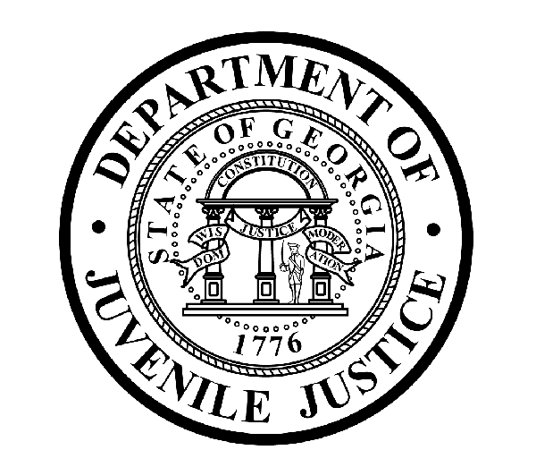

Avery D. Niles, CommissionerDepartment of Juvenile Justice

Glenn Allen, Director3408 Covington Highway ▪ Decatur, Georgia ▪ 30032-1513
Office of CommunicationsTelephone: (404) 508-7147 ▪ Fax: (404) 508-7341
FOR IMMEDIATE RELEASE CONTACT:
Matt Montgomery
December 3, 2018 DJJ Communications
(404) 508-5119
publicaffairs@djj.state.ga.us

DEPARTMENT OF JUVENILE JUSTICE TO HOLD CAREER FAIR IN JEFFERSON COUNTY

Decatur, GA – The Georgia Department of Juvenile Justice (DJJ) will hold a Career Fair on Thursday, December 6, at the Jefferson County Leisure and Senior Center from 9:00 a.m. until 1:00 p.m.

DJJ is currently recruiting for Juvenile Correctional Officers at the Milledgeville Youth Development Campus, in Milledgeville, Ga. Individuals interested in applying are asked to bring their Driver’s License and Social Security Card.

For more information, contact us at 404-683-8823.

Date: Thursday, Dec. 6
Location: 209 E. 7th Street
Louisville, Ga.
Time: 9:00 a.m. – 1:00 p.m.

###
ABOUT DJJ

The Georgia Department of Juvenile Justice (DJJ) is a multi-faceted agency that serves the needs of the state’s young offenders up to the age of 21. The Department employs more than 4,000 men and women at 26 secure facilities (19 Regional Youth Detention Centers and 7 Youth Development Campuses) and 96 Community Services Offices throughout the state to effect justice and redirect the young lives in the agency’s care. Visit us on the web at djj.georgia.gov or djjcareers.org.

