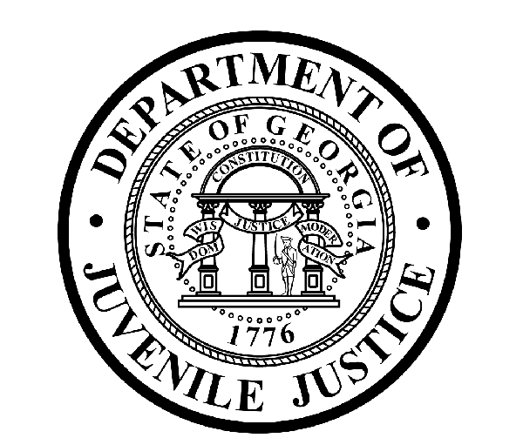

L. Gale Buckner, CommissionerDepartment of Juvenile Justice

Jim Shuler, Director3408 Covington Highway ▪ Decatur, Georgia ▪ 30032-1513
Office of CommunicationsTelephone: (404) 508-7147 ▪ Fax: (404) 508-7341
FOR IMMEDIATE RELEASE CONTACT:
Jim Shuler, Director
July 31, 2012 DJJ Communications
(404) 508-7238
JimShuler@djj.state.ga.us

DJJ COMMISSIONER MAKES APPOINTMENT OF NEW WAYCROSS RYDC DIRECTOR

(ATLANTA-GA) The Commissioner of the Georgia Department of Juvenile Justice is pleased
to announce the appointment of a new Director for the Waycross Regional Youth Detention
Center (RYDC). Commissioner L. Gale Buckner confirmed that effective August 16th, 2012, Mr.
Melvin Whitlow has been selected to head DJJ’s secure detention facility in Ware County,
Georgia.

Mr. Whitlow joins the Georgia Department of Juvenile Justice from Holy Cross Children's Services where he served as Regional Director since October of 2011.

The new Waycross RYDC Director has a long and notable career managing detention and residential treatment facilities. He also has a solid social work background with his degree from the University of Detroit Mercy and recent years spent doing social work for the State of Michigan.

Whitlow says his great passion is to serve students with a high degree of professionalism while helping them achieve maximum development of their skills and abilities.

Director Whitlow is a member of National and Michigan Juvenile Detention Associations and serves as Detention Center Practices and Procedures Advisor for a ministries group for incarcerated youth.

The Waycross RYDC is a facility designed to provide temporary supervision and secure care for youth who have been convicted of offenses and are waiting for disposition of their cases by the court. Sometimes youth who have been committed to DJJ custody are placed in an RYDC like Waycross while they’re waiting for treatment in a long-term facility or community program.

DJJ Commissioner Buckner says “It will be Director Whitlow’s responsibility to ensure that departmental safety and security policy and procedures are observed at Waycross RYDC and that facility staff follow DJJ’s strict policies and professional standards.”

END RELEASE

