

Avery D. Niles, Commissioner **Department of Juvenile Justice**

**Scott Mall** 3408 Covington Highway ▪ Decatur, Georgia ▪ 30032-1513

**Office of Communications** Telephone: (404) 508-7147 ▪ Fax: (404) 508-7341



**FOR IMMEDIATE RELEASE** **CONTACT:**

**Scott Mall**

**SEPT 12, 2016 DJJ Communications**

**(404) 518 - 5119**

[**Scott.Mall@djj.state.ga.us**](mailto:Scott.Mall@djj.state.ga.us)

**Vignati Appointed to Federal Advisory Committee**

**on Juvenile Justice**

**Atlanta, GA –** Joseph Vignati, Deputy Commissioner of the Division of Community Serviceswith the Georgia Department of Juvenile Justice, has been appointed to the Federal Advisory Committee on Juvenile Justice (FACJJ) by the Office of Juvenile Justice and Delinquency Prevention of the U.S. Department of Justice. He will serve as the primary member for Jurisdiction G, which comprises Alabama, Arkansas, Georgia, Louisiana, Mississippi, North Carolina and South Carolina. Vignati’s term will begin on October 1, 2016, and continue through September 30, 2018, at which time he will be eligible to serve an additional two-year term.

“This appointment is an honor for Joe and for the Georgia Department of Juvenile Justice and it speaks volumes for what he has accomplished over the past couple years at DJJ to be selected to this elite group,” stated DJJ Commissioner Avery D. Niles. “On behalf of all of DJJ’s employees, we are proud and delighted for Joe. He will help convey FACJJ’s perspectives on juvenile justice issues to the President, Members of Congress and the OJJDP Administrator.”

Reacting to the appointment, Vignati said, “I am humbled to be selected for this role with the Committee and look forward to representing Georgia and other states in the Southeast. Members of the FACJJ provide input regarding the concerns of the communities they represent. Local and state leadership is critical when it comes to designing and overseeing long-term juvenile justice reform. I am appreciative of the opportunity to help shape this important work.”

The first meeting Vignati will attend is scheduled for September 29-30 in Washington, D.C. The meeting will highlight U.S. Department of Justice and OJJDP initiatives that influence program development and have the potential to change the way the needs of system-involved children and youth are addressed. According to Administrator Robert L. Listenbee, the work of OJJDP centers on an evidence-based and developmental approach to juvenile justice and delinquency prevention.

In his letter confirming the appointment, Administrator Listenbee wrote Vignati, “I look forward to our future conversations and learning more about your experiences addressing the needs of our nation’s vulnerable children, youth and families.”

Intimately involved in all aspects of Georgia’ juvenile justice system for the past 29 years, Vignati has tirelessly served at-risk youth in a wide variety of roles, both in his career with state government and as a volunteer in community settings.  During his tenure with the Governor’s Office, he successfully secured $67 million in federal criminal justice funds for the state of Georgia.

Vignati joined the Georgia Children and Youth Coordinating Council in 2000 and served as the state’s Juvenile Justice Specialist until 2014. In 2008, he was named Director of Justice Programs of the newly created Governor’s Office for Children and Families in Georgia and served as Administrator of the Office’s Justice Division. In 2009, Georgia Governor Sonny Perdue issued an official commendation recognizing him as a great asset to the state.

In 2010, Vignati was elected the Coalition for Juvenile Justice’s (CJJ) National Juvenile Justice Specialist by his peers in the 56 U.S. states and territories and served a two-year term. The CJJ presented the Tony Gobar Outstanding Juvenile Justice Specialist Award to Vignati in 2011 for his “demonstrated passion and dedication to bettering the juvenile justice system, advocacy for detention alternatives and service as a leader and a voice for juvenile justice specialists from around the nation in his role as the CJJ National Juvenile Justice Specialist. By exemplifying leadership through service, he reminds us all that every child is indeed special.”

In 2012, Georgia Governor Nathan Deal issued an official commendation recognizing “his ongoing contributions to the protection and well-being of Georgia’s children.” In 2015 the Georgia Juvenile Services Association honored Vignati with the Harold K. Ables Award, recognizing his significant contributions to the field.

Vignati currently serves as Co-Chair of the Juvenile Incentive Grant Funding Committee that has helped award over $20 million in grant funds specifically aimed to reduce unnecessary out-of-home placements of youth appearing before juvenile courts across Georgia.

On May 15, 2015, he was appointed Deputy Commissioner at DJJ, responsible for 97 offices providing state juvenile probation and aftercare services across Georgia.

He holds a bachelor’s degree in politics from Augusta University in Augusta, Georgia, and graduated *summa cum laude* in 1992 with a master’s degree in public administration from Georgia State University. Vignati, his wife Kathryn and their four children live in Decatur.

###

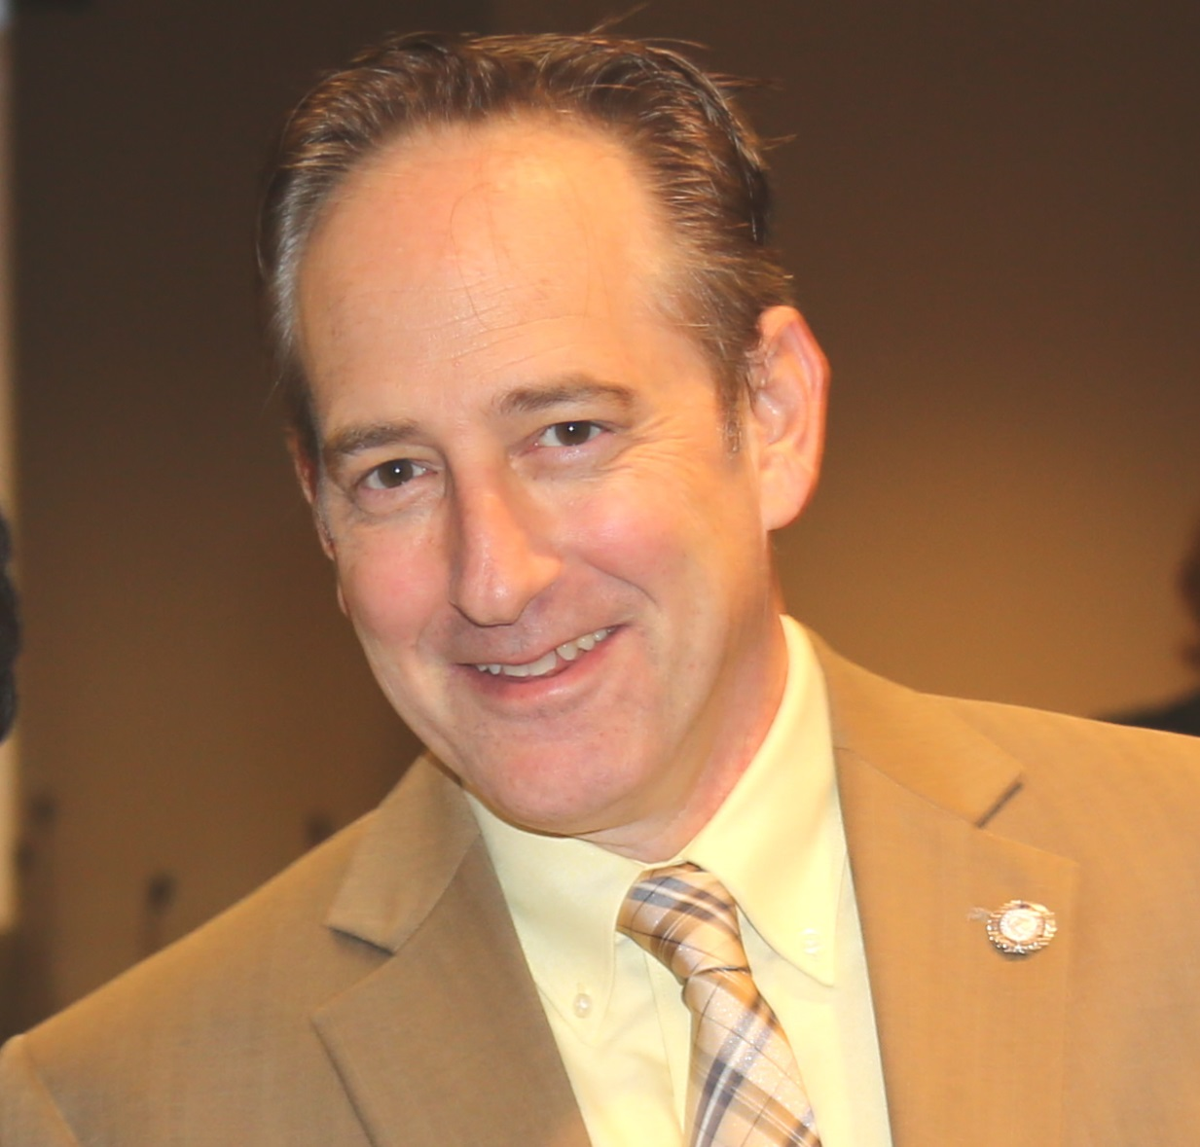

*Photo of Joe Vignati courtesy of the Georgia Department of Juvenile Justice*