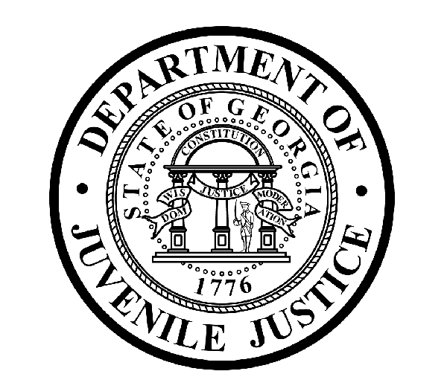

Avery D. Niles, CommissionerDepartment of Juvenile Justice

Jim Shuler, Director3408 Covington Highway ▪ Decatur, Georgia ▪ 30032-1513
Office of CommunicationsTelephone: (404) 508-7147 ▪ Fax: (404) 508-7341
FOR IMMEDIATE RELEASE CONTACT:
Jim Shuler, Director
April 23, 2014 DJJ Communications
(404) 508-7238
JimShuler@djj.state.ga.us

DJJ BRINGS IN TOP REENTRY RESEARCH EXPERTS
Juvenile Justice Reform Project Helps Young Offenders
Overcome Barriers and Avoid Repeat Detention in GA
(ATLANTA - GA) Commissioner Avery D. Niles is pleased to announce the Department of Juvenile Justice is launching a research project for the State of Georgia in support of the Governor’s new juvenile justice reform “Reentry Initiative”. The Department is collaborating with two of the country’s top youth reentry research experts to develop a comprehensive case management program to help young offenders overcome major barriers to finding viable employment while under DJJ community supervision.

Under the guidance of Commissioner Avery Niles, DJJ planners, counselors, educators, security advisors, mental health providers and a newly-formed DJJ Reentry Services Unit are teaming up with respected reentry research scientists Dr. Mark Lipsey and Dr. David Altschuler.

Dr. Mark Lipsey is Director of the Peabody Research Institute at Vanderbilt University’s Peabody College of Education and Human Development. He is a member of the Tennessee Criminal Justice Coordinating Council and the Science Advisory Board for the federal Office of Justice Programs.

Dr. David Altschuler is the principal research scientist at the Johns Hopkins Institute for Policy Studies, Bloomberg School of Public Health and co-author of a 2004 article on the challenges and opportunities faced by former juvenile offenders upon their reentry to society.

Dr.’s Lipsey and Altschuler are providing technical assistance for the planning and design of a state-of-the-art societal reentry model for the Georgia Department of Juvenile Justice. In early April Governor Nathan Deal signed Senate Bill 365 into law to help rehabilitated, non-violent young offenders make successful reentry into society. The Lipsey-Altschuler societal reentry model must ensure that DJJ’s programs for youth in juvenile secure facilities and community programs are backed by research evidence supporting their effectiveness to reduce recidivism.
(MORE MORE MORE)
(PAGE TWO TWO TWO)

Dr.’s Lipsey and Altschuler will coordinate with DJJ’s newly formed Reentry Services Unit which Commissioner Niles formally launched this month to standardize agency reentry operations consistent with the Department's mission, policies and procedures.

“We’re embarking on an unprecedented juvenile justice reform partnership with these prominent research experts,” said Commissioner Avery Niles. “With their help we’ll design a working reentry plan for Georgia youth when they’re released from their court ordered commitments.”

“If we can prevent our youth from ‘doing a boomerang’ right back into Georgia’s juvenile system, well, that in turn could prevent them from ending up in the adult system someday,” said Commissioner Niles. “If we can safely return them to their own neighborhoods, we’ll also be turning today’s tax burdens into tomorrow’s tax payers."

In order to ensure a safe and successful return to the community, Lipsey and Altschuler propose DJJ should include individualized reentry plans for each youth in custody. Lipsey and Altschuler seek to develop a data-driven model capable of monitoring the progress and development of youth in the program and capable of tracking improvements or detecting trends toward recidivism.

The objective of the Lipsey-Altschuler research is to design a model policy to increase success rates of youth who transition from DJJ secure facilities and return to their communities. Commissioner Niles says the challenge faced by DJJ’s new Reentry Services Unit is to recognize and address obstacles that make it difficult for former juvenile offenders to obtain viable employment and then retain it while under community supervision.

DJJ’s new five-member Reentry Services Unit works under the supervision of the department’s Associate School Superintendent, Dr. Audrey R. Armistad. “Now that the Governor has signed Senate Bill 365, we’re hoping this critical research will help us see more former young offenders returning to the workforce instead of returning to the Georgia juvenile justice system,” said Dr. Armistad.

“The spirit behind Georgia’s Juvenile Justice Reform Law is for DJJ to invest in mentoring, vocational, educational and rehabilitative programs for some of this state’s most troubled young people,” said Commissioner Niles. “That means we will be constantly tweaking and developing evidence-based programs to help change the lives of these young offenders and then providing them the opportunity to work at becoming productive Georgians.”

Even as Lipsey and Altschuler’s research study is underway, DJJ has already been at work developing components for a wide-ranging reentry program that includes support through volunteer programs, faith-based connections and civic groups. DJJ is also partnering in training programs at technical colleges and university systems to help youth find jobs when they’re released.
“This reentry project is going to help promote Georgia public safety too, by reducing the threat of harm to people, families and their property from youth returning to their communities from secure facilities,” said Commissioner Niles. “Either Georgia develops a viable reentry program now to help teach our juvenile offenders these essential life skills, or we may face them again later as adult repeat offenders,” the Commissioner said. “With the Governor’s support, we are offering these youth hope while protecting our citizens by supporting the launch of our state-of-the-art reentry initiative at DJJ.”

(END RELEASE)

