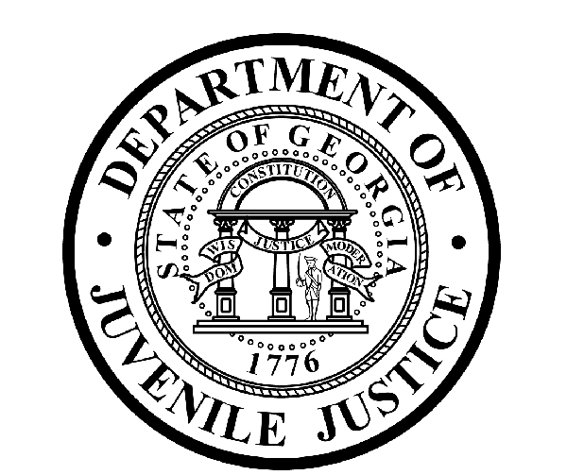

Avery D. Niles, CommissionerDepartment of Juvenile Justice

Jim Shuler, Director3408 Covington Highway ▪ Decatur, Georgia ▪ 30032-1513
Office of CommunicationsTelephone: (404) 508-7147 ▪ Fax: (404) 508-7341
FOR IMMEDIATE RELEASE CONTACT:
Jim Shuler, Director
June 29, 2013 DJJ Communications
(404) 508-7238
JimShuler@djj.state.ga.us

Commissioner Encourages Public to Use Agency TIP-Line:
“If You See Something, Say Something”

(ATLANTA - GA) DJJ Commissioner Avery D. Niles publicly pledged again today that the Department of Juvenile Justice will continue to maintain a Zero Tolerance policy against sexual misconduct violations at Georgia’s juvenile detention centers. His renewed pledge follows the recent release of a federal survey which alleges that Georgia has some of the highest rates of sexual abuse in juvenile detention centers in the nation.

Commissioner Niles said that even while his agency is in the middle of his own “top to bottom” internal inquiry to determine why some investigators did not complete all their assigned cases last year, he wants “..To reassure Georgia parents that we remain dedicated to our goal to ensure a sexually safe environment for the youth in our custody.”

To focus more attention on safe day- to- day juvenile justice operations, the Commissioner is now encouraging assistance from public partners. “We want the public to report what they know about department misconduct by using our innovative agency TIP-Line,” said Commissioner Niles. “It’s available to anyone, anytime.”

The DJJ TIP-Line was designed by Intelligence Analysts as an anonymous reporting system to encourage the flow of critical information from concerned DJJ staff and youth offenders.

Agency Analysts confirm useful information from anonymous tips and refer it for investigation and when appropriate, for prosecution. The system is devised so that tips submitted online will remain confidential. But concerned citizens who want to establish in-depth whistleblower discussions with investigators can opt to include their contact information for follow-up.

(MORE MORE MORE)

(PAGE TWO)

Tipsters with information to share about illegal, unethical or dangerous activities inside Georgia Department of Juvenile Justice facilities, can access the TIP Forms on the DJJ website at these links:

http://www.djj.state.ga.us
http://www.djjnewsandviews.org
http://www.djjnewsandviews.org/gangs101
http://www.djjnewsandviews.org/preageorgia/

“This TIP-Line was set up to provide another channel for reporting sexual abuse, sexual harassment, staff misconduct and policy violations,” said Commissioner Niles. “Information shared on the DJJ TIP-Line can include the names of victims and identify their alleged assailants, so the TIP-Line can actually result in arrests and prosecutions.”

“Whether it’s inside or outside our secure facilities we want youth in all our programs to use the TIP-Line to speak up and say ‘NO’ to sexual abuse,” said Commissioner Niles. “We want to make sure our residents are never intimidated about seeking help if they ever encounter abuse.”

“We also want our DJJ statewide staff to know we’re listening in the Commissioner’s Office. If our staff or public partners have something important to report and they want to keep it anonymous, all they have to do is fill out the email form on the TIP-Line site,” said Commissioner Niles. “A single tip of confidential information about potential gang activity, contraband smuggling, or unlawful policy violations can have a positive impact on our safety and security, prevent an injury or even save a life,” said Niles.

“This TIP-Line is another essential security tool we’re using to make this agency one of the best in the nation,” said Commissioner Niles. “We encourage anyone who sees something to say something to help safeguard our youth and staff.”

(END RELEASE)

