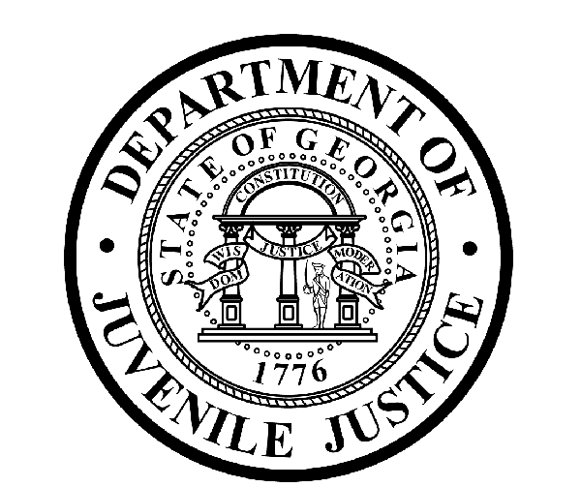

Avery D. Niles, CommissionerDepartment of Juvenile Justice

Jim Shuler, Director3408 Covington Highway ▪ Decatur, Georgia ▪ 30032-1513
Office of CommunicationsTelephone: (404) 508-7147 ▪ Fax: (404) 508-7341
FOR IMMEDIATE RELEASE CONTACT:
Jim Shuler, Director
March 30, 2015 DJJ Communications
(404) 508-7238
JimShuler@djj.state.ga.us

GA Juvenile Justice Makes “SPLASH” to Save Lives This Summer
DJJ Supports First Lady’s Water Safety Campaign on April 1st

(Atlanta, GA) – On behalf of Commissioner Avery D. Niles, the Department of Juvenile Justice announces it is proud to partner with First Lady Sandra Deal and the Georgia Children’s Cabinet for the start of the state’s Water Safety Campaign to save lives this summer.

Georgia’s First Lady will officially launch the SPLASH summer water safety campaign with a News Conference kick-off in the Capitol Building North Wing on Wednesday, April 1st at 10-AM. “SPLASH” stands for “..Supervision, Prevention, Look before you leap, Arms-length, Swim lessons, and Have a water safety plan..”

Prevention means fencing-in pools, covering drains and taking safety steps ahead of time. Parents should create a family plan so everyone is prepared for summer water play and knows how to swim.

“Georgia’s Water Safety Partners have great advice for making summer fun for your kids this year,” said DJJ Commissioner Avery Niles. “Keep eyes on your children at all times when they’re in water. Stay close enough to rescue them. And always check the water-depth before jumping in,” Niles said.

Water Safety Partners from the Department of Juvenile Justice, Department of Public Health, Department of Natural Resources, Children’s Health Care of Atlanta, Georgia Children’s Cabinet and Georgia Power, will all have tables in the Capitol North Wing for sharing water safety items and life-saving tips.

Safety experts will present live demonstrations about the best water safety techniques. This year’s water safety education program is all about preventing death and injuries among Georgia youth near pools and lakes or anywhere young people may be swimming or playing near water this summer.

Tables will be set-up from 9:00 AM to 10:30 AM for distribution of posters and free safety campaign promotional items. SPLASH-logo sun visors and beach balls will be donated by the Georgia Department of Juvenile Justice.

The public is invited to attend this important safety educational event and DJJ employees are encouraged to participate in the kick-off to safe summer fun for Georgia’s kids.
(END RELEASE)

