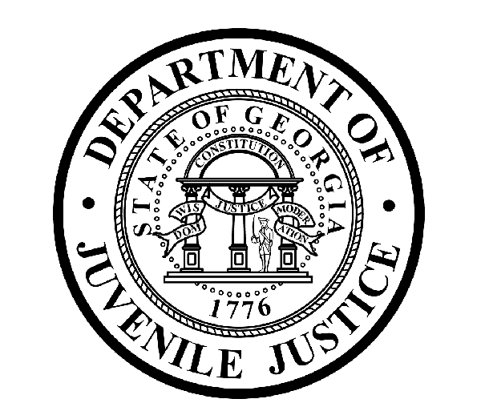

Avery D. Niles, CommissionerDepartment of Juvenile Justice

Jim Shuler, Director3408 Covington Highway ▪ Decatur, Georgia ▪ 30032-1513
Office of CommunicationsTelephone: (404) 508-7147 ▪ Fax: (404) 508-7341
FOR IMMEDIATE RELEASE CONTACT:
Jim Shuler, Director
March 25, 2013 DJJ Communications
(404) 508-7238
JimShuler@djj.state.ga.us

DJJ BUSINESS MANAGER ARRESTED AT SANDERSVILLE RYDC
JAILED ON 21 FELONY COUNTS OF THEFT

(Washington County - GA) Commissioner Avery D. Niles of the Georgia Department of Juvenile Justice announced today that Baldwin County Sheriff’s Deputies have arrested the Administrative Operations Coordinator of the Sandersville RYDC. The arrest was made as part of a DJJ Internal Affairs Investigation in connection with the suspected theft of state funds from deposits of corrections staff meal sales at the Sandersville Regional Youth Detention Center.

Commissioner Avery Niles said Administrative Operations Coordinator James Sanders, who had functioned as business manager for the Sandersville RYDC, was taken into custody this afternoon by deputies from the Baldwin County Sheriff’s Office. Sanders was charged with 21 felony counts of Theft by Taking.

Sanders had been placed under suspension without further access to facility funds after a discrepancy in sales deposits was discovered by a DJJ Central Office Audit Team. Commissioner Niles has ordered Sanders’ immediate separation from the department in conjunction with today’s felony arrest with termination proceedings already underway.

The Commissioner says DJJ Internal Affairs determined Sanders was allegedly withdrawing cash illegally from the agency meal account and replacing the cash with personal checks. When investigators obtained a subpoena for Sanders’ bank account, they discovered the thefts allegedly occurred more than 20 times over a period of several months and totaled more than two thousand dollars. The compromised agency account was discovered when Sanders allegedly replaced state cash with a bounced check, resulting in his arrest.

Investigators say they have no evidence at this time to indicate the former Administrative Operations Coordinator was syphoning money from any other agency accounts. Nonetheless, the Commissioner of the Department of Juvenile Justice ordered a Central Office Audit Team examination at the Sandersville RYDC.
(MORE MORE MORE)

. (PAGE TWO)

Commissioner Avery Niles endorses transparency when DJJ must take strong measures like today’s arrest of former Administrative Operations Coordinator James Sanders.

Commissioner Niles said, “At the Department of Juvenile Justice, staff members who violate positions of trust and responsibility will continue to face severe consequences, regardless of employee rank or position in this agency. I gave clear warning when I was appointed Commissioner that criminal behavior and serious violations of policy will be not be tolerated in our professional juvenile justice workplace,” said Niles.

Suspect James Sanders will be held at the Washington County Jail. The investigation by the DJJ Office of Internal Affairs continues at this time.

The Commissioner’s’ core message since his November 2012 appointment by Governor Nathan Deal has emphasized that the critical duties of the Department of Juvenile Justice are to uphold and enforce policy, ethics, and safety and security measures at Georgia’s juvenile justice facilities so that both DJJ detainees and staff can function in a safe and secure learning environment.

(END RELEASE)

DJJ DISCLAIMER: “Information regarding this arrest is public record and was obtained from area law enforcement agencies. All suspects are presumed innocent until found guilty in a court of law.”

