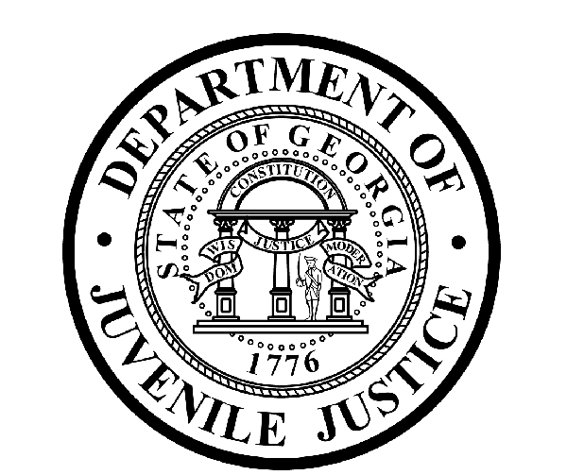

Avery D. Niles, CommissionerDepartment of Juvenile Justice

Jim Shuler, Director3408 Covington Highway ▪ Decatur, Georgia ▪ 30032-1513
Office of CommunicationsTelephone: (404) 508-7147 ▪ Fax: (404) 508-7341
FOR IMMEDIATE RELEASE CONTACT:
Jim Shuler, Director
June 18, 2015 DJJ Communications
(404) 508-7238
JimShuler@djj.state.ga.us

Department of Juvenile Justice Recruiting in Rockdale
DJJ Hiring Correctional Officers at June 18th Job Fair

“DJJ is a great place to make your work count.”
Avery D. Niles, Commissioner

(ROCKDALE - GA) DJJ is adding the Rockdale Regional Youth Detention Center (RYDC) in Conyers, Georgia to this month’s recruitment calendar.

Georgia Juvenile Justice Commissioner Avery D. Niles is sending a team of recruiters to Rockdale to interview qualified candidates for Juvenile Corrections Officer (JCO 1 & 2) positions during the upcoming DJJ recruiting fair on Thursday, June 18th.

Commissioner Niles instructs all recruiters to maintain over watch for Georgia veteran applicants at DJJ job fairs. The Department of Juvenile Justice has immediate openings for qualified veterans and mature applicants with the professional drive to help juvenile offenders achieve successful reentry into society as productive citizens.

Niles says fulltime juvenile corrections careers require candidates with “Can-Do!” attitudes. “DJJ is a great place to make your work count,” Commissioner Niles said. The Rockdale Recruitment Fair schedule is below.

*Please note career fair locations and times may change OR additional career fair dates may be added to our recruiting schedule. Applicants should check the DJJ website for late-breaking schedule changes at www.djjcareers.org BEFORE visiting a DJJ job fair.

Date: Thursday, June 18th - GENERAL PUBLIC
Rockdale Regional Youth Detention Center (RYDC)
2165 Chambers Drive
Conyers, GA. 30012
Time: 10:00 AM - 2:00 PM

( MORE MORE MORE )
(PAGE TWO TWO TWO)

DJJ recruiters are authorized to interview qualified candidates on-site. Applicants should bring their resumes and dress for job interviews. All job seekers can click on www.djjcareers.org for more information about career opportunities in juvenile corrections.

In order to progress smoothly through the interview process for Juvenile Corrections Officers, candidates for the JCO 1 & 2 positions should bring copies of the following:

- Completed State of Georgia application
- State issued ID - Valid Driver License
- Social Security Card
- Birth Certificate
- High School Diploma or GED
- DD214 Long Form with discharge indicated
- Naturalization Forms (if NON-US Citizen)
- If P.O.S.T. Certified, (Please bring two (2) forms of Gov. issued ID & P.O.S.T. Profile)

** If the applicant has a 4-year degree from an accredited college they are exempt from having to take the Compass test or provide proof of acceptable ACT or SAT scores.

Candidates should bring Passing Test Scores as follows:
- Compass Scores (Reading 70 Writing 32)**
- SAT Scores (Verbal: 430 Math: 400) or ACT Scores (Verbal: 18 Math:16)**
- CPE Scores (Reading: 75 Math: 75 English 75)

Former military service members with Honorable Discharge should click on www.djjcareers.org to learn about DJJ's one-time Military Salary Increase Incentive on eligible job titles at “DJJ Careers for Veterans”. There is no charge for participation at juvenile corrections career fairs.

**Please note that career fair times and locations may change and additional career fair dates may be added to our recruiting schedule. Applicants should check the DJJ website for late-breaking schedule changes at http://www.djjnewsandviews.org/djjcareers/ before visiting a job fair.

(END RELEASE)

