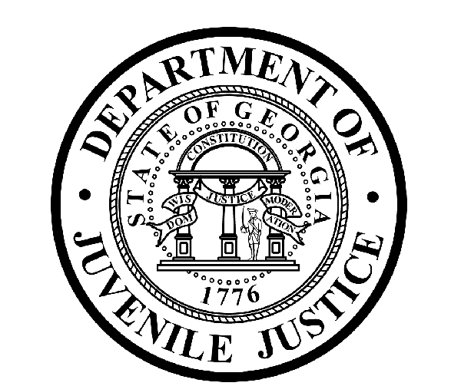

Avery D. Niles, CommissionerDepartment of Juvenile Justice

Jim Shuler, Director3408 Covington Highway ▪ Decatur, Georgia ▪ 30032-1513
Office of CommunicationsTelephone: (404) 508-7147 ▪ Fax: (404) 508-7341
FOR IMMEDIATE RELEASE CONTACT:
Matt Montgomery
March 28, 2014 DJJ Communications
(404) 508-7142 MatthewMontgomery@djj.state.ga.us

COMMUNITY CANNED FOOD DRIVE EXCEEDS DJJ GOALS
“Restock the Shelves” Campaign Helps Neighborhood Food Banks
Put 30,000 Meals on Tables Across Georgia

(ATLANTA – GA) Commissioner Avery D. Niles is pleased to announce that volunteers and staff at the Georgia Department of Juvenile Justice have exceeded their collection goals for their
first statewide canned food drive.

“We set a one can donation goal for each DJJ employee at our sites and offices across the state,” said Commissioner Avery Niles. “..And when we finished counting from our collection boxes, it totaled tenfold times that! Our juvenile justice employees and partners gathered more than 42-thousand food items to share with Georgia families in need this winter.”

DJJ’s “Restock the Shelves” winter canned good campaign is already benefiting food pantries and local shelters around the state. More than 40-thousand donated food items works-out to nearly 36,000 pounds of food which equals approximately 30,000 meals.

“We’re already hearing a lot of positive things,” said Commissioner Niles. “This is going to do a lot of good in our communities. There are a lot of people in some communities that could use a helping hand.”

The canned good collecting was scheduled to end in February, but because of the winter ice storms that pummeled parts of Georgia and left many people snowbound, DJJ extended this restocking campaign halfway into March. The extra effort paid off, helping to keep the volunteers at many Georgia food banks busy.

In an email to the Department of Juvenile Justice, the Atlanta Community Food Bank wrote, “Thank you so much for this wonderful food drive! The timing of “Restock the Shelves” is fantastic considering that 60% of Georgia’s public school children are enrolled in the free-reduced school lunch program. But while those children are home during spring break, many of their families rely more heavily on donations like these to be able to eat. Thank you!”
(MORE MORE MORE)

(PAGE TWO TWO TWO)

After DJJ’s annual December toy drive ended, DJJ employees continued to demonstrate their community spirits, engaging partners to pitch in and help replenish food pantry supplies. The drive also became an ideal project for some DJJ youth who worked their community service hours sorting and stacking the contents of collection boxes and organizing bins of food.

While the generous canned good contributions across the state were impressive, one DJJ district went well above and beyond the call of duty. District 11 in Georgia’s Southeast Region amassed more than 18,000 food items, with more than 9,000 cans collected by Evans and Tattnall County staff members and nearly 4,000 cans accumulated by DJJ staff in Liberty and Long Counties.

“Restock the Shelves ‘14” began as a personal initiative conceived by DJJ Commissioner Avery D. Niles. He envisioned the campaign as a modest method to enable the 4-thousand state employees in his agency to be able give back to their local communities “.. during a time of year when many people have forgotten the giving spirit of the December holidays..”

“All these donated food items stay in the areas where they’re collected to maximize the benefits to the community. I am proud of the immediate and generous response of our DJJ employees to help collect food for the communities we serve,” said Commissioner Niles. “These donations will help Georgia food banks provide meals and other necessities to the nearly 1-in-5 Georgians who are unsure of where their meals will come from this month. You just never know the blessing you can be to someone else.”

Commissioner Niles predicts the unexpected success of DJJ’s first ‘Restock the Shelves’ drive will secure the campaign’s future as an annual agency project to benefit Georgia children and families in distress. For additional information about “Restock the Shelves 14”, visit the DJJ website at http://www.djjnewsandviews.org/restocktheshelves.

(END RELEASE)

..See the photographs (next few pages) of DJJ COMMISSIONER AVERY D. NILES in front of the DJJ Central Office canned good collection boxes for the “RESTOCK THE SHELVES ‘14” campaign and the EVANS/TATTNALL and LIBERTY/LONG COUNTY staff collections.

THESE PHOTOS ARE CLEARED FOR USE IN ALL PUBLICATIONS AS NEEDED WITH PHOTO CREDIT, GEORGIA DJJ.
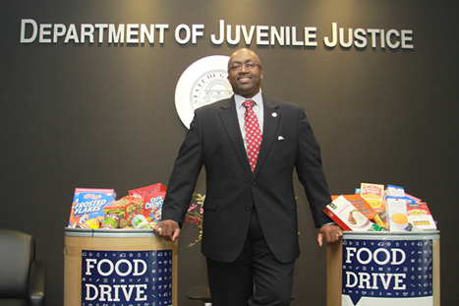

PHOTO CREDIT: GEORGIA DJJ DJJ COMMISSIONER AVERY D. NILES

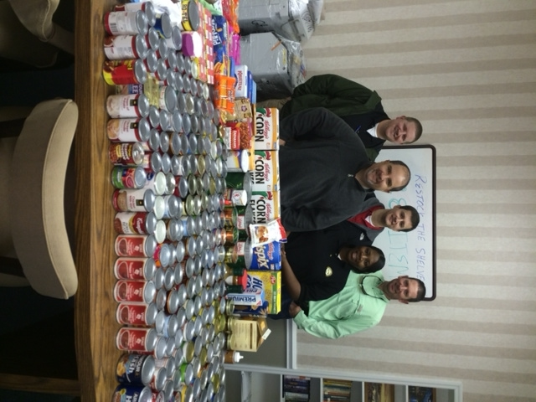

PHOTO CREDIT: GEORGIA DJJ

The Evans/Tattnall Court Services Office Staff – Leaders of the Restock the Shelves ’14 Campaign

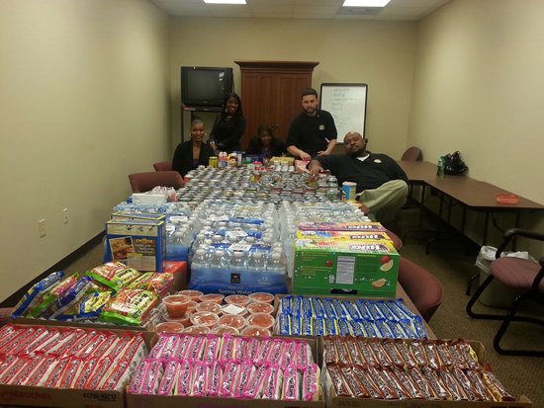

PHOTO CREDIT: GEORGIA DJJ

Department of Juvenile Justice employees in Liberty and Long Counties collected over 4,000 cans during Restock the Shelves ’14

(END RELEASE)

