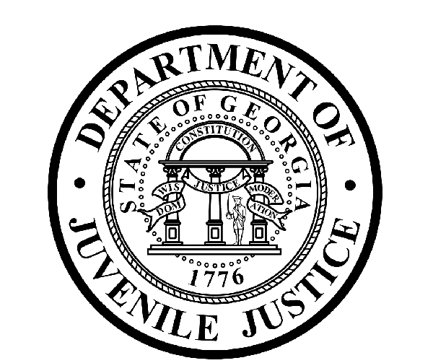
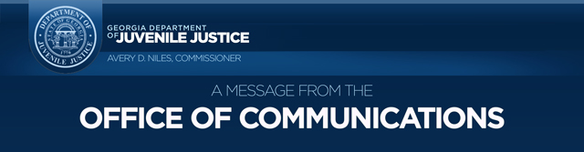
Avery D. Niles, CommissionerDepartment of Juvenile Justice

Scott Mall3408 Covington Highway ▪ Decatur, Georgia ▪ 30032-1513
Office of CommunicationsTelephone: (404) 508-7147 ▪ Fax: (404) 508-7341
FOR IMMEDIATE RELEASE CONTACT:
Matt Montgomery
NOVEMBER 29, 2016 DJJ Communications
(404) 508-7142 MatthewMontgomery@djj.state.ga.us

DJJ CANNED FOOD DRIVE BENEFITS GEORGIA COMMUNITIES
“Restock the Shelves 16” Campaign

(ATLANTA, GA) The Department of Juvenile Justice (DJJ) is conducting a statewide canned food drive collection campaign benefitting local food banks across Georgia. Named “Restock the Shelves ‘16”, the DJJ employee food collection project is a follow-up on a successful campaign conducted in 2014-15. Restock the Shelves ’16 will begin on November 29 and run through the end of 2016.

DJJ Commissioner Avery D. Niles stated, “I am proud of the generous response that DJJ employees made in the past to help collect food and toiletry items for our communities. Now, as we enter the 2016 holiday season, the collection and donation of similar items will once again help local food banks provide meals and other necessities to the nearly one-in-five Georgians who are unsure of where their meals will come from this season.”

Restock the Shelves ‘16 is an opportunity for the Department and its employees to help local food banks replenish their supplies prior to the busy holiday and winter seasons. All donated items will stay in the area where collected to maximize the benefit in the community.

The success of previous Restock the Shelves food drives, along with the initiative of DJJ employees can help to grow the program in unexpected and positive ways. Leaders of Restock the Shelves ‘16 plan to add donation boxes in the community and work with local Boy Scout and Girl Scout troops, local school systems and community providers. In addition, and as they have done previously, youth in the care of DJJ will also participate through donations at court services offices around the state.

(more)
(Page 2)

DJJ will collect canned food and toiletry items and then partner with the following food banks across Georgia:

- ALBANY – Food Bank of Southwest Georgia – 912-883-2139
- ATHENS – Food Bank of Northeast Georgia – 706-354-8191
- ATLANTA – Atlanta Community Food Bank – 404-892-9822
- AUGUSTA – Golden Harvest Food Bank – 706-736-1199
- COLUMBUS – Second Harvest Food Bank of the Chattahoochee Valley – 706-561-4755
- MACON – Middle Georgia Community Food Bank – 912-742-3958
- SAVANNAH – Second Harvest Food Bank of Coastal Georgia – 912-236-6750
- VALDOSTA – Valdosta Food Bank – 912-244-2678

Among the most needed items for donation are canned meats, canned fruits and fruit juice, canned beans, canned soups, stews and pasta. Other items welcomed include peanut butter, macaroni and cheese, whole grain cereals, paper products, diapers and toiletries.

For additional information about Restock the Shelves ‘16, visit the DJJ website at http://www.djjnewsandviews.org/restocktheshelves.

###

