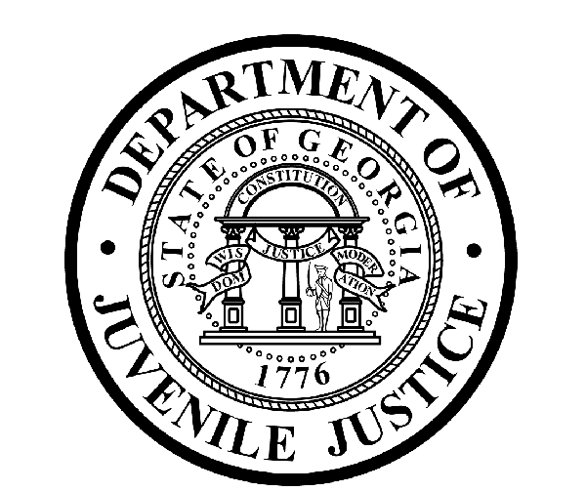

Avery D. Niles, CommissionerDepartment of Juvenile Justice

Scott Mall3408 Covington Highway ▪ Decatur, Georgia ▪ 30032-1513
Office of CommunicationsTelephone: (404) 508-7147 ▪ Fax: (404) 508-7341

FOR IMMEDIATE RELEASE CONTACT:
Scott Mall
SEPT 13, 2016 DJJ Communications
(404) 518 - 5119
Scott.Mall@djj.state.ga.us

Bell-Forsyth Judicial Circuit District Attorney Penny A. Penn Appointed to Board of Department of Juvenile Justice

Atlanta, GA – Penny A. Penn, the district attorney for the Bell-Forsyth Judicial Circuit, was appointed to the Board of the Department of Juvenile Justice (DJJ) by Governor Nathan Deal. She will represent Congressional District 7 on the DJJ Board.

“On behalf of the Department, I welcome the appointment of District Attorney Penn to the DJJ Board,” said DJJ Commissioner Avery D. Niles. “Ms. Penn has an outstanding record in law enforcement, and her experience will be helpful to me and the entire DJJ staff.”

Commenting on her appointment, District Attorney Penn stated, “I am honored to be appointed by Governor Deal to the DJJ Board. I look forward to serving the citizens of the state by working with the other members of the Board in their efforts to assist the Department of Juvenile Justice with its mission to rehabilitate youthful offenders.”

DJJ Board Chair Elaine P. Snow, the retired Chief of Police for the City of Rome, said “I know I speak for each member of the DJJ Board in welcoming District Attorney Penny A. Penn to the Board. We look forward to her active participation in our work.”

Penn has served as the Bell-Forsyth Judicial Circuit District Attorney since January 2003. She is an elected state constitutional officer charged with the prosecution of felony offenses committed in Forsyth County. She is also responsible for a range of administrative and managerial duties related to the office.

Prior to her election, Penn served as the Chief Assistant District Attorney for the Bell-Forsyth Judicial Circuit from November 1998 until January 2003. Her responsibilities included the prosecution of felony cases from arrest through appeal (including serving as the lead counsel in 25 jury trials). She argued cases before the Georgia Supreme Court and Court of Appeals. In addition, she also assisted the District Attorney with administrative matters, including budgetary and personnel decisions. Penn was also responsible for training and supervision of assistant district attorneys.

Penn also has previous experience with the Fulton County District Attorney’s Office and the Fulton County Public Defender’s Office. She earned a bachelor’s degree in English from Wheaton College in Norton, Massachusetts and a juris doctor degree from the Emory University School of Law.

###



Photo of Penny Penn

