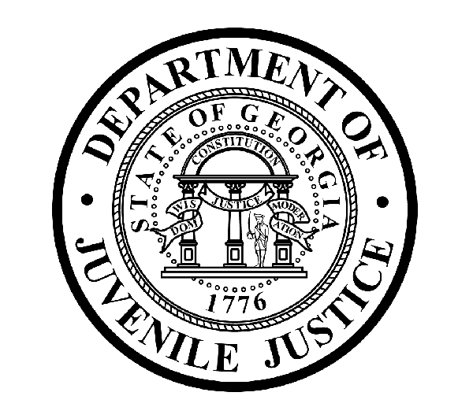

Avery D. Niles, CommissionerDepartment of Juvenile Justice

Jim Shuler, Director3408 Covington Highway ▪ Decatur, Georgia ▪ 30032-1513
Office of CommunicationsTelephone: (404) 508-7147 ▪ Fax: (404) 508-7341
FOR IMMEDIATE RELEASE CONTACT:
Jim Shuler, Director
October 28, 2013 DJJ Communications
(404) 508-7238
JimShuler@djj.state.ga.us

Expiring Facility Contract Will Save DJJ $6 Million+

(ATLANTA – GA) Commissioner Avery D. Niles announced today that the Department of Juvenile Justice will allow the current contract for operations at the Paulding Regional Youth Detention Center (RYDC) in Dallas, Georgia to end on its expiration date of December 31, 2013.

“The closing of just this one Regional Youth Detention Center will result in DJJ’s annual savings of more than $6-million dollars, without displacing any youth currently in our system,” the Commissioner said. “Secure detention incurs a significant expense -- about $90,000 dollars per year, per youth in custody,” said Commissioner Niles.

According to Commissioner Niles, the decision to allow the six-month contract extension to expire was based on balancing the economics of reducing considerable overhead facility costs, with minimal reduction of bed space in the system, while making millions in funds available for additional treatment and counseling services for thousands of youth in DJJ’s care and custody.

“This decision is being made before the year-end, after balancing costs against the current trending population in this RYDC’s service area,” Commissioner Niles said.

DJJ plans to begin the orderly relocation of youth from the Paulding RYDC secure facility in early December 2013. Some Paulding facility youth will be transferred to Georgia’s Sumter Youth Development Center (YDC). At Sumter, DJJ will bring a 75-bed capacity facility back on-line this December following a pre-planned, long-term maintenance and refurbishing project. The transferred DJJ youth will continue to receive the full spectrum of appropriate services and treatment.
(MORE MORE MORE)
(PAGE TWO)

As of January 2014, an additional 20-bed capacity will also be coming on-line for DJJ at the refurbished Martha K. Glaze Regional Youth Detention Center (RYDC) in Clayton County. The remaining Paulding facility youth will be diverted to other DJJ secure facilities in the Greater Atlanta Metro Area in late December 2013. All juvenile offenders at the Paulding RYDC will be transferred to other DJJ secure facilities by the end of December 2013.

The DJJ’s secure facility in Paulding County is currently run by Youth Services International, a private corrections services company also known as YSI, which operates the state-owned youth detention facility under contract with the State of Georgia.

DJJ Commissioner Avery Niles said, under Georgia’s contract provisions with YSI, Youth Services International will ensure appropriate staffing levels remain in place to maintain safety and security at the Paulding Regional Youth Detention Center during the transitions to other DJJ facilities.

Commissioner Niles said DJJ plans to work closely with YSI administrators to assist in locating appropriate employment opportunities for the private contractor’s employees currently working at the decommissioned RYDC, based on their individual skills, qualifications, and background check results.

“DJJ continues its longstanding relationship with YSI as they continue to operate another state owned secure facility in Crisp County and their own Youth Development Center in Milan, Georgia under contract with the State of Georgia,” Commissioner Niles said. “We look forward to a substantial savings and a smooth transition of services.”

(END RELEASE)

