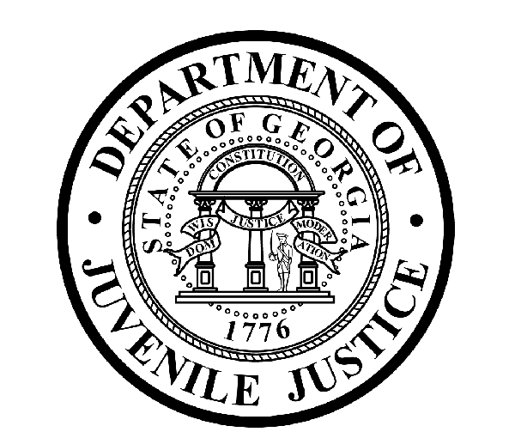

Avery D. Niles, CommissionerDepartment of Juvenile Justice

Jim Shuler, Director3408 Covington Highway ▪ Decatur, Georgia ▪ 30032-1513
Office of CommunicationsTelephone: (404) 508-7147 ▪ Fax: (404) 508-7341
FOR IMMEDIATE RELEASE CONTACT:
Jim Shuler, Director
August 19, 2015 DJJ Communications
(404) 508-7238
JimShuler@djj.state.ga.us

New Deputy Commissioner Named for Secure Facilities
Gwinnett Sheriff’s Major Dwayne Orrick Joins DJJ Leadership Team

(DECATUR - GA) DJJ Commissioner Avery D. Niles is pleased to announce the latest addition to his Secure Facilities Leadership Team. As of August 24, 2015, former Gwinnett County Sheriff’s Major Dwayne Orrick will join the department as DJJ’s Deputy Commissioner (DC) for Secure Facilities.

The Commissioner’s choice for this critical Deputy Commissioner position comes to DJJ from the leadership team of the Gwinnett County Sheriff’s Office where he commanded the Training and Support Services Division. Major Orrick is the former Police Chief of Roswell and Cordele, Georgia with a combined twenty-one years of local public safety leadership service.

“Deputy Commissioner Orrick’s public safety management background and years of law enforcement experience is recognized nationwide,” said Commissioner Niles. “He literally wrote a book on how to successfully recruit and retain a cadre of professional officers, which I view as a critical component for the future operations of our agency. His reputation as an experienced trainer and mentor precede his appointment to DJJ,” Commissioner Niles said.

“My main goals are to ensure the safety of our youth and staff at 27 DJJ secure facilities across the state, to provide a consistent environment that encourages qualified men and women to grow their corrections careers in juvenile justice, and to ensure an environment where youth can focus on their educations and develop skills for reentry into their communities to become productive and law abiding citizens,” the new Deputy Commissioner said. “I’m excited to be working with the DJJ Team.”

Prior to his management level experience in both police and sheriff’s departments, Major Orrick was employed with the Georgia Department of Community Affairs as a Criminal Justice Management Consultant. Orrick has years of field experience as a police officer, field training officer, and deputy sheriff. He is a graduate of the 186th Session of the FBI National Academy and the Georgia International Law Enforcement Exchange (GILLEA) to Israel.

(MORE, MORE, MORE)

(PAGE TWO TWO TWO)

“Deputy Commissioner Orrick will help build upon DJJ’s reputation in juvenile corrections as a great place for career corrections professional to learn and grow their job skills, while providing the leadership needed to keep the youth in our care safe and secure,” said Commissioner Niles.

Orrick currently serves as a Board Member on the Governor’s Commission on Family Violence and the CIT Advisory Committee for the Georgia Chapter of the National Alliance on Mental Illness (NAMI). He previously served as a Board Member on the State Board of Public Safety, the governing authority for the Georgia State Patrol, Georgia Bureau of Investigation, and the Georgia Public Safety Training Center, as well as a member of the Georgia POST Council and the POST Council Probable Cause Committee.

The new Deputy Commissioner is a Past-President and Board Member with the Georgia Association of Chiefs of Police. He holds a Bachelor of Arts in Criminal Justice and a Masters of Public Administration from the University of Georgia. DC Orrick is a monthly columnist for Law and Order magazine and the author of his non-fiction work, Recruitment, Retention and Turnover of Police Personnel. Commissioner Niles welcomes DC Dwayne Orrick to his extensive new responsibilities with the DJJ Executive Team.

(END RELEASE)

