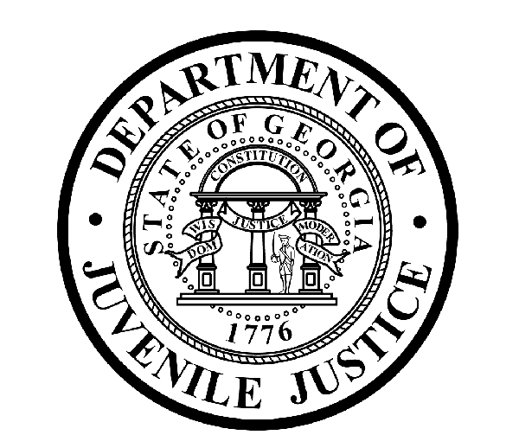

Avery D. Niles, CommissionerDepartment of Juvenile Justice

Jim Shuler, Director3408 Covington Highway ▪ Decatur, Georgia ▪ 30032-1513
Office of CommunicationsTelephone: (404) 508-7147 ▪ Fax: (404) 508-7341
FOR IMMEDIATE RELEASE CONTACT:
Jim Shuler, Director
September 15, 2015 DJJ Communications
(404) 508-7238
JimShuler@djj.state.ga.us

Department of Juvenile Justice Recruiting in SEPTEMBER
DJJ Job Fairs Slated for Savannah, Columbus & Marietta

(SAVANNAH, COLUMBUS & MARIETTA - GA) The Georgia Department of Labor in Savannah, the Turner Chapel AME Church in Marietta, and the Columbus Trade Center are highlighted on this month’s DJJ recruitment calendar.

Georgia’s Juvenile Justice Commissioner Avery D. Niles is sending dedicated teams of recruiters to seek qualified candidates for Juvenile Corrections Officer (JCO) positions during the upcoming DJJ job fairs on September 16th, 24th and 30th. Serious applicants need to know that fulltime juvenile corrections careers require “Can-Do!” attitudes and professional performance.

Commissioner Niles says his recruiting teams are always on the lookout for Georgia veterans at DJJ’s job fairs. The Department of Juvenile Justice has immediate openings for professionally motivated mature adults to help young offenders make their successful reentries from juvenile custody back into Georgia society as productive citizens.

“DJJ is a great place to make your work count,” Commissioner Niles said. There is no charge for participation at juvenile corrections career fairs. The September Recruitment Fair schedule is below.

*Please note career fair locations and times may change OR additional career fair dates may be added to our recruiting schedule. Applicants should check the DJJ website for late-breaking schedule changes at www.djjcareers.org BEFORE visiting a DJJ job fair.

Date: Wednesday, September 16th, 2015- GENERAL PUBLIC
DJJ Resource & Job Fair
Georgia Department of Labor
301 West Oglethorpe
Savannah, GA. 31405
Time: 9:00 AM - 1:00 PM
Contact: Belinda Martinez, 912-356-2773.
( MORE MORE MORE )
(PAGE TWO TWO TWO)

Date: Thursday, September 24th, 2015 - GENERAL PUBLIC
Marietta Career Expo
Turner Chapel AME Church
492 North Marietta Pkwy NE
Marietta, GA. 30060
Time: 10:00 AM - 3:00 PM
Contact: Katrina Brown kbrown@cobbworks.org

Date: Wednesday, September 30th, 2015 - GENERAL PUBLIC
Career Expo & Job Fair
Columbus Trade Center
801 Front Ave.
Columbus, GA. 31901
Time: 10:00 AM - 2:00 PM
Contact: Isaac Williams Jr., 706-321-2627

DJJ recruiters are authorized to interview qualified JCO candidates on-site. Applicants should come dressed for job interviews and bring resumes. All job seekers can click on www.djjcareers.org for more information about career opportunities in juvenile corrections.

In order to progress smoothly through the interview process for Juvenile Corrections Officers, candidates for JCO positions should bring copies of the following:

- Completed State of Georgia application
- State issued ID - Valid Driver License
- Social Security Card
- Birth Certificate
- High School Diploma or GED
- DD214 Long Form with discharge indicated
- Naturalization Forms (if NON-US Citizen)
- If P.O.S.T. Certified, (Please bring two (2) forms of Gov. issued ID & P.O.S.T. Profile)

Candidates should bring Passing Test Scores as follows:
- Compass Scores (Reading 70 Writing 32)**
- SAT Scores (Verbal: 430 Math: 400) or ACT Scores (Verbal: 18 Math:16)**
- CPE Scores (Reading: 75 Math: 75 English 75)

** Applicants with a 4-year degree from an accredited college are exempt from taking the Compass test or providing proof of acceptable ACT or SAT scores.

Former military service members with Honorable Discharge should click on www.djjcareers.org to learn about DJJ's one-time Military Salary Increase Incentive on eligible job titles at “DJJ Careers for Veterans”. There is no charge for participation at juvenile corrections career fairs.

**Please note that career fair times and locations may change and additional career fair dates may be added to our recruiting schedule. Applicants should check the DJJ website for late-breaking schedule changes at http://www.djjnewsandviews.org/djjcareers/ before visiting a job fair.

(END RELEASE)

“DJJ is a great place to make your work count.”
Avery D. Niles, Commissioner
Georgia Department of Juvenile Justice

