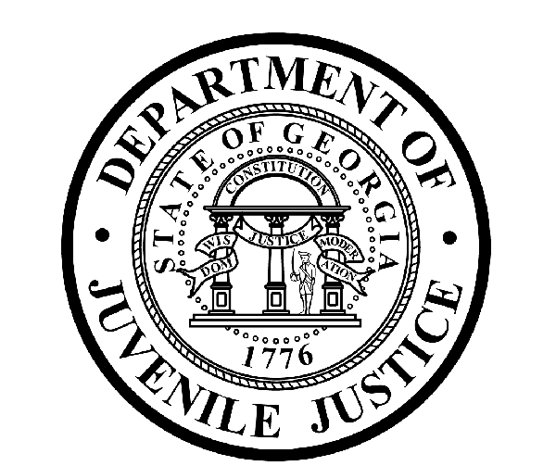

Avery D. Niles, CommissionerDepartment of Juvenile Justice

Jim Shuler, Director3408 Covington Highway ▪ Decatur, Georgia ▪ 30032-1513
Office of CommunicationsTelephone: (404) 508-7147 ▪ Fax: (404) 508-7341
FOR IMMEDIATE RELEASE CONTACT:
Jim Shuler, Director
November 15, 2012 DJJ Communications
(404) 508-7238
JimShuler@djj.state.ga.us

Augusta YDC Evaluation Report Says Security Upgrades Needed
DJJ Commissioner to Name New Augusta YDC Director

(AUGUSTA-YDC) A recent DJJ internal report designed to routinely analyze the status of Safety, Security and Physical Plant conditions at the Augusta Youth Development Campus was released today under provisions of the Georgia Open Records Act in fulfillment of requests by some local Augusta news media.

The performance audit conducted by the DJJ Office of Continuous Improvement (OCI) was compiled prior to the October escape of five juveniles from the Augusta YDC. In the DJJ report, the agency identified a number of what it terms as “deficiencies” to be addressed and corrected by the Augusta YDC Staff with support from DJJ Central Office.

“The Department of Juvenile Justice regularly conducts these OCI internal audits to ensure that safety and security policies are being followed,” explained DJJ’s new Commissioner, Avery D. Niles.

“But after all the investigations DJJ has conducted at Augusta YDC -- and after all the personnel changes and security compliance this agency has invested there -- this performance audit is unacceptable and we mean to change things,” said Commissioner Niles. “As a result of the escape DJJ failed to protect the community. Audit reports like this compromise our agency integrity.”

Commissioner Niles confirms that deficiencies were discovered in several evaluation categories surveyed during the course of the internal audit at the Augusta YDC. But the Commissioner also indicated that as a matter of transparency, DJJ has already disclosed the most crucial areas of deficiency from the OCI report in advance to the public during the preliminary phase of the Augusta YDC escape investigation.

(MORE MORE MORE)

(PAGE TWO)

“Before and after the October escape, DJJ Central Office instructed Augusta YDC Managers and Staff to implement and oversee specific details and improvements needed to correct existing problems, strengthen safety and security practices, and to ensure the operation of a sound facility,” said Commissioner Niles. “After the Augusta YDC escape, DJJ shared a deficiency list with the public detailing which specific areas needed immediate improvement. In a previous DJJ news release we called it ‘Security Improvements Ordered’,” he said.

Security Improvements Ordered:

- ensure detainee movement and population counts are conducted properly
- ensure dorms are managed in a manner which prevents safety and security issues
- ensure staff frequently practice emergency drills in preparation for real crises
- ensure perimeter checks are conducted as outlined in policy
- ensure all staff members are familiar with the escape prevention plan, and
- ensure the emergency notification process for local law enforcement is structured to accurately reflect when notification times or attempted contacts are made to the Sheriff’s Department

Since taking office at the Department of Juvenile Justice November 1st, Commissioner Niles already has given instructions that safety and security deficiencies described in the Augusta OCI audit will be investigated and prioritized with enhanced compliance measures systematically put in place.

The Commissioner has plans to place a new full time Director at the Augusta YDC around Mid-December. The official selection process is already underway. Commissioner Niles said the new Augusta Director, “..will have full authority to oversee, implement, and direct all actions necessary to get this facility in line with DJJ standards and policy. Escapes and poor performance audits will not be tolerated.”

Behind the scenes, Commissioner Niles made an unannounced visit to the Augusta facility earlier this month and sent in technical assistance personnel from DJJ Central Office with a Corrective Action Plan. Some added perimeter safety measures already have been put in place for Augusta YDC but cannot be enumerated due to security reasons. New state of the art stadium lighting to help illuminate the 456 acre campus, will soon be fully operational there.

While the DJJ investigation into the Augusta YDC escape continues, the new Commisioner indicates more staffing changes may be expected at the Augusta facility stemming from the investigation or as a result of deficiencies reflected in the performance audit.

“Safety and security and a professional, ethical staff remain as major goals for Augusta YDC,” said Commissioner Niles. “There is no room for compromise when safety and security violations at one of our facilities threaten the security of our staff and our residents, or endanger the safety of the community.”

(END RELEASE)

