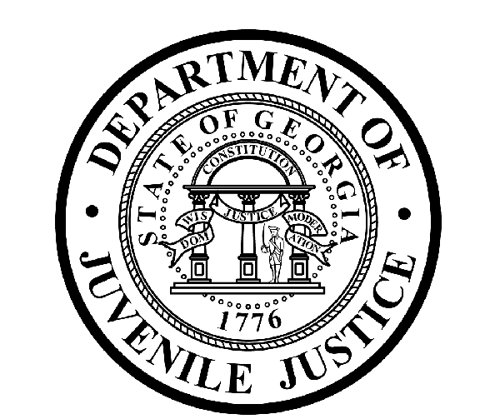

Avery D. Niles, CommissionerDepartment of Juvenile Justice

Scott Mall3408 Covington Highway ▪ Decatur, Georgia ▪ 30032-1513
Office of CommunicationsTelephone: (404) 508-7147 ▪ Fax: (404) 508-7341
FOR IMMEDIATE RELEASE CONTACT:
Jim Shuler
October 28, 2016 DJJ Communications
(404) 508-7147
JimShuler@djj.state.ga.us

DJJ Hiring in November!
Georgia Department of Juvenile Justice Recruiting Statewide:
Americus, Atlanta, Carrollton, Cochran, Dublin, Lawrenceville, Metter, Robins AFB, Savannah and Statesboro

(STATEWIDE-GA) Department of Juvenile Justice (DJJ) Commissioner Avery D. Niles has an important message to share with serious jobseekers in November. DJJ is offering full-time employment in one of Georgia’s most challenging career areas and agency recruiters are looking for candidates who want their work to make a real difference in their community.

“We’re recruiting in locations all over Georgia to find motivated applicants who can accept the personal challenge of helping young offenders through their troubled life transitions while they’re in state custody,” said Commissioner Niles.

The Commissioner continued, “We want to hire more specialists with the personal drive to become part of our dedicated team. DJJ wants mature, responsible candidates and we’re always looking for applicants who want to put their prior specialty experience in corrections, the military or law enforcement to work in a structured juvenile justice system environment.”

DJJ recruiters are conducting a month-long candidate search in November at career fairs in 12 Georgia communities (Americus, Atlanta, Carrollton, Cochran, Dublin, Lawrenceville, Metter, Robins AFB, Savannah and Statesboro). The department is filling professional positions for Juvenile Corrections Officers (JCOs), highly qualified teachers and Registered Nurses (RNs). The agency is offering employment opportunities at secure facilities throughout Georgia’s juvenile justice system.

*Please note career fair locations and times may change OR additional career fair dates may be added to the DJJ recruiting schedule. Applicants should check the DJJ website for late-breaking schedule changes at www.djjcareers.org BEFORE visiting a DJJ job fair.

(MORE)

(Page Two)

November Job Fairs are sorted by dates:

Date: Tuesday, November 1, 2016 – OPEN to GENERAL PUBLIC
South Georgia Technical College Job Fair
Location: SGTC, Pope Center
Americus, GA
Time: 1:00 p.m. – 6:00 p.m.
Contact: Cynthia Carter (229) 931-2057

Date: Wednesday, November 2, 2016 – OPEN to GENERAL PUBLIC
Armstrong State University Career Fair
Location: 11935 Abercorn Street
Savannah, GA
Time: 10:00 a.m. – 2:00 p.m.
Contact: Crystal Goode (912) 344- 2563

Date: Wednesday, November 2, 2016 – OPEN to GENERAL PUBLIC
Military Success Career Workshop - University of West Georgia
Location: University of West Georgia
Carrollton, GA
Time: 11:00 a.m. – 1:00 p.m.
Contact: Iteah Pounds (678) 839-6593

Date: Thursday, November 3, 2016 – OPEN to GENERAL PUBLIC
Public Service Career Fair/Georgia Southern University
Location: GSU – Russell Union Ballroom (85 Georgia Ave.)
Statesboro, GA
Time: 2:00 p.m. – 4:00 p.m.
Contact: Mary Lu Adams (912) 478-5197

Date: Thursday, November 3, 2016 – OPEN to GENERAL PUBLIC
Middle Georgia State University Career Fair
Location: MGSU - Cochran Campus Sanford Hall (1100 Second Street SE)
Cochran, GA
Time: 11:00 a.m. – 1:00 p.m.
Contact: Heather McIntosh (478) 471-2714

Date: Wednesday, November 9, 2016 – MILITARY ONLY
Robins AFB Quarterly Job Fair
Location: Robins AFB, Heritage Club
Robins AFB, GA
Time: 10:00 a.m. – 2:00 p.m.
Contact: Venus Mansourzadel (478) 926-6559

Date: Thursday, November 10, 2016 – OPEN to GENERAL PUBLIC
Veteran’s Career Fair
Location: Savannah Technical College, 5717 White Bluff Road
Savannah, GA
Time: 9:00 a.m. – 1:00 p.m.
Contact: Juanita Simmons (912) 356-2773

Date: Thursday, November 10, 2016 – STUDENTS and ALUMNI ONLY
Veterans Service 2016 Career Fair
Location: 5150 Sugarloaf Parkway, Busbee Ctr. - Bldg 700
Lawrenceville, GA
Time: 12:00 p.m. – 3:00 p.m.
Contact: Osvaldo Montalvo (770) 209-3086
(MORE)

(Page Three)

Date: Tuesday, November 15, 2016 – STUDENTS and ALUMNI ONLY
American International University
Location: AIU Campus, 6600 Peachtree Dunwoody Rd.
Atlanta, GA
Time: 12:00 p.m. – 2:00 p.m.
Contact: Pia Scott (404) 965-6456

Date: Tuesday, November 15, 2016 – OPEN to GENERAL PUBLIC
Atlanta Metropolitan State College Career Fair
Location: 16380 Metropolitan Pkwy, S.W.
Atlanta, GA
Time: 12:00 p.m. – 2:00 p.m.
Contact: Chelsia Philbrick (404) 756-4016

Date: Thursday, November 17, 2016 – OPEN to GENERAL PUBLIC
Job Fair for Eastman YDC @ Georgia Dept. of Labor
Location: 910 North Jefferson Street
Dublin, GA
Time: 9:00 a.m. – 3:00 p.m.
Contact: Patsy Carr (478) 275-6525

Date: Friday, November 18, 2016 – OPEN to GENERAL PUBLIC
College & Career Day /Job Training Unlimited
Location: Metter High School, 34905 Hwy. 129 South
Metter, GA
Time: 9:00 a.m. – 1:00 p.m.
Contact: Patsy Carr (478) 275-6525

Applicants for Juvenile Corrections Officer positions should bring copies of these important documents to the interview process:
- Compass Scores (Reading: 70 Writing: 32)** Accuplacer (Reading: 55 Writing: 60 Numerical: 34) **
- SAT Scores (Verbal: 430 Math: 400) or ACT Scores (Verbal: 18 Math: 16)**
- Valid Driver’s License
- Birth Certificate
- High School Diploma or GED
- DD214 Long Form with discharge indicated
- Naturalization Forms if Non-US Citizen
- If P.O.S.T. Certified, please bring two (2) forms of Govt. issued ID & P.O.S.T. Profile **
**Applicants with a 4-year degree from an accredited college are exempt from taking the Compass test or providing proof of acceptable ACT or SAT scores.

Interested job seekers can click on www.djjcareers.org for more information about career opportunities in juvenile corrections. DJJ is ‘Veteran-Friendly.’ Former military service members with Honorable Discharges should also click on www.djjcareers.org to learn about DJJ's one-time Military Salary Increase Incentive on eligible job titles at “DJJ Careers for Veterans.”

**Please note that career fair times and locations may change and additional career fair dates may be added to our recruiting schedule at any time. Applicants should check the DJJ website for late-breaking schedule changes at http://www.djjnewsandviews.org/djjcareers/ before visiting a job fair.

###

“DJJ is a great place to make your work count.”
Avery D. Niles, Commissioner
Georgia Department of Juvenile Justice

(MORE)

(Page Three)

The Georgia Department of Juvenile Justice (DJJ) is a multi-faceted agency that serves the needs of this state`s young offenders up to the age of 21. The Department employs more than 4,000 men and women at 26 secure facilities and 92 community services offices throughout the state to effect justice and redirect the young lives in the agency`s care.

Including those who are placed on probation, more than 50,000 youths are diverted each year to evidence-based community programs, sentenced to short-term incarceration or committed to the Department`s long-term custody by the Juvenile Courts. It is the duty of DJJ’s professional corrections staff to preserve public safety and safeguard the citizens of Georgia, as well as protect the victims of crimes so that they can rebuild their lives.

At the same time, DJJ holds juvenile offenders accountable for their delinquent conduct so that they can take responsibility for their actions through probation, supervision and secure detention. The youth are provided with medical and psychological treatment, as well as specialized education and programs designed to equip them with the social, intellectual and emotional tools needed to achieve their successful reentry and reintegration into community, workplace and neighborhood settings as more productive and law-abiding citizens.

