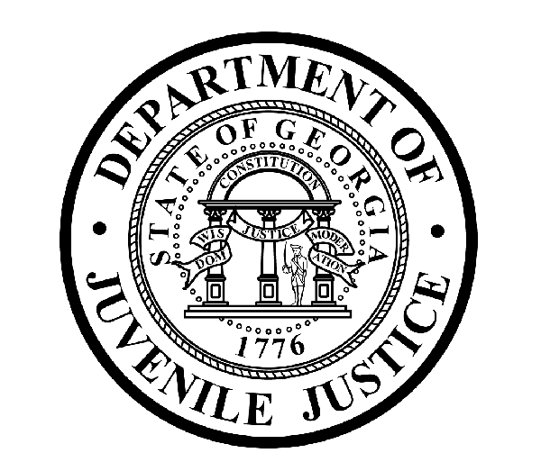

Avery D. Niles, CommissionerDepartment of Juvenile Justice

Scott Mall3408 Covington Highway ▪ Decatur, Georgia ▪ 30032-1513
Office of CommunicationsTelephone: (404) 508-7147 ▪ Fax: (404) 508-7341
FOR IMMEDIATE RELEASE CONTACT:
Jim Shuler
OCTOBER 31, 2016 DJJ Communications
(404) 508-7147
JimShuler@djj.state.ga.us

DJJ Commissioner Niles Named to Nominating Committee for State’s Child Advocate

(Atlanta, GA) – Georgia Governor Nathan Deal has issued an Executive Order naming members of a Nominating Committee to consider nominees for the position of Advocate in the state’s Office of Child Advocate. Among those chosen for the Nominating Committee are Avery D. Niles, Commissioner of the Department of Juvenile Justice (DJJ). This is the second time Commissioner Niles has been named to a Nominating Committee for the Advocate position.

Reacting to his nomination, Commissioner Niles stated, “I am honored to be named by Governor Deal to the Nominating Committee for the State of Georgia’s Child Advocate. The mission of the Office is the protection of the children of the State of Georgia. This includes assisting and restoring the security of children whose well-being is threatened.”

Niles continued, “I look forward to working with other committee members to review the background and credentials of candidates who are capable of handling these critically important duties protecting Georgia’s children.”

The Honorable Steve Teske, who is Chief Judge of the Clayton County Juvenile Court and serves on the DJJ Judicial Advisory Council, was also named to the Nominating Committee. “While each of the other members of the Nominating Committee is eminently qualified to serve, I am especially glad to see Judge Teske as a member. His input to the issues that DJJ deals with is invaluable,” Niles said.

In addition to Niles and Teske, other members of the Nominating Committee include:

Frank Berry, Commissioner of the Department of Behavioral Health and Developmental Disabilities

Robyn Crittenden, Commissioner of the Department of Human Services

Richard Darby, Retired Chief of Police of the City of Cornelia

Judy Fitzgerald, Chief of Staff of the Department of Behavioral Health and Developmental Disabilities

Carey Miller, Deputy Executive Counsel of the Office of the Governor

The Honorable David Miller, District Attorney of the Southern Judicial Circuit

###

The Georgia Department of Juvenile Justice (DJJ) is a multi-faceted agency that serves the needs of this state`s young offenders up to the age of 21. The Department employs more than 4,000 men and women at 26 secure facilities and 92 community services offices throughout the state to effect justice and redirect the young lives in the agency`s care.

Including those who are placed on probation, more than 50,000 youths are diverted each year to evidence-based community programs, sentenced to short-term incarceration or committed to the Department`s long-term custody by the Juvenile Courts. It is the duty of DJJ’s professional corrections staff to preserve public safety and safeguard the citizens of Georgia, as well as protect the victims of crimes so that they can rebuild their lives.

At the same time, DJJ holds juvenile offenders accountable for their delinquent conduct so that they can take responsibility for their actions through probation, supervision and secure detention. The youth are provided with medical and psychological treatment, as well as specialized education and programs designed to equip them with the social, intellectual and emotional tools needed to achieve their successful reentry and reintegration into community, workplace and neighborhood settings as more productive and law-abiding citizens.

