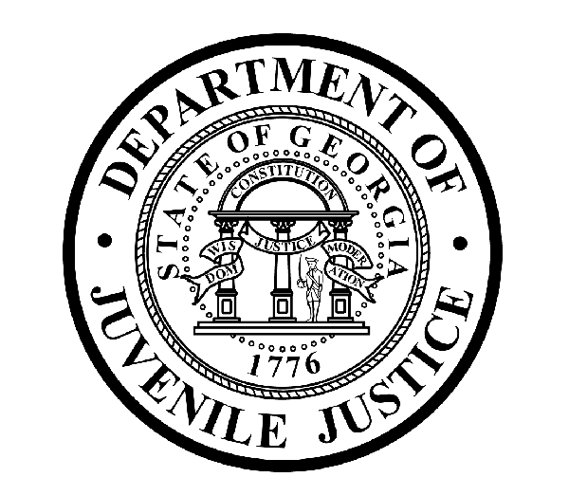

Avery D. Niles, CommissionerDepartment of Juvenile Justice

Scott Mall3408 Covington Highway ▪ Decatur, Georgia ▪ 30032-1513
Office of CommunicationsTelephone: (404) 508-7147 ▪ Fax: (404) 508-7341
FOR IMMEDIATE RELEASE CONTACT:
Jim Shuler
OCTOBER 26, 2016 DJJ Communications
(404) 508-7147
JimShuler@djj.state.ga.us

DJJ Commissioner Avery D. Niles Receives 2016 Martha K. Glaze Award from Council of Juvenile Court Judges
Recognized for Meeting Needs of Young Offenders

(DECATUR, GA) The Council of Juvenile Court Judges of Georgia (CJCJ) recognized Department of Juvenile Justice (DJJ) Commissioner Avery D. Niles for his ongoing efforts to partner with the courts to protect and improve the lives of juvenile offenders seeking rehabilitation and reentry into their communities as productive citizens. The Council is composed of all judges of the courts exercising jurisdiction over juveniles. It develops policies and provides support for juvenile courts through legal research services, legislative tracking and programs to help protect the best interests of children and the state.

At its annual conference in Athens this week, the CJCJ presented Commissioner Niles with their 2016 Martha K. Glaze Award for his energies establishing rapport and planning with judges and the courts. The award is presented to a non-judicial individual recognized by the Council for significant contributions in the field of juvenile justice and child welfare. DJJ is one of many stakeholders working with the juvenile courts to address current social issues affecting children and families arising from substance abuse, domestic violence and untreated mental health issues.

Senior Juvenile Court Judge, Cliff Jolliff, who formerly presided in Hall and Dawson Counties, congratulated Commissioner Niles for “his outstanding leadership to develop and maintain a close agency relationship with the courts and the community helping initiate Georgia’s juvenile justice reforms.”

The Council’s award is named in honor of Judge Martha K. Glaze, who retired from Clayton County’s Juvenile Court system after a career of more than 20 years of distinguished service on the bench. Glaze was the county's first full-time Juvenile Court judge and sat on the bench from 1977 to 1999. Judge Glaze was known as an outstanding leader in the development of improvements and enhancements to the Georgia juvenile courts and for resolving difficult cases in a just manner. As a former president of the Judges’ Council, Glaze brought nationwide acclaim to the administration of juvenile justice in Georgia when she was presented the Meritorious Service Award by the National Council of Juvenile and Family Court Judges in 1997.

Commissioner Niles stated, “On behalf of the staff of the Department of Juvenile Justice, I want to thank the Council and its membership for this inspirational award.” He added, “This award has added significance, since DJJ has a secure Regional Youth Detention Center in Hampton named in honor of Judge Glaze. Her legacy is important to both the Council and DJJ.”

As the 2016 Martha K. Glaze Award recipient, Commissioner Niles joins the ranks of such Georgia notables as Chick-fil-A founder S. Truett Cathy, DJJ Board Member Adam Kennedy, Governor’s Office of Planning and Budget Division Director Joe Hood, and the Supreme Court of Georgia’s Committee on Justice for Children Deputy Director Michelle Barclay.

###

The Georgia Department of Juvenile Justice (DJJ) is a multi-faceted agency that serves the needs of this state`s young offenders up to the age of 21. The Department employs more than 4,000 men and women at 26 secure facilities and 92 community services offices throughout the state to effect justice and redirect the young lives in the agency`s care.

Including those who are placed on probation, more than 50,000 youths are diverted each year to evidence-based community programs, sentenced to short-term incarceration or committed to the Department`s long-term custody by the Juvenile Courts. It is the duty of DJJ’s professional corrections staff to preserve public safety and safeguard the citizens of Georgia, as well as protect the victims of crimes so that they can rebuild their lives.

At the same time, DJJ holds juvenile offenders accountable for their delinquent conduct so that they can take responsibility for their actions through probation, supervision and secure detention. The youth are provided with medical and psychological treatment, as well as specialized education and programs designed to equip them with the social, intellectual and emotional tools needed to achieve their successful reentry and reintegration into community, workplace and neighborhood settings as more productive and law-abiding citizens.

