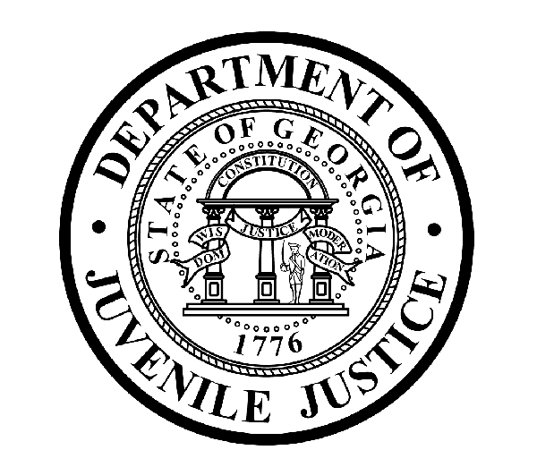

Avery D. Niles, CommissionerDepartment of Juvenile Justice

Jim Shuler, Director3408 Covington Highway ▪ Decatur, Georgia ▪ 30032-1513
Office of CommunicationsTelephone: (404) 508-7147 ▪ Fax: (404) 508-7341
FOR IMMEDIATE RELEASE CONTACT:
Jim Shuler, Director
September 20, 2013 DJJ Communications
(404) 508-7238
JimShuler@djj.state.ga.us

JUVENILE JUSTICE COMMISSIONER HIRES NEW
ASST-DEPUTY COMMISSIONER FOR SECURE FACILITIES

(ATLANTA - GA) DJJ Commissioner Avery D. Niles is pleased to announce the latest addition to his Secure Facilities Leadership Team. This week Commissioner Niles named USMC Sergeant Major (retired) Gary Tolar as DJJ’s Assistant Deputy Commissioner for Secure Facilities.

Commissioner Niles welcomed Sergeant Major Tolar and commended him for the extensive strategic planning and management experience he brings to DJJ as the department prepares to meet the upcoming deadlines of Georgia’s new juvenile justice reform law. As DJJ’s new Assistant Deputy Commissioner for Secure Facilities, Tolar will draw upon his thirty year military career experience.

“Assistant Deputy Commissioner Tolar has built a professional skill set for developing large professional operations in high-pressure environments,” said Commissioner Avery Niles. “He brings dual qualifications for short and long range planning and a depth of leadership this agency needs to make its secure facilities safer and more secure, and more productive and efficient,” the Commissioner said.

The Commissioner’s choice for Assistant Deputy Commissioner comes to DJJ from the U.S. Marine Corps’ 4th Reconnaissance Battalion where, as Inspector-Instructor Sergeant Major, Gary Tolar was responsible for ensuring all aspects of U.S. missions conformed to operational guidelines and for coordinating Combined Joint – Interagency Exercises.

Assistant Deputy Commissioner Tolar served in numerous leadership positions and deployed in direct support of multiple USMC operations including Reaction Air Contingency Force (Haiti), Operation Southern Watch (Yugoslavia), Operation Deny Flight (Yugoslavia), Operation Restore Hope (Somalia), Operation Provide Promise (Somalia), Operation Allied Force (Kosovo), Operation Noble Anvil (Kosovo) and Operation Iraqi Freedom (Iraq multiple tours).
(MORE MORE MORE)
(PAGE TWO)

Mr. Tolar was awarded (2) Bronze Star Medals, (2) Meritorious Service Medals, the Combat Action Ribbon, (5) Navy and Marine Corps Achievement Medals and Aircrew Wings for his military service.

DJJ Commissioner Avery Niles says the Department of Juvenile Justice supports and promotes
Governor Nathan Deal’s statewide ‘Hire a Georgia Veteran’ campaign. “At DJJ we proudly signed the pledge to provide enhanced hiring opportunities for Veterans,” said Commissioner Niles. “Sergeant Major (Ret.) Gary Tolar served his country for thirty years and now we look forward to working with him at DJJ to serve the State of Georgia.”

“I am certain that Assistant Deputy Commissioner Tolar will benefit from his key military assignments to help reinforce the kind of structure and organization we envision for DJJ’s Secure Facility operations,” said Commissioner Niles.

“The new Assistant Deputy Commissioner has directed specialized work forces, streamlined missions, increased productivity and produced outstanding safety records as part of his Operational Planning, Management and Compliance background,” said Commissioner Niles. “We expect Mr. Tolar to apply his strategic insight and supervisory experience and deliver similar results at our secure facilities.”

Mr. Tolar is from Loganville, Georgia. He is currently working on his Business Management degree through the University of Virginia.

DJJ has a staff of 4,200 dedicated employees managing programs, services and facilities throughout Georgia. The Department of Juvenile Justice provides supervision, detention, and a wide range of treatment and educational services for youths referred by the Juvenile Courts. More than 50,000 youths are served each year by DJJ, including youths placed on probation, sentenced to short-term incarceration, or committed into custody by the Juvenile Courts.

Commissioner Niles said, “We’re making preparations every day at DJJ to prepare for Georgia’s new Juvenile Justice Reform Law when it goes into effect in just a few months. We need strong leadership at work to make our department strategies and innovative planning succeed. We’re building an entire executive team of professionals like Mr. Tolar who are capable of helping us move this agency forward with the momentum of the new law,” said Niles.

In addition to the DJJ Central Office in Decatur, there are more than 100 DJJ office and facility locations throughout Georgia. The Department of Juvenile Justice offers careers in Education, Administration, Behavioral Health and Health Care, Human Resource Management and Development, Law Enforcement, Food Service, Housekeeping, and Plant Management and Maintenance.

For more information about career descriptions at the Department of Juvenile Justice join us on the web at http://www.djj.state.ga.us/Careers/DJJEmploy.aspx . For current listings of job openings at DJJ go to http://www.djjnewsandviews.org/djjcareers/brochures.html .

(END RELEASE)

