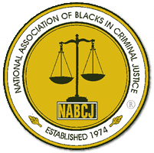
The Georgia Chapter & Clark Atlanta Student Chapter

National Association of Blacks in Criminal Justice

Presents

Workshop
Scholarship Awards Luncheon
Job Fair
Theme: "Creating a Legacy of Diversity and Inclusion Today in Tomorrow`s Leaders".

Friday, April 5, 2013

Clark Atlanta University
Student Center (Henderson Bldg)
Multipurpose Room

Workshop – 9:30 am – 10:30 am
Luncheon – 11:30 am – 1:30 pm

Donation: $25.00

To purchase tickets contact:

Danny Stone 404-635-5423 Diane Easter 404-635-5667
Rebecca Benoit 678-686-1204 Terry Collins 678-686-1262 Margaret Harris 678-686-1962 John Herring 404-417-2643 Brenda Murrell 770-883-5558

**** Make checks or money orders payable to: NABCJ, GA Chapter ****

