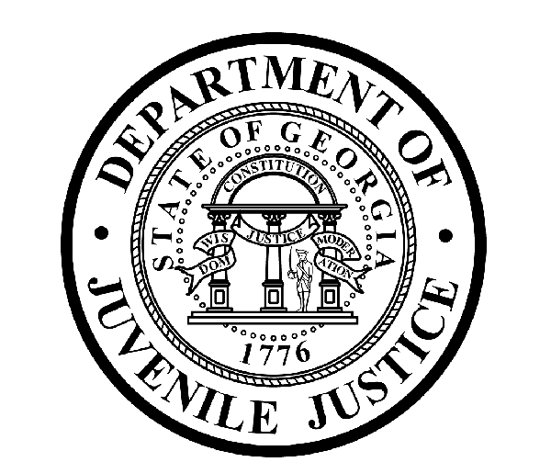

Avery D. Niles, CommissionerDepartment of Juvenile Justice

Jim Shuler, Director3408 Covington Highway ▪ Decatur, Georgia ▪ 30032-1513
Office of CommunicationsTelephone: (404) 508-7147 ▪ Fax: (404) 508-7341
FOR IMMEDIATE RELEASE CONTACT:
Jim Shuler, Director
April 19, 2013 DJJ Communications
(404) 508-7238
JimShuler@djj.state.ga.us

MUSCOGEE CORRECTIONS OFFICERS FACE CONTRABAND CHARGES
DJJ Probe Brings Prosecutions, Resignations & Terminations to YDC
LONG-TERM INTERNAL INVESTIGATION CRACKS-DOWN ON DRUGS & CONTRABAND

(MUSCOGEE COUNTY - GA) Today the Commissioner of the Georgia Department of Juvenile Justice announced more felony arrests, staff resignations and terminations at a DJJ detention facility as a direct result of the Commissioner’s “ongoing statewide crackdown to rid the agency of any internal corruption, white collar crime, or policy violations that might threaten the integrity of the DJJ Mission.”

Commissioner Avery D. Niles announced the arrest of Juvenile Corrections Officer (JCO) Anthony Harvey of the Muscogee Youth Development Campus (YDC) on felony charges of Crossing the Guard Line with a Controlled Substance (Contraband), misdemeanor Possession of Marijuana and misdemeanor charges of Violation of Oath of Office.

Commissioner Niles also announced the pending arrest of Muscogee YDC Juvenile Corrections Officer Keith Spruills. Spruills faces felony charges of Crossing Guard Lines with Contraband, felony charges of Introducing Contraband Inside a Juvenile Secure Facility, and misdemeanor charges of Violation of Oath of Office.

The Commissioner said both JCO Harvey and JCO Spruills have been placed on immediate Suspension without Pay. Warrants were obtained today.

“We are wasting no time recommending criminal prosecution wherever evidence is found and prosecution is warranted to remove officer misconduct from our ranks and to protect Georgia’s youth in detention,” said Commissioner Niles. “..And I promise the agency will continue to fast-track administrative and criminal corrective measures wherever a need is found to combat internal corruption and wrong-doing,” the Commissioner said.

(MORE MORE MORE)

(PAGE TWO)

The charges are part of a long-term DJJ internal investigative effort designed to crackdown on illegal contraband smuggling at the Youth Development Center. “That investigation is ongoing,” said Commissioner Niles.

JCO Anthony Harvey has worked as a Juvenile Corrections Officer at DJJ’s Muscogee Youth Development Campus for about six years. He was arrested after a Department of Corrections K-9 Unit ‘alerted’ on Officer Harvey’s vehicle where it was parked inside the ‘guard lines’ during a random security sweep at the Muscogee YDC. DJJ Investigators then discovered marijuana in Harvey’s vehicle.

DJJ Investigators say they have also obtained evidence allegedly linking JCO Spruills to the smuggling of “cellphones, cigarettes, lighters, and blunt spray” to youths being detained at the Muscogee YDC.

This week’s contraband crackdown marks a continuation of this agency’s commitment to utilize
the tough new provisions of Georgia’s felony contraband law. The charges against JCO Harvey and JCO Spruills could now trigger criminal prosecutions resulting in convictions with up to four-year prison sentences.

Commissioner Niles, who sanctions agency transparency for strong measures resulting from the ongoing investigation said, “I gave clear warning when I was appointed Commissioner that regardless of employee seniority, rank or position, there will be serious consequences for all criminal and policy violators at DJJ.”

The ongoing DJJ investigation at Muscogee YDC began with the October 2012 arrest of 36-year-old parent of a committed youth at the detention center. The parent was arrested for concealing an illegal cellphone in her clothing in order to smuggle it into her teenage child during her parental visit while school graduation ceremonies were underway. “We all regard cellphone contraband smuggling as a very serious security breach,” said DJJ Commissioner Niles.

During the ongoing contraband investigation timeframe, two other Muscogee YDC juvenile corrections officers submitted their resignations and a third officer was administratively terminated.

Because of heightened threats to the safety and security of all Georgia corrections centers, Georgia lawmakers passed special legislation in July 2012 making it a felony to smuggle contraband past juvenile detention facility guard lines. When the Governor signed SB-366 into law, it became a felony to smuggle guns, knives, ammunition, explosive devices, alcohol, drugs, marijuana, cellphones and other illegal contraband into Georgia’s juvenile facilities.

Since his November 2012 appointment by Governor Nathan Deal, the Commissioner’s core message has emphasized that the critical duties of the Department of Juvenile Justice are to uphold and enforce policy, ethics, and safety and security measures at Georgia’s juvenile justice facilities so both DJJ detainees and staff can function in safe and secure learning environment.

Today, Commissioner Niles predicted more administrative and criminal misconduct violations and prosecutions could come to light at Muscogee YDC as the contraband investigation continues. “DJJ investigators are determined to continue to work to bring an end to this kind of corruption throughout the DJJ system,” the Commissioner said.

(END RELEASE)

DJJ DISCLAIMER: Information regarding this arrest is public record and was obtained from area law enforcement agencies. All suspects are presumed innocent until found guilty in a court of law.

(PAGE THREE)

 Keith Spruills

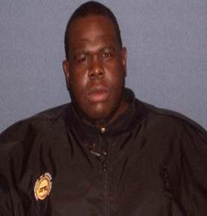 Anthony Harvey

