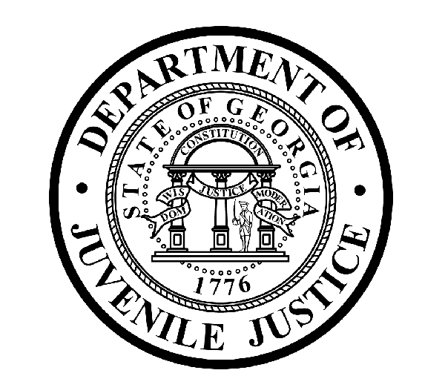

Avery D. Niles, CommissionerDepartment of Juvenile Justice

Jim Shuler, Director3408 Covington Highway ▪ Decatur, Georgia ▪ 30032-1513
Office of CommunicationsTelephone: (404) 508-7147 ▪ Fax: (404) 508-7341
FOR IMMEDIATE RELEASE CONTACT:
Jim Shuler, Director
May 7, 2013 DJJ Communications
(404) 508-7238
JimShuler@djj.state.ga.us

COMMISSIONER FIRES CADETS FROM DJJ TRAINING ACADEMY
NEW RECRUITS DISMISSED ON ALCOHOL MISCONDUCT CHARGES

(Forsyth - GA) Today Commissioner Avery D. Niles of the Georgia Department of Juvenile Justice announced the dismissal of two new cadets from DJJ’s Basic Juvenile Corrections Officer Training (BJCOT) program on alcohol misconduct charges.

Former Cadets Marcy Queen and Omar Sallee, who had been assigned to DJJ’s Metro Regional Youth Detention Center (RYDC) facility in Atlanta, were fired for reporting to Evening Formation at the DJJ Training Academy in Forsyth, Georgia “while under the influence of alcohol.” Cadets Queen and Sallee were employed with the department for less than three months. Commissioner Niles ordered their immediate suspension followed by termination.

“There is simply no room at our Academy or our agency for this level of misconduct,” said DJJ Commissioner. Niles.

“The Academy is where we learn if new recruits are truly cut-out to be Juvenile Corrections Officers,” said Niles. “I have no tolerance for Basic Corrections Officers who violate basic policy before they even finish the state mandate program,” the Commissioner said.

Prior to beginning their Basic Corrections Officer Training each new cadet is required to sign an official form acknowledging they have read the department’s strict rules and regulations prohibiting the consumption or possession of alcohol while enrolled in Academy training. Their signature indicates their awareness that failure to comply with DJJ policy while on the Georgia Public Safety Training Center (GPSTC) campus is a serious offense which can result in disciplinary action including dismissal.

After completing less than three weeks of basic training, these former cadets were charged in violation of the POST Council Rule prohibiting consumption of alcohol while enrolled in a state mandate program and for violation of DJJ Policy 3.15 (Reporting to work under the influence of alcohol).
(MORE MORE MORE)
(PAGE TWO)

“The Academy is where our dedicated training staff instructs new officers how to maintain a safe and secure environment for DJJ staff and youth,” said Commissioner Niles. “Each day’s schedule in our Juvenile Corrections Officer Training is designed to deliver critical components of juvenile justice facility programs and procedures. I refuse to waste even an hour of salary from tax payer resources on any cadet who doesn’t take the job, the training, and the DJJ mission seriously.”

The cost per cadet to cover lodging, meals, manuals and certificates for the Basic Juvenile Corrections Officer Training program is about $745.00 per student. A full Department of Juvenile Justice analysis shows training including cadet and instructor salaries costs around $24,000.00 per cadet.

“We’re investing in quality training and we’re transforming the culture of this agency,” said Commissioner Niles. “And while we’re enforcing safety and security reforms, the place to start is right here at the point of entry in recruiting and training. I’ll continue to fast-track similar dismissals and use other corrective measures wherever I see they’re needed,” said Niles.

Today’s termination announcement was the latest in a recent series of sweeping personnel actions designed to crackdown on staff misconduct and policy violations throughout the agency.
“I’m looking for quality dedicated individuals to wear our uniform and enforce our policies. We want to train professional corrections officers who will help hold the young offenders in our care accountable so they can become productive, law abiding citizens,” the Commissioner said.

Since his appointment by the Governor in November, Commissioner Niles has emphasized agency-wide get-tough warnings for major policy violations. “At the Department of Juvenile Justice, staff members who violate positions of trust and responsibility will continue to face severe consequences, regardless of time on the job, employee rank or position in this agency. I gave clear warning when I was appointed Commissioner that serious violations of policy and criminal behavior will not be tolerated in our professional juvenile justice workplace,” said Niles.

The Commissioner’s’ core message emphasizes that the critical duties of the Department of Juvenile Justice are to uphold and enforce policy, ethics, and safety and security measures at Georgia’s juvenile justice facilities so that both DJJ staff and the youth assigned to our care can function in a safe and secure learning environment.

(END RELEASE)

