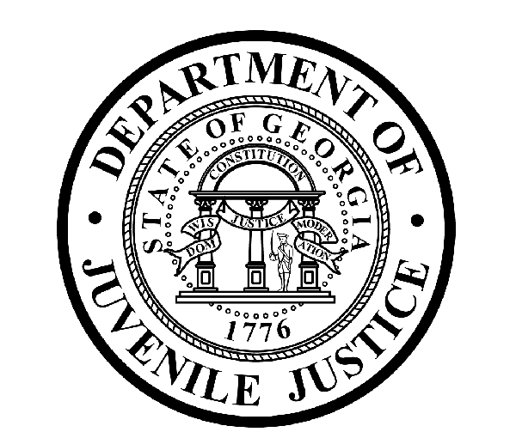

Avery D. Niles, CommissionerDepartment of Juvenile Justice

Jim Shuler, Director3408 Covington Highway ▪ Decatur, Georgia ▪ 30032-1513
Office of CommunicationsTelephone: (404) 508-7147 ▪ Fax: (404) 508-7341
FOR IMMEDIATE RELEASE CONTACT:
Jim Shuler, Director
March 27, 2015 DJJ Communications
(404) 508-7238
JimShuler@djj.state.ga.us

Schedule Change for DJJ Citizens’ Academy in Macon
Georgians Signing-Up for an Inside Look at Juvenile Justice

(Macon - GA) The Department of Juvenile Justice is holding its second Citizens' Academy in Macon, Georgia this April and Commissioner Avery D. Niles wants local concerned citizens and community stakeholders to know there’s a schedule change for the upcoming first session. The DJJ Citizens' Academy is now slated to begin April 23rd, 2015.

The Citizens’ Academy is an intensive five-week workshop providing an in-depth look into the operational and administrative functions of DJJ. Commissioner Niles said the Citizens’ Academy project provides additional transparency in government by allowing local citizens to observe Georgia’s new juvenile reforms at work.

“DJJ has a core belief in transparent government and we support the governor's vision for a safer and better-educated Georgia,” said Commissioner Avery Niles. “Our Citizens' Academy will provide a select panel of members in Macon with a 360-degree scope of enhanced juvenile corrections practices.”

The Academy curriculum was developed to help educate the public about innovative reforms in Georgia juvenile justice. Commissioner Niles said Governor Nathan Deal’s support has brought about meaningful changes that are already at work to help reduce juvenile offender populations and recidivism rates in the juvenile justice system.

“The academy sessions will be scheduled at our Youth Development Campuses, Court Service Offices, and local courts around the City of Macon and Bibb County,” Commissioner Niles said. “Our Citizens’ Academy will provide a unique opportunity to see and experience DJJ's commitment to young offenders and their families, to observe enhanced juvenile reentry programs, and to understand DJJ’s non-negotiable mission to promote safer communities for all Georgians by holding juvenile offenders accountable,” said Commissioner Niles.

( MORE MORE MORE)

( PAGE TWO TWO TWO )

The course will commence with an agency overview and introduction to DJJ executive leadership. The curriculum covers topics ranging from secure confinement and community supervision to earning high school diplomas and GED’s with an introduction to Georgia's 181st School District.

Space will be restricted for the DJJ Citizens' Academy, so invitations will be limited by the Commissioner’s Office to a roster of twenty Macon area citizens to participate in the Academy. An application process will determine consideration for admittance into each session and Criminal History and Background Clearances must be obtained prior to participation.

NEW Sessions Schedule - DJJ Citizens’ Academy:
Session 1 April 23, 2015: Macon Terminal
Session 2 April 30, 2015: Bibb County Juvenile Court
Session 3 May 07, 2015: Macon RYDC
Session 4 May 12, 2015: Macon CSO
Session 5 May 14, 2014: Macon YDC
Session 6 May 21, 2015: Bibb County Juvenile Court (Graduation)

A statewide schedule for future Citizen Academy sessions is under development. Additional Academy schedules will be announced on DJJ’s News & Views website at
http://www.djjnewsandviews.org/ or for additional information, please contact:

Latera Davis, Director
Office of Victim, Volunteer, and Chaplaincy Services
Division of Operations and Compliance
Georgia Department of Juvenile Justice
Office: 404-508-6532
Cell: 404-683-8819
lateradavis@djj.state.ga.us

(END RELEASE)

The Department of Juvenile Justice provides supervision, detention, and a wide range of treatment, educational and reentry services for youth referred by the Juvenile Courts. More than 50,000 youth are served each year by DJJ, including youth placed on probation, sentenced to short-term incarceration, or committed into custody by the Juvenile Courts.

In addition to the DJJ Central Office in Decatur, there are more than 100 DJJ court office and facility locations throughout Georgia.

For more information about special programs at the Department of Juvenile Justice join us on the web at http://www.djjnewsandviews.org/

