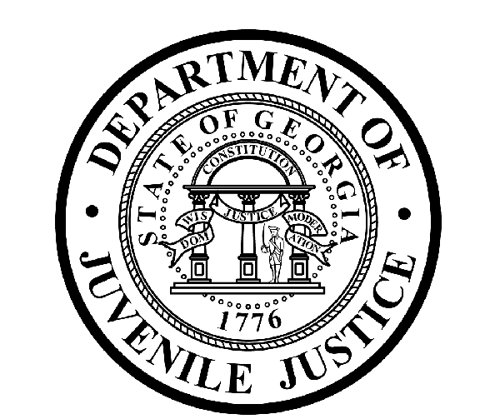

Avery D. Niles, CommissionerDepartment of Juvenile Justice

Jim Shuler, Director3408 Covington Highway ▪ Decatur, Georgia ▪ 30032-1513
Office of CommunicationsTelephone: (404) 508-7147 ▪ Fax: (404) 508-7341
FOR IMMEDIATE RELEASE CONTACT:
Jim Shuler, Director
July 9, 2013 DJJ Communications
(404) 508-7238
JimShuler@djj.state.ga.us

COMMISSIONER NAMES NEW LEGISLATIVE LIAISON &
INVESTIGATIONS DIRECTOR FOR JUVENILE JUSTICE

(ATLANTA - GA) DJJ Commissioner Avery D. Niles is pleased to announce his selection for two top direct reports at the Georgia Department of Juvenile Justice. Commissioner Niles has named John T. Smith as his new Legislative Liaison Director.

Smith recently came from the Office of the Lieutenant Governor of Georgia, serving as official External Affairs and Policy Advisor for the Lt. Governor and working with legislative council to help write new law. He managed all financial operations on the Lt. Governor’s 2006 and 2010 statewide campaigns, while helping to develop key political relationships.

John served as a legislative aide in the Georgia State Senate during the 2007 and 2008 legislative sessions, writing legislative summaries and producing weekly Senate publications for legislators and staff.

John is a graduate of the Georgia State University College of Business where he concentrated on studies in International Trade, Investments and Corporate Finance before graduating with a Bachelor of Business Administration degree in Finance.

“The DJJ Office of Legislative Liaison serves as this department’s primary contact on all legislative issues and works closely with members of the General Assembly,” said Commissioner Niles.

“As we make careful preparations at this agency for Georgia’s new Juvenile Justice Reform Law to go into effect in January, we will need a professional with John’s legislative background to help us stay in close touch on public policy issues with lawmakers, stakeholders and the Governor’s Office,” said Niles. “I have asked John T. Smith to help shepherd DJJ through these long awaited revisions and systemic changes to Georgia’s juvenile justice system.”

(MORE MORE MORE)

(PAGE TWO)

Commissioner Niles also named Director Ricky H. Rich to the top investigative unit spot at DJJ Central Office as the department’s new Director of Investigations.

The Commissioner commended Rich for the extensive law enforcement management experience he brings to DJJ. Director Rich will be responsible for upholding high professional standards for the division under state law, for safeguarding the integrity of internal investigations and for maintaining investigative compliance mandated within the juvenile justice system.

“Director Rich’s law enforcement experience spans more than thirty-five years with state and local agencies in Georgia,” said Commissioner Niles. “He has the leadership and strategies this agency needs for reorganizing the Investigations Division, developing its real strengths, and correcting its deficiencies.” the Commissioner said.

The Commissioner’s choice for Director of Investigations is a former Deputy Director and Law Enforcement Coordinator from the Governor’s highway safety office. At highway safety, Director Rich drew upon his police Narcotics and Intelligence Unit experience, took a working model of a multi-jurisdictional drug task force, and used it as a pattern to build the prototype for Georgia’s first statewide traffic enforcement network.

Now GATEN, the Georgia Traffic Enforcement Network, provides information sharing, training and communications to law enforcement partners in all 159 Georgia counties. Georgia’s highly successful GATEN network concept has evolved into the innovative model that has mobilized many other life-saving state highway safety offices around the country.

“We expect to see Director Rich implement that same kind of enhanced inter-agency cooperation and problem solving on a statewide basis for DJJ to generate greater law enforcement coordination and partnerships with our neighboring law enforcement agencies,” said Commissioner Niles.

Director Rich has a Bachelor of Business Administration Degree from North Georgia College, and a Master’s Degree in Public Administration from Georgia Law Enforcement Command College at Columbus State University. He is a graduate of the Georgia Leadership Institute Executive Leadership Program.

Rich served as Past State President of the Georgia Fraternal Order of Police and is a member of their Executive Board. He belongs to the Georgia Association of Chief’s of Police, the Peace Officers Association of Georgia, the National Sheriff’s Association Traffic Safety Committee, and the International Association of Chief’s of Police Safety Committee. His law enforcement career accomplishments have been documented in the VIPER Intelligence News Letter and in Police Chief Magazine.

Director Rich’s law enforcement duties have ranged from City of Gainesville Deputy Marshal, Gainesville Police Department Traffic Enforcement Coordinator, and Patrol Division Sergeant. As Gainesville Police Vice-Intelligence, Narcotics Supervisor, and CID Investigator, he investigated thefts, assaults, prescription drug violations, arsons and homicides. He also served as Vice-Intelligence & Narcotics Field Supervisor for the Gainesville-Hall County Multi-Agency Narcotics Squad, investigating drug cases and conducting intelligence operations on illegal gang activity, cults, motorcycle gangs, white supremacists and subversive groups.

Commissioner Avery Niles said, “With this hire we hope to begin the process of rebuilding the reputation of DJJ’s investigative division as an efficient, productive and professional unit.”

(END RELEASE)

