

Avery D. Niles, CommissionerDepartment of Juvenile Justice

Jim Shuler, Director3408 Covington Highway ▪ Decatur, Georgia ▪ 30032-1513
Office of CommunicationsTelephone: (404) 508-7147 ▪ Fax: (404) 508-7341
FOR IMMEDIATE RELEASE CONTACT:
Jim Shuler, Director
December 12, 2014 DJJ Communications
(404) 508-7238
JimShuler@djj.state.ga.us

GA JUVENILE JUSTICE & ATLANTA TRACK CLUB PARTNER TO “BEAT THE STREETS”
Kilometer Kids running program launched at DJJ’s Metro RYDC

(ATLANTA - GA) Commissioner Avery D. Niles is pleased to announce the launch of an innovative exercise program designed to introduce running to disadvantaged youth. The Georgia Department of Juvenile Justice and Atlanta Track Club will jointly host a “Beat the Streets” Program kickoff event on Wednesday, December 17th at the Metro Regional Youth Detention Center (Metro RYDC) from 10AM until 12-Noon. The Metro RYDC is located at 1300 Constitution Road in Atlanta, Georgia.

Beat the Streets is a FREE 11-week incentive-based running program modeled after Atlanta Track Club’s successful Kilometer Kids healthy exercise initiative. Atlanta Track Club specifically tailored the running program for DJJ youth housed at the Metro RYDC. Enrolled youth will accept the challenge to try to run 26.2 miles, the length of a marathon, over the course of the program. To keep them motivated, the youth will have a chance to earn incentive prizes along the way.

“Working with Atlanta Track Club to create the Beat the Streets program for our youth is worthwhile community collaboration," said DJJ Commissioner Avery D. Niles. “Exercise programs like this help instill personal discipline and an appreciation for individual achievement and accomplishment. The running skills learned during Beat the Streets can have a long term health benefit and lasting positive influence of life decisions,” Commissioner Niles said.

Atlanta Track Club launched Kilometer Kids in 2007 with a focus on inspiring Atlanta youth to achieve health and fitness through a fun and supportive running program. Kilometer Kids was designed to empower children with the knowledge they need to make smart lifestyles choices. The program has grown significantly from small beginnings in 2007 and now impacts more than 5,000 children each year in the Atlanta region and beyond.

(MORE MORE MORE)

(PAGE TWO TWO TWO)

“We are proud to partner with the Department of Juvenile Justice for the Beat the Streets program,” said Atlanta Track Club Executive Director, Rich Kenah. “At Atlanta Track Club, we see running as a transformational tool which provides individuals the skills and support to develop healthy lifelong habits in all aspects of one’s life. We are committed to a healthy and active Atlanta and to providing the community our support to help reach these goals.”

Terrence Trammell, a Decatur, Georgia native and two-time Olympic silver medalist will also be in attendance at the Wednesday morning kickoff event, inspiring the youth there by speaking to them about where their effort and dedication to healthy habits and fitness can take them in life. He will also conduct a few basic exercises with the participants. Trammell won silver medals in the 110 meter hurdles at both the 2000 and 2004 Summer Olympics, as well as two gold and three silver medals at IAAF World Championship events from 2001 to 2006.

With more than 21,000 members, Atlanta Track Club is the second largest running organization in the United States. In addition to the AJC Peachtree Road Race, the largest 10K running event in the world and the Atlanta Half Marathon and Thanksgiving Day 5K, Atlanta Track Club directs more than 30 events per year. Through the support of its members and volunteers, Atlanta Track Club also maintains a number of community initiatives including honoring high school cross country track & field athletes through Atlanta Track Club’s All-Metro Banquets, and supporting the Grady Bicycle EMT program.

In keeping with the provisions of Georgia’s Juvenile Justice Reform Law, the Department of Juvenile Justice is committed to working with local and state partners to provide DJJ youth with new opportunities to develop the skills and structure needed for successful reentry into our communities.

DJJ would like to thank both Atlanta Track Club and Mizuno USA for their partnership in the development of this program and the commitment to provide footwear and technical running shirts for the youth who are participating in the program.

For more information about programs at the Department of Juvenile Justice, visit them on the web at www.djj.state.ga.us. To learn more about Atlanta Track Club, view their website at www.atlantatrackclub.org.

DJJ Deputy Commissioner Sarah Draper will be available for on and off camera interviews regarding the Beat the Streets program. Ms. Draper may be contacted at 404-273-7416 or via email at sarahdraper@djj.state.ga.us.

(END RELEASE)

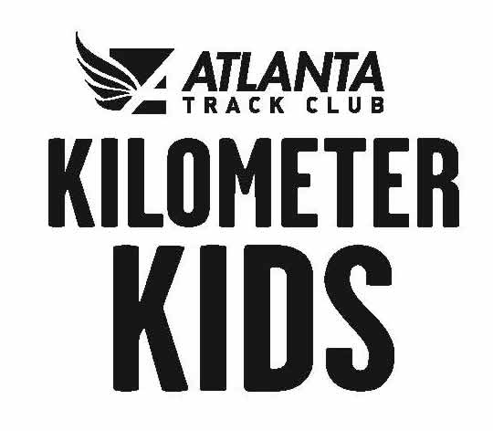

PHOTO CREDIT: Courtesy Atlanta Track Club Kilometer Kids Logo

