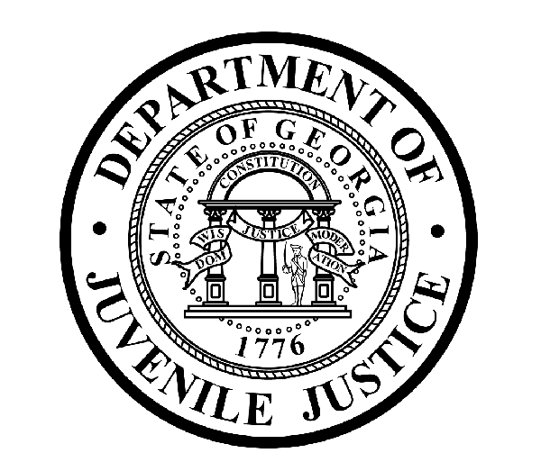

Avery D. Niles, CommissionerDepartment of Juvenile Justice

Jim Shuler, Director3408 Covington Highway ▪ Decatur, Georgia ▪ 30032-1513
Office of CommunicationsTelephone: (404) 508-7147 ▪ Fax: (404) 508-7341
FOR IMMEDIATE RELEASE CONTACT:
Jim Shuler, Director
August 1, 2013 DJJ Communications
(404) 508-7238
JimShuler@djj.state.ga.us

GOVERNOR DEAL SWEARS IN NEW DJJ BOARD MEMBER

(ATLANTA - GA) Governor Nathan Deal swore in the newest member of the Board of Juvenile Justice today. Governor Deal administered the oath of office to District 6 Member Kelly Stewart. DJJ Commissioner Avery D. Niles was at the Governor’s Office to welcome the newly appointed Board Member.

Board Member Stewart currently serves as the Vice President of Human Resources for the Lucas Group Executive Search Firm headquartered in Atlanta. She is also a Johns Creek City Council Woman, elected to the Post 5 seat in November 2010.

Kelly Stewart has also served at the local, state and federal levels of government: She worked as a county administrator; at the University System of Georgia; and on Capitol Hill at the U.S. House of Representatives.

Stewart's community service activities include United Way and the Salvation Army and she is the recipient of a governor's citation for her volunteer work with Junior Achievement. Board Member Stewart has also served as the inaugural president of the Buckhead Republican Women. She and her husband, Tom, are members of the Chairman's Council of the Fulton County Republican Party.

Board Member Stewart received her Master's Degree in City Planning from the Georgia Institute of Technology with specializations in Economic and Land Development. She holds a Bachelor's Degree in Public Administration from Brenau University, and earned an Associate Degree in Psychology from Gainesville College. She is a Sunday school assistant at First Baptist Church Atlanta and sings in the choir.

(MORE MORE MORE)

(PAGE TWO)

As DJJ’s newest Board Member, Stewart was appointed by Governor Nathan Deal to represent Congressional District 6. DJJ Board members are appointed by the Governor to serve in an advisory capacity to the Department of Juvenile Justice, providing leadership and guidance to the Commissioner. The Board is made up of 15 members representing each Congressional District in the state to help improve Georgia’s juvenile justice system.

Stewart said, “These are exciting times to be called to serve as a member of this Board. There are challenging days ahead as the new Juvenile Justice Reform law brings positive change to the Department of Juvenile Justice. This Board is about to witness historic new measures affecting Georgia’s juvenile offenders. It’s an honor to be offered this opportunity with fellow Board members to provide support to Commissioner Niles and the Department.”

Commissioner Avery D. Niles expressed the appreciation of the agency and the Board for the Governor’s latest appointment to DJJ. “We are grateful for the volunteer background and professional experience this new Board Member will bring to our mission and we admire her fresh perspective,” Commissioner Niles said. “We welcome Kelly Stewart to the DJJ Board as our Team carries on this important task of Georgia’s juvenile justice reforms. I can think of nothing more important to the future of our state and communities than our mutual goal to help Georgia’s juvenile offenders become productive citizens.”

(END RELEASE)

