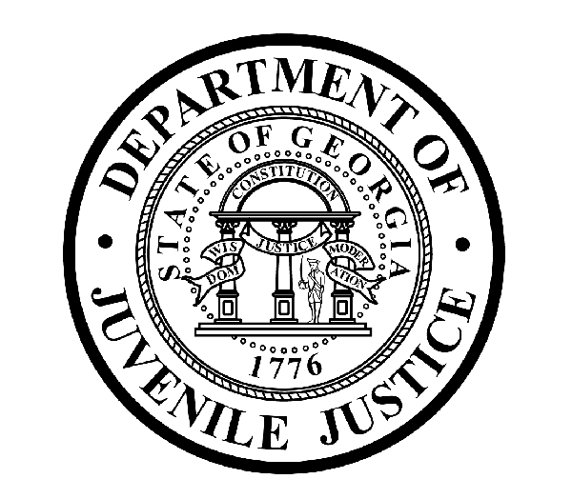

Avery D. Niles, CommissionerDepartment of Juvenile Justice

Jim Shuler, Director3408 Covington Highway ▪ Decatur, Georgia ▪ 30032-1513
Office of CommunicationsTelephone: (404) 508-7147 ▪ Fax: (404) 508-7341
FOR IMMEDIATE RELEASE CONTACT:
Jim Shuler, Director
May 2, 2013 DJJ Communications
(404) 508-7238
JimShuler@djj.state.ga.us

DJJ Commissioner Congratulates Governor
On Signing of Juvenile Justice Reforms Bill
(DALTON - GA) Today, Department of Juvenile Justice Commissioner Avery D. Niles congratulated Governor Nathan Deal on the passage and signing of Georgia’s massive juvenile justice reform legislation in the Senate. Based on the recommendations of a special panel convened by Governor Deal, the goal of the legislation is to reduce the number of repeat juvenile offenders and bring down costs.

“The passage of Georgia’s juvenile justice reform bill speaks volumes about Governor Nathan Deal’s leadership,” said DJJ Commissioner Niles. “Working together with his special reform council and our Legislators, Governor Deal has helped shepherd this innovative overhaul legislation for Georgia’s juvenile system,” said Commissioner Niles.

The reforms will provide judges with more discretion in juvenile case sentencing; offer more drug and mental health counseling; and place more emphasis on local community-based outreach programs rather than commitment to detention centers for non-violent juvenile offenders.

The Reform Bill is a “win-win-win” equation for juvenile justice in Georgia,” said Commissioner Niles. “It’s a win to get help for youth who are neglected or abused -- It’s a win for troubled teens who need community outreach, not detention -- And it’s a win for Georgia taxpayers who are entitled to protection from felony youth offenders, but who shouldn’t have to shoulder high security system costs for low-risk juvenile offenses.”

Supporters say the reasons behind the legislation’s active support across party lines were two-fold: Georgia currently spends more than $90-thousand dollars a year for each juvenile offender held in detention and 65-percent of those offenders end up back in detention within three years after their release.

(MORE MORE MORE)

(PAGE TWO)

Georgia’s current juvenile code has been in effect here since the ‘70’s. Advocates claim the sweeping changes enacted today by the General Assembly are projected to create a potential $28 million dollars in savings for the State of Georgia during the next two years alone.

Recent polls conducted for the Pew Charitable Trusts show Georgia voters want a juvenile justice system which keeps communities safe and holds youth accountable, while helping them become productive citizens. Governor Nathan Deal asked his special reform council to study the state’s juvenile justice system and formulate ways to improve public safety while decreasing costs.

“Here in Georgia, we’ve actually been watching this process of judicial history being made first in our General Assembly and now with the Governor signing this legislation into law,” said DJJ Commissioner Niles. “I am so fortunate to see this promising reform happening during my first year in office at the Georgia Department of Juvenile Justice.”

The provisions of Georgia’s juvenile justice reform act are effective as of next January to allow effected state agencies and entities to prepare for the dramatic new changes, strategies and added responsibilities.

“What an honor it is to be Commissioner of the Department of Juvenile Justice during this pivotal time,” said Commissioner Niles. “I thank the more than 4,000 professional staff members working at DJJ centers and offices across the state as we face this new challenge of Georgia juvenile justice reform together: ‘One Team’ -- ‘One Mission’.

(END RELEASE)

