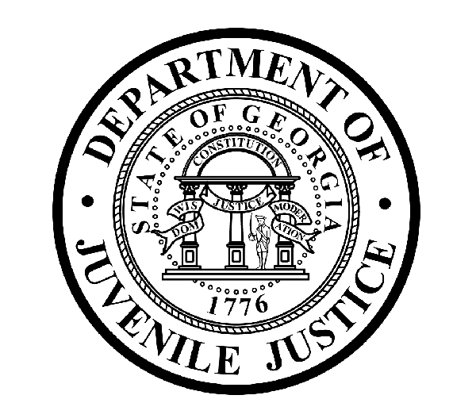

Avery D. Niles, CommissionerDepartment of Juvenile Justice

Jim Shuler, Director3408 Covington Highway ▪ Decatur, Georgia ▪ 30032-1513
Office of CommunicationsTelephone: (404) 508-7147 ▪ Fax: (404) 508-7341
FOR IMMEDIATE RELEASE CONTACT:
Jim Shuler, Director
April 26, 2013 DJJ Communications
(404) 508-7238
JimShuler@djj.state.ga.us

DJJ COMMISSIONER ANNOUNCES NEW BOARD MEMBER APPOINTMENT

(ATLANTA - GA) The Commissioner of the Georgia Department of Juvenile Justice is pleased to announce the appointment of a newly named DJJ Board member by Governor Nathan Deal. Commissioner Avery D. Niles announced the appointment of Julia D. Neighbors to the Board of Juvenile Justice.

Board Member Neighbors currently serves as the project manager for JUSTGeorgia, a statewide juvenile justice coalition involved in the recent re-write of Georgia’s Juvenile Code and the promotion of healthier, safer communities and better outcomes for our children and youth.

As a former senior attorney with the Fulton County Office of the Child Attorney, Julia Neighbors brings additional child advocate experience to the DJJ Board. She also previously held the position of Executive Director of Fulton County Court Appointed Special Advocates, Inc.

Board Member Neighbors currently serves on the board of directors for Georgia CASA, the Council of Intown Neighborhood Schools and the Historic District Development Corp. She holds a Law Degree from Emory University and a Bachelor’s Degree in English from the University of Michigan. Neighbors and her husband, Ken, live in Atlanta with their two sons, Kenneth and Kaden.

As DJJ’s newest Board Member, Neighbors was appointed by Governor Deal to represent Congressional District 5. DJJ Board members are appointed by the Governor to serve in an advisory capacity to the Department of Juvenile Justice, providing leadership and guidance to the Commissioner. The Board is made up of 15 members representing each Congressional District in the state to help improve Georgia’s juvenile justice system.

(MORE MORE MORE)

(PAGE TWO)

Neighbors said, “Being at the table during this exciting time for Georgia juvenile justice is an honor and I am ready to serve. I hope to help the Board and Commissioner in their efforts to implement the positive new measures that will come about as a result of the Juvenile Justice Reform bill.”

Commissioner Avery D. Niles expressed the appreciation of the agency and the Board for the Governor’s latest appointment to DJJ. “We admire the viewpoint and experience this new Board Member will bring to our task,” said Commissioner Niles. “Julia Neighbors will bring fresh perspective to the Board and we wish her all the best as she faces the many challenges that will come with Georgia’s juvenile justice reforms. I can think of nothing more important to our communities and the future of our state than our common effort to help Georgia’s juvenile offenders become productive citizens.”
(END RELEASE)

