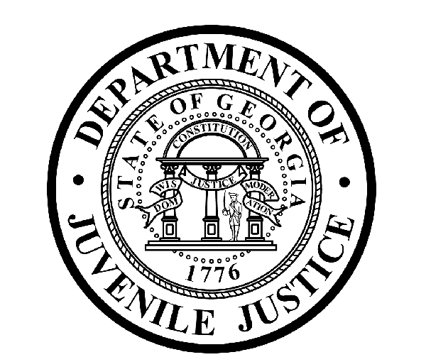

Avery D. Niles, CommissionerDepartment of Juvenile Justice

Jim Shuler, Director3408 Covington Highway ▪ Decatur, Georgia ▪ 30032-1513
Office of CommunicationsTelephone: (404) 508-7147 ▪ Fax: (404) 508-7341
FOR IMMEDIATE RELEASE CONTACT:
Jim Shuler, Director
April 2, 2014 DJJ Communications
(404) 508-7238
JimShuler@djj.state.ga.us

DJJ APRIL CAREER FAIRS SCHEDULED
Department of Juvenile Justice Scouting for New Recruits
Dalton, Statesboro, Warner Robins, Griffin, Albany, Clarkston, Swainsboro

(STATEWIDE - GA) DJJ Commissioner Avery D. Niles is pleased to announce the Department of Juvenile Justice is planning another round of job fairs around the state this month. The department hopes to attract veterans and other highly qualified applicants seeking rewarding careers in the professionally challenging field of juvenile corrections.

The job fairs are free and open to the general public. DJJ recruiters will be hosting the April Career Fairs in search of competent candidates for a wide range of career positions including administration, transportation, communications, probation, I-T, engineering, counseling, maintenance, and correctional officers.

"We’re basically taking our Human Resources division on the road so we can offer these job opportunities directly to a talented, capable civilian workforce that’s looking for fulltime employment right here in Georgia," said Commissioner Niles. DJJ has eight job fairs planned around the state before the end of April. The April 7th job fair at Dalton State College is the first stop on the DJJ recruitment schedule this month, followed by stops in Statesboro and Warner Robins, Georgia.

April 7, 2014
Dalton State College main campus
650 College Dr.
Dalton, GA 30720
706-272-4429
2:00-5:00pm

April 8, 2014
Career Fair
Ogeechee Technical College
One Joe Kennedy Blvd.,
Statesboro, GA 30458
9:00am – 12:30pm
(PAGE TWO)
April 10, 2014
Middle Georgia State College
100 University Blvd.
Warner Robins, GA
10:00am – 2:00pm

“The State of Georgia is also an excellent career destination for our returning veterans,” said Commissioner Niles. “Special skill sets learned in the armed forces can seamlessly carry over into these new correctional careers. Veterans bring discipline, maturity, experience and leadership skills to the work place,” said DJJ Commissioner Niles.” DJJ will be back in Warner Robins April 18th.

April 18, 2014
Spring Career and Academic Fair
G-Building
80 Cohn Walker Drive
Warner Robins, GA

“Governor Deal has pledged one of Georgia’s top priorities is to ensure Georgia veterans find meaningful employment as they return home,” says Commissioner Niles. “The Department of Juvenile Justice supports Governor Nathan Deal’s ‘Hire a Georgia Veteran Campaign’ and we have signed the Governor’s pledge to provide enhanced hiring opportunities for veterans.” DJJ will be recruiting in Griffin, Georgia on April 22nd.

April 22, 2014
Crescent Tech College
501 Varsity Road
Griffin, Georgia 30223
2:00 – 4:00pm

April 23, 2014
Annual Spring Career Fair
Albany Technical College
1704 S. Slappey Blvd.
Albany, GA 31701
9:00am – 12:00pm

April 23, 2014
Southeastern Technical College, Swainsboro Campus
Swainsboro, GA
9:00am – 12:00pm

DJJ offers a one-time Military Salary Increase Incentive on eligible job titles to current and former military service members, who have served on active duty. To be eligible, service members must have an Honorable Discharge. The one-time incentive is based upon the current number of active duty years served.

The Department of Juvenile Justice has career opportunities available for Administrative positions, Corrections and Transportation Officers, Security Emergency Response Teams, Probation and Parole Specialists, Registered Nurses and Physicians, Professional Social Workers, Special Education Teachers and more. Click on http://www.djjnewsandviews.org/djjcareers/ for more information about careers at DJJ, then click on the section about DJJ Careers for Veterans.
(END RELEASE)

