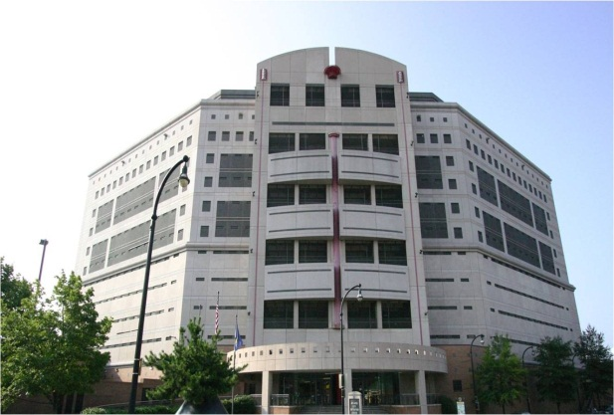
- The Atlanta City Detention Center (ACDC) incorporates the progressive “direct supervision” model of design and management and, at 17 stories tall and 471,000 sq. ft. in size, was recognized by the American Concrete Institute as the best new high-rise building in Georgia in 1994.
- In Fiscal Year 2011, the ACDC provided care and custody for more than 35,000 offenders who were arrested by local, state and federal law enforcement agencies.
- In Fiscal Year 2011, the ACDC managed 2,841 offenders sentenced by city court.
- In Fiscal Year 2011, the ACDC boarded more than 3,500 federal prisoners which generated revenue to offset expenditures. In Fiscal Year 2011, the ACDC collected more than $4.5 million in “other agency” prisoner boarding fees.
- In Fiscal Year 2011, the ACDC averaged 505 offenders in custody per day.
- The ACDC has 297 employees, including 237 sworn corrections officers.
- The ACDC provides facility tours and presentations to civic, educational and corporate groups.
- The ACDC provides inmate work crews to clean up public spaces and remove graffiti from community structures in partnership with Community Court, Atlanta Police Department, Department of Public Works, and Department of Parks and Recreation.

Junior Corrections Officer Program
254 Peachtree Street, NE
Atlanta, Georgia 30303
Phone: 404-865-8010

[Future Solutions Now]
Junior Corrections Officer Program
Kasim Reed
Honorable Mayor of Atlanta
The Atlanta City Council
Ceasar Mitchell, President
Carla Smith, Council District 1
Kwanza Hall, Council District 2
Ivory Lee Young, Jr., Council District 3
Cleta Winslow, Council District 4
Natalyn Archibong, Council District 5
Alex Wan, Council District 6
Howard Shook, Council District 7
Yolanda Adrean, Council District 8
Felicia Moore, Council District 9
C.T. Martin, Council District 10
Keisha Bottoms, Council District 11
Joyce Sheppard, Council District 12
Michael Bond, Post 1
Aaron Watson, Post 2
Lamar Willis, Post 3

City of Atlanta
Department of Corrections
254 Peachtree Street, S. W.
Atlanta, Georgia 30303
Chief, Patrick Labat
Assistant Chief, Diane Jones
Deputy Chief John Jackson,
Program Coordinator
Atlanta City Detention Center
Junior Corrections Officer Program

Program Overview
The Atlanta City Detention Center Junior Corrections Officer Program allows students to learn the Criminal Justice System by exploring the three branches of public safety including Police, Courts and Corrections. Participants will receive training in discipline, law, first aid as well as a multitude of life experiences to include leadership, service, social responsibility, general health and fitness.
The Junior Corrections Officer Program is a six week course beginning March 9, 2013. The program will be held on Saturdays from 9:00 AM until 12:00 PM. Participants are encouraged to eat breakfast prior to arrival. Lunch will be served. Enrollment is limited to 30 students.
Participants will remain in the program until completion; however, participants may resign willfully or be removed from the program for failure to maintain the prerequisites outlined in the enrollment brochure.
Interested candidates should contact Deputy Chief John Jackson for further information at (404) 865-8034 or his assistant, Mrs. Cross at rcross@atlantaga.gov.

Qualifications
- Candidates must maintain a “C” or above grade point average (GPA).
- Candidates must be in good standing in their school, church and/or community.
- Candidates must be 13 to 18 years of age and attend an Atlanta Public School Middle or High School.
- Candidates must be drug and alcohol-free at all times throughout the program.
- Candidates must adhere to all ACDC department rules and regulations.
- Candidates must provide a letter of recommendation from school counselor, teacher, civic group or church leader.
- Parents must sign permission slip and attend a 3 hour course prior to child’s admission into the program.

Student Comments
“The element of real life that was thrown at me at the jail has thoroughly encouraged me to keep myself out of trouble and out of jail.”

“It was a real eye opening experience because we were able to see firsthand what crime can lead to, but that situation is also created by lack of executing on good opportunities.”

Application
Full Name
Age (as of 3/24/12)
School
Grade (2011-12)
GPA:
Emergency Contact NAME:
Emergency Contact PHONE NUMBER:
Briefly Describe your interest in this program:
Parent Name:
Parent Signature:
Date:
Participant Signature:
Date:

