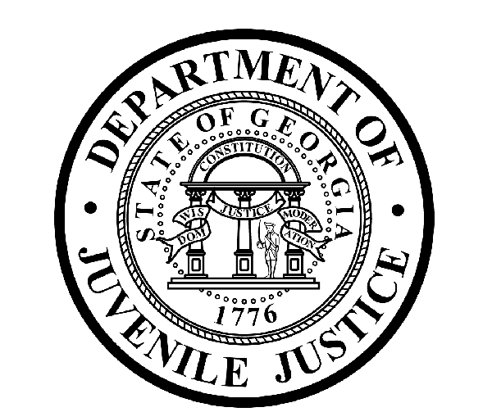

Avery D. Niles, CommissionerDepartment of Juvenile Justice

Jim Shuler, Director3408 Covington Highway ▪ Decatur, Georgia ▪ 30032-1513
Office of CommunicationsTelephone: (404) 508-7147 ▪ Fax: (404) 508-7341
FOR IMMEDIATE RELEASE CONTACT:
Jim Shuler, Director
August 27, 2013 DJJ Communications
(404) 508-7238
JimShuler@djj.state.ga.us

COMMISSIONER PICKS NEW H-R EXECUTIVE TEAM FOR JUVENILE JUSTICE

(ATLANTA - GA) DJJ Commissioner Avery D. Niles is pleased to announce the selections for his new H-R Executive Team for the Georgia Department of Juvenile Justice. Commissioner Niles has named Nadine Crocker as Director of Human Resources and Courtney Ware as the new H-R Deputy Director.

Nadine Crocker Named Human Resources Director
Director Nadine Crocker has twenty-plus years of Human Resources experience working in job classification and compensation, recruitment and selection, employee relations, talent management and employment law. She has held previous positions as an H-R Manager, a Compliance Analyst, Personnel Technician, and as Personnel Analyst 1/2/3.

Director Crocker has served in the Georgia Department of Human Resources (DHR), Georgia Bureau of Investigation (GBI), Department of Motor Vehicles Services (DMVS), Department of Juvenile Justice (DJJ) and the Department of Labor (DOL). She began her career as a Clerk Typist in the Fulton County Department of Family and Children Services (DFCS).

Crocker has a Bachelor’s Degree in Business Administration and Human Resources Management from Saint Leo University in Florida. She is a member of the Society for Human Resource Management (SHRM) and the Council for State Personnel Administration, and she holds certification as a Professional in Human Resources (PHR).

The new H-R Director is a 24-year U.S. Army Retired Master Sergeant (E-8). She is a member of Beulah Missionary Baptist Church and resides in Ellenwood, Georgia with her husband Randy.

Courtney Ware is New H-R Deputy Director
Deputy Director Courtney Ware comes to the Department of Juvenile Justice from the Georgia Department of Corrections where she has ten years of Human Resources experience.
(MORE MORE MORE)
(PAGE TWO)
Ware has worked in budget and financials, contracts and purchasing, and compliance audits and personnel transactions. Deputy Director Ware has held previous positions as Administrative Operations Coordinator, Personnel Analyst 1/2/3, HR Program Coordinator, and Personnel Analysis Section Manager.

Deputy Director Ware served as DOC’s agency point of contact for training, assistance and compliance for FLSA, FMLA, ADA and EEOC program awareness and accountability. Ware lives in Atlanta, has a BBA in Marketing from James Madison University and an MBA in Management from Atlanta’s Mercer University.

Commissioner Avery Niles said, “There are good things ahead for this department. We’re making preparations every day at DJJ to prepare for Georgia’s new Juvenile Justice Reform Law when it goes into effect in just a few months. We’re building an entire executive team of professionals like Director Crocker and Deputy Director Ware who are capable of helping us move this agency forward with the momentum of the new law,” said Niles.

DJJ has an authorized staff of 4,500 dedicated employees managing programs, services and facilities throughout Georgia. The Department of Juvenile Justice provides supervision, detention, and a wide range of treatment and educational services for youths referred by the Juvenile Courts. More than 50,000 youths are served each year by DJJ, including youths placed on probation, sentenced to short-term incarceration, or committed into custody by the Juvenile Courts.

“We will need strong leadership at work in DJJ Human Resources to make our department recruitment strategies and innovative retention planning succeed. We must develop the real strengths of this agency’s staff and successfully manage our personnel deficiencies to meet the challenge of juvenile justice reform,” said Commissioner Niles.

The Department of Juvenile Justice in Georgia has careers serving youth in meaningful and effective programs to help aid in their growth and development. DJJ offers careers in Education, Administration, Behavioral Health and Health Care, Human Resource Management and Development, Law Enforcement, Food Service, Housekeeping, and Plant Management and Maintenance. In addition to the DJJ Central Office in Decatur, there are more than 100 DJJ office and facility locations throughout Georgia.

For more information about career descriptions at the Department of Juvenile Justice join us on the web at http://www.djj.state.ga.us/Careers/DJJEmploy.aspx . For current listings of job openings at DJJ go to http://www.djjnewsandviews.org/djjcareers/brochures.html .

(END RELEASE)

