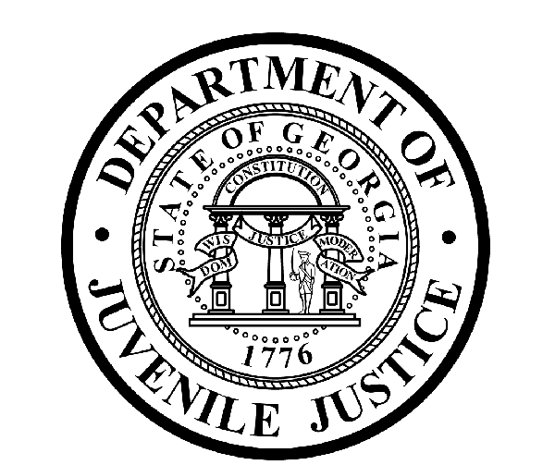

Avery D. Niles, CommissionerDepartment of Juvenile Justice

Jim Shuler, Director3408 Covington Highway ▪ Decatur, Georgia ▪ 30032-1513
Office of CommunicationsTelephone: (404) 508-7147 ▪ Fax: (404) 508-7341
FOR IMMEDIATE RELEASE CONTACT:
Jim Shuler, Director
June 30, 2014 DJJ Communications
(404) 508-7238
JimShuler@djj.state.ga.us

DJJ Completes Closure of Gwinnett RYDC Operations
Youth Relocation.. “a Smooth Transition”

(GWINNETT COUNTY – GA) Commissioner Avery D. Niles announced today that the Georgia Department of Juvenile Justice has completed the shut-down of its daily operations at DJJ’s Regional Youth Detention Center (RYDC) in Gwinnett County, GA and has all but concluded its Final Facility Closure Plan there.

“After making our official closing announcement in early December, our transition staff began slowly reducing our juvenile population at the Gwinnett RYDC,” said Commissioner Avery Niles. “As of mid-June, DJJ was no longer accepting new juvenile offenders in Gwinnett.”

Commissioner Niles said the last youth offender in DJJ custody has now been transferred from the Gwinnett secure facility and DJJ staff will start preparing the remaining state property for shipping, sorting boxes for reuse at other DJJ facilities, and launching a final room- to- room maintenance check. The DJJ facility will be removed from active agency status.

“We are truly grateful to the courts and prosecutors and our many law enforcement partners throughout Gwinnett County jurisdictions for helping us achieve such an orderly relocation of our youth from the Gwinnett Regional Youth Detention Center,” the Commissioner said. “Working with our DJJ Gwinnett staff, they have made this an extremely smooth and well-ordered transition.”

Commissioner Niles announced the closing of the Gwinnett facility more than six months before its decommissioning to help provide local law enforcement, judiciary and other stakeholders with an early start for development on local contingency plans for revised staffing and transportation schedules. DJJ held monthly coordination meetings with Gwinnett County law enforcement officials and local stakeholders to plan for the relocation of youth offenders and the transition of juvenile services.

Now, youth offenders from the juvenile justice service areas in Rockdale County and southern Gwinnett County will be assigned to DJJ’s newly-renovated Regional Youth Detention Center in Rockdale, GA. Youth offenders from the DJJ service area in Hall County and northern Gwinnett County will be designated for the Youth Detention Center in neighboring Gainesville, GA.
(MORE MORE MORE)
(PAGE TWO)

The DJJ youth who were diverted from Gwinnett to other juvenile facilities in Rockdale and Gainesville continue to receive the same levels of quality health care and access to the same high standard educational opportunities as before.

“The closing of this RYDC will result in long-term savings to our citizens without displacing any of the youth currently in our system,” Commissioner Niles said. The Department of Juvenile Justice made the decision to close the Gwinnett youth detention center based on expectations of ever-increasing maintenance costs for the aging facility.

“This facility has undergone the substantial wear and tear of a thirty-year-old public building in unceasing round-the-clock use,” said Commissioner Niles. “After encountering costly plumbing and roofing system deficiencies, we could foresee more infrastructure breakdowns ahead in any future timeline,” the Commissioner said. “It was time for us to move on with a contingency plan.”

The department’s Human Resources division has helped Gwinnett RYDC staff find re-employment at other nearby DJJ facilities as operations at Gwinnett were being phased-out. “DJJ is committed to the placement of this Gwinnett County staff because this staff is committed to the DJJ mission,” Commissioner Niles said. “We need experienced professionals like this Gwinnett DJJ Team.”

“I appreciate all the personal commitments during this transition that helped us reinforce a local juvenile justice service system where together, we set the standards to achieve the profession’s best practices,” said Niles. “We will continue to work together on this DJJ Team to serve these communities and the needs of the youth entrusted to our custody and care.”

For more information about the Georgia Department of Juvenile Justice and the closing of the Gwinnett Regional Youth Detention Center (RYDC) visit the FAQ webpage at:
www.djjnewsandviews.org/gwinnettrydcclosure .
(END RELEASE)

