FREE Gang Training
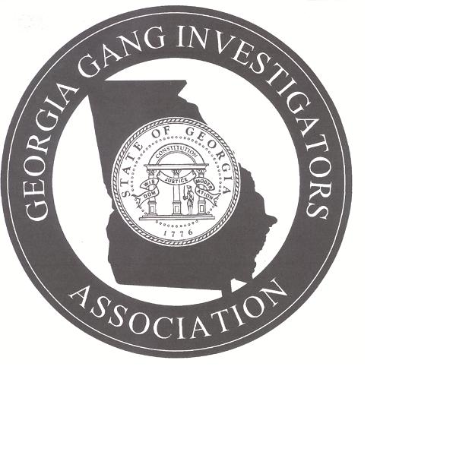

Sponsored by
Georgia Gang Investigators Association, Department of Juvenile Justice - Office of Training
and
Prosecuting Attorney’s Council of Georgia
Basic Street Gangs and Youth
Date: July 9, 2012
Time: 8:00 a.m. - 5:00 p.m.
Location: Georgia Public Safety Training Center Auditorium

Gang Instructors: DA Investigator Jose Diaz – Gwinnett DA’s Office , Instructor Wally Marchant - GPSTC, Investigator Joe Amerling – Gainesville PD and Investigator Marco Silva – Gwinnett Co PD

8 hours GA P.O.S.T. Credit

The Georgia Gang Investigators Association
Registration Form
Please Print

Student Name: ____________________________________
Agency: __________________________________________
Agency Address: ___________________________________
_________________________________________________
Student Cell Phone: ________________________________
Student E-Mail Address: _____________________________
_________________________________________________
Note: For Georgia P.O.S.T. Credit students must provide their OKEY number at the time of registration.
DJJ staff will register through TRIS; schedule ID: 1969.
To register for this FREE Street Gang training please fax your registration form to Lisa Casey Bryson at 404-508-7298 or by e-mail to Lisa Casey Bryson at lisacaseybryson@djj.state.ga.us
For further information please call Lisa Casey Bryson at 678-350-4939
Register Now!

