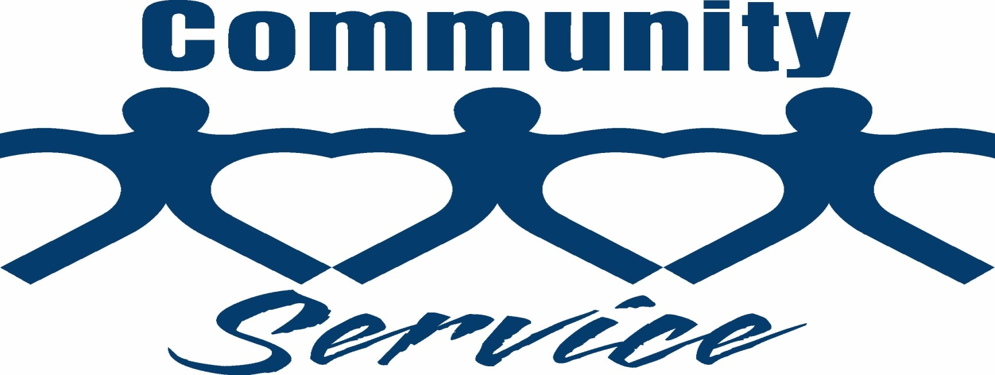

- Why Community Service
is Important.
- The Proper Etiquette when Participating in Community Service.
- How being a Community
Service Volunteer can Help Them.
- Local Agencies that Utilize Youth as Community Service Volunteers.

Free
Community Services Workshop for Youth ages 13 & over
Thursday, June 28th, 2012
1:00 pm until 3:00 pm
Hosted by the
Department of Juvenile Justice
Effingham Court Services Office

Workshop Location:
Effingham County Extension Office
284 Hwy 119 S, Springfield
**Located on Hwy 119 across the road from the
Effingham County Animal Shelter on the hill.

To RSVP or for Additional Information
Contact:

Mrs. Bragg at 912-754-6223
Youth will learn in an
Interactive and Fun
Environment:
DJJ youths participating in this workshop will receive 2 hours of community service credit. Youth will have the opportunity to earn up to 5 additional credit hours by bringing in any of the following items to the workshop: 5 non-perishable food items (1 hr credit), 1 package of diapers (5 hrs credit), 2 packs of baby wipes (1 hr credit), 1 New Mesh or Clear bookbag (5 hrs credit) .
Come Join the Fun!
Door Prizes, Refreshments and Games

Seating is limited.
Please call to reserve your spot by Friday, June 22, 2012

