

Avery D. Niles, CommissionerDepartment of Juvenile Justice

Jim Shuler, Director3408 Covington Highway ▪ Decatur, Georgia ▪ 30032-1513
Office of CommunicationsTelephone: (404) 508-7147 ▪ Fax: (404) 508-7341
FOR IMMEDIATE RELEASE CONTACT:
Jim Shuler, Director
June 3, 2014 DJJ Communications
(404) 508-7238
JimShuler@djj.state.ga.us

DJJ LAUNCHES SENIOR SERVICE LEARNING PROJECT in GAINESVILLE
Juvenile Offenders Taught to “SHOW THEM WE CARE”

(GAINESVILLE - GA) What do juvenile offenders have in common with Georgia’s elderly? Because of a new Senior Service Learning Project just starting at the Department of Juvenile Justice, committed youth here are learning they may frequently share feelings of loneliness and abandonment, similar to those of Georgia’s elderly, who often feel confined or forgotten in senior centers and assisted living facilities.

A participating nursing home in Gainesville, Georgia will be the first to benefit from this partnership where confined DJJ youth will make greeting cards as their community project to brighten the lives of the elderly who have no visitors or families to embrace their needs in their senior years.

“This is the Commissioner’s new Learning Project to increase awareness among DJJ’s young offenders toward seniors,” said Deputy Commissioner Sarah Draper at DJJ’s Division of Operations and Compliance. “We call our learning project, ‘Show Them We Care’. Our Office of Victim Services is working with our Division of Education and Reentry Services to make this project a success.”

The goal of ‘Show Them We Care’ is to help DJJ’s young offenders develop an understanding and empathy for Georgia’s aging population receiving medical attention and living assistance in hospitals and nursing homes.

The first task for participants at Georgia’s 20 Regional Youth Detention Centers was a hands-on assignment to create a poem and a greeting card design for local senior center residents. DJJ youth were instructed to fashion their cards with special focus on topics about how communities care for seniors, how to encourage empathy for senior’s loneliness and lack of family support.

DJJ youth from across the state used their creative talents to construct a variety of cheerful, colorful, and thoughtful cards based on the ‘Show Them We Care’ theme. Juvenile Justice Commissioner Avery D. Niles envisioned this simple awareness program not only to benefit local senior citizens, but to educate youth about the realities of elder abuse before they reenter their communities after serving their commitments.
(MORE MORE MORE)
(PAGE TWO TWO TWO)

“Too often communities forget about our aging seniors,” said Commissioner Niles. “Too often they’re left alone in homes and centers without sufficient support systems.”

“We want to educate our youth about elderly care and abuse,” said Commissioner Niles. “We want them to start with this simple way to become involved and show aging adults that someone cares. We hope that eventually hands-on projects like this will encourage our youth to think about other serious needs in their communities on their own.”

DJJ turned the Senior Service Project into a contest to search for the best-made cards. Participating youth created more than one hundred hand-made greeting cards for the competition. The winning card that came from the Bob Richards RYDC in Rome, Georgia will be recognized by the Commissioner at the next DJJ Board meeting. The winner was a hand-drawn rose on a background of clouds with a penciled verse that reads, “If there are times when you feel scared, just remember someone cares.”

Commissioner Niles personally delivered a basket containing more than a hundred special cards for the Bell Minor Nursing Home in Gainesville where he told nursing staff this was just the beginning of the special project. Niles said the Department of Juvenile Justice is committed to encouraging DJJ youth to design the special cards for nursing home residents.

The Commissioner also announced DJJ’s “We Care” Campaign is formally adopting Bell Minor Nursing Home through service learning and outreach projects. The Bell Minor Staff expressed their appreciation to Commissioner Niles and told him, “No one can know how something as small as a greeting card can make such a big difference to brighten someone’s day.”

For more information about special projects from the DJJ Office of Victim Services, visit us on the web at
http://www.djjnewsandviews.org/victimservices .

(END RELEASE)

PHOTOS BELOW ARE FROM THE DJJ “Show Them We Care” SERVICE LEARNING PROJECT. PHOTO ONE SHOWS HUNDREDS OF HAND-MADE GREETING CARDS DELIVERED TO NURSING HOME RESIDENTS. PHOTO TWO DEPICTS DJJ COMMISSIONER AVERY D. NILES DELIVERING A BASKET OF GREETING CARDS FROM THE “SHOW THEM WE CARE” SERVICE PROJECT. PHOTOS MAY BE USED BY NEWS PUBLICATIONS WHEN ACCOMPANIED BY PHOTO CREDIT, “Courtesy Georgia DJJ”.

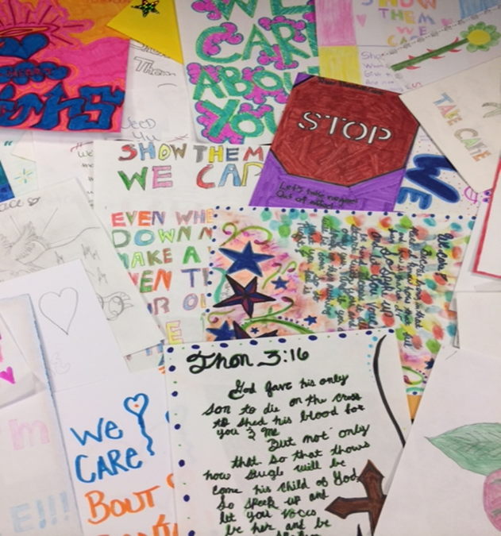

PHOTO CREDIT: Courtesy Georgia DJJ “Show Them We Care” Greeting Cards

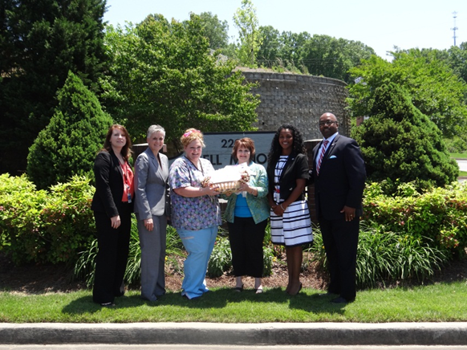

PHOTO CREDIT: DJJ Commsr Avery D. Niles Delivers Greeting Cards
Courtesy Georgia DJJ to Gainesville Nursing Home

