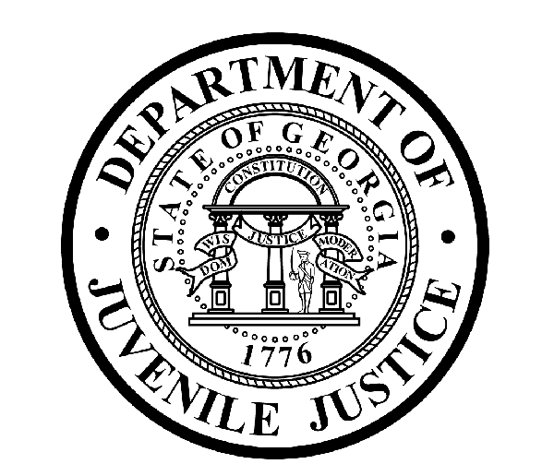

Avery D. Niles, CommissionerDepartment of Juvenile Justice

Jim Shuler, Director3408 Covington Highway ▪ Decatur, Georgia ▪ 30032-1513
Office of CommunicationsTelephone: (404) 508-7147 ▪ Fax: (404) 508-7341
FOR IMMEDIATE RELEASE CONTACT:
Jim Shuler, Director
September 8, 2014 DJJ Communications
(404) 508-7238
JimShuler@djj.state.ga.us

Department of Juvenile Justice Hiring in September
During DJJ’s “Autumn of Opportunity”
Dublin, Macon & Warner Robins

(STATEWIDE - GA) Recruiting teams continue to cross the state this September during DJJ’s “Autumn of Opportunity”. Commissioner Avery D. Niles announced there are three more recruiting fairs on the agency’s recruitment calendar this month, scheduled in Dublin, Macon and Warner Robins.

DJJ’s first stop will be in Dublin this week, to connect with job seekers looking for full time careers in juvenile corrections. Participation at juvenile corrections career fairs is free and with the exception of some military recruiting fairs, most events are open to the general public. Serious applicants should dress for success and bring their resumes.

Date: September 9th - GENERAL PUBLIC
Dublin GA Dept Of Labor Job Fair
910 North Jefferson Street
Dublin, GA 31021-6308
Time: 10 a.m. - 3 p.m.
Contact Person: Patsy Carr - GA DOL (478) 275-6525

Date: September 18th - GENERAL PUBLIC
Goodwill Diversity Job Fair
Anderson Conference Center
5171 Eisenhower Parkway
Macon, GA 31206
Time: 1 p.m. - 4 p.m.
Contact Person: Jennifer Welch – (478) 471-4244

(MORE MORE MORE)

(PAGE TWO TWO TWO )

Date: September 26th - MILITARY
Robins Air Force Base (RAFB) Civilian Personnel Job Fair –
Heritage Club - Robins Air Force Base
215 Page Road #269
Warner Robins, GA 31098
Time: 9 a.m. - 1 p.m.
Contact Number: (478) 926-1001

**Please note that career fair times and locations may change and additional career fair dates may be added to our recruiting schedule. Applicants should check the DJJ website for late-breaking schedule changes at http://www.djjnewsandviews.org/djjcareers/ before visiting a job fair.

State recruiters will be searching for qualified candidates for a wide range of available DJJ career opportunities: including Educators and Special Education Teachers, Registered Nurses and Physicians, Corrections and Transportation Officers, Social Workers, Probation and Parole Specialists, Security Emergency Response Teams, I-T Technicians, Food Service Providers and more.

Job seekers can click on http://www.djjnewsandviews.org/djjcareers/ for more information about excellent career opportunities for both civilian and veteran applicants looking for professional employment in juvenile corrections. Applicants who have served in the Armed Forces should also click on the section about “DJJ Careers for Veterans” to learn more.

(END RELEASE)

