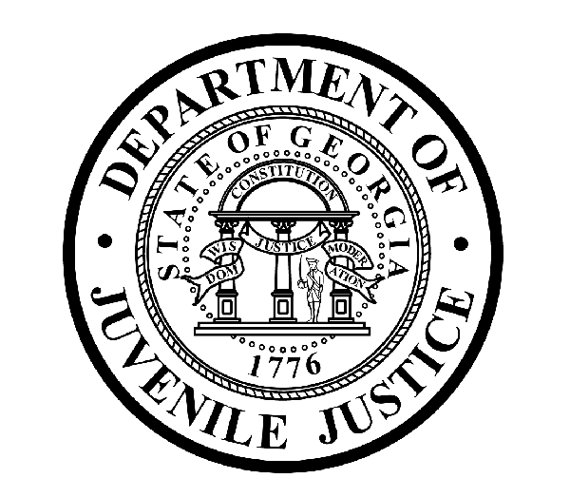

Avery D. Niles, CommissionerDepartment of Juvenile Justice

Jim Shuler, Director3408 Covington Highway ▪ Decatur, Georgia ▪ 30032-1513
Office of CommunicationsTelephone: (404) 508-7147 ▪ Fax: (404) 508-7341
FOR IMMEDIATE RELEASE CONTACT:

April 6, 2013 DJJ Communications
(404) 508-7147

SAVANNAH RYDC OFFICER ARRESTED ON DRUG CHARGES

(Chatham County - GA) Commissioner Avery D. Niles of the Georgia Department of Juvenile Justice announced today that Savannah State University Police Officers have arrested off-duty juvenile corrections officer (JCO) Kevin Maurice Biggins on felony drug charges.

University Police authorities notified DJJ Internal Affairs that 31-year-old Kevin Biggins was in a student dorm room on the Savannah State University campus when arrested. Police say Biggins is enrolled as a student at the college.

University Police report Biggins was taken into custody after the arresting officer discovered Biggins had allegedly concealed in his clothing a plastic bag which contained two prescription bottles and 13 smaller bags filled with marijuana.

Police report Biggins then allegedly directed the arresting officer to a handgun in a drawer where the officer also discovered an unmarked prescription bottle containing an illegal stash of oxycodone pills.

Biggins was taken into custody Friday afternoon and booked into the Chatham County Jail where he is currently being held on charges of felony Possession of Marijuana with Intent to Distribute, felony Possession of a Controlled Substance with Intent to Distribute, and Possession of a Firearm on School Property.

University Police investigators indicate additional charges may be forthcoming. Their investigation continues at this time.

Following the Friday arrest, DJJ Commissioner Avery Niles announced he would order immediate administrative action for the suspension of JCO Biggins from all duties at the Department of Juvenile Justice. Before his arrest, Biggins was posted as a juvenile corrections officer at the Savannah Regional Youth Detention Center (RYDC) in Chatham County.

(MORE MORE MORE)

(PAGE TWO)

The Commissioner said there was no immediate evidence to indicate Biggins may have moved contraband into the state detention facility where he worked. The Commissioner ordered an immediate DJJ internal affairs check into all contraband incidents reported at the Savannah RYDC for any possible connections involving the juvenile corrections officer.

Commissioner Niles, who endorses agency transparency in matters like the public reporting of this arrest said, “There is no room for corrupt or criminal behavior here. The DJJ Commissioner’s Office will continue to cooperate with all prosecuting authorities. I gave clear warning when I was appointed that irrespective of staff seniority, rank or position, those who break Georgia law or violate DJJ policy will face serious consequences,” Niles said.

The Commissioner’s’ core message since his November 2012 appointment by Governor Nathan Deal has emphasized that the critical duties of the Department of Juvenile Justice are to uphold and enforce policy, ethics, and safety and security measures at Georgia’s juvenile justice facilities so both DJJ detainees and staff can function in a safe and secure learning environment.

A booking photograph of Kevin Maurice Biggins is attached at the end of this news release.

(END RELEASE)

DJJ DISCLAIMER: “Information regarding this arrest is public record and was obtained from area law enforcement agencies. All suspects are presumed innocent until found guilty in a court of law.”

