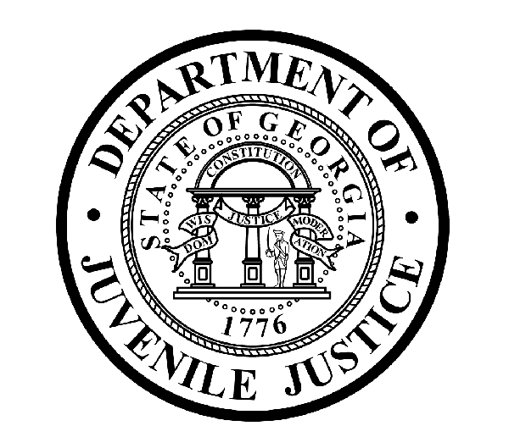

Avery D. Niles, CommissionerDepartment of Juvenile Justice

Jim Shuler, Director3408 Covington Highway ▪ Decatur, Georgia ▪ 30032-1513
Office of CommunicationsTelephone: (404) 508-7147 ▪ Fax: (404) 508-7341
FOR IMMEDIATE RELEASE CONTACT:
Jim Shuler, Director
MARCH 2, 2016 DJJ Communications
(404) 508-7238
JimShuler@djj.state.ga.us

Department of Juvenile Justice Hiring in March
Recruiters Looking Statewide for Corrections Officer Candidates:
Dublin, Valdosta, Warner Robins, Bainbridge, Statesboro, Hinesville, Americus, Clarkston, Augusta, Atlanta & Lovejoy

(STATEWIDE - GA) Georgia’s Juvenile Justice Commissioner Avery D. Niles says DJJ is seeking veterans and other highly qualified candidates to fill new Juvenile Corrections Officer (JCO) employment opportunities now available at Georgia juvenile justice facilities throughout the state.

Ten job fairs are scheduled on DJJ’s recruitment calendar this month in DJJ’s South, East and West Recruiting Regions. Recruiters will be setting up career fairs in Dublin, Valdosta, Warner Robins, Bainbridge, Statesboro, Hinesville, Americus, Clarkston, Augusta, Atlanta and Lovejoy.

“We’re looking for mature, responsible adults,” said Commissioner Niles. “We’re doing on the spot interviews. We’re hiring candidates who are deeply motivated to help young offenders through their troubled life transitions.”

*Please note career fair locations and times may change OR additional career fair dates may be added to our recruiting schedule. Applicants should check the DJJ website for late-breaking schedule changes at www.djjcareers.org BEFORE visiting a DJJ job fair.

South Region

Date: Wednesday, March 2ND, 2016 – STUDENTS ONLY
Cochran Spring Career Fair
Middle Georgia State University
Dublin, GA 31021
Time: 10:00 AM – 1:00 PM
DJJ Target Employer Facility: Eastman YDC and RYDC
Contact: Dr. Melinda Robinson-Moffett (478) 471-2441

(MORE MORE MORE)
(PAGE TWO TWO TWO)
Date: Thursday, March 10th, 2016 - GENERAL PUBLIC
Georgia Department of Labor Career Fair
GDOL, 221 South Ashley Street
Valdosta, GA
Time: 1:00PM – 4:00PM
DJJ Target Employer Facility: All Southern Facilities
Contact: Tony McKenzie (229) 333-5211

Date: Wednesday, March 23, 2016 - GENERAL PUBLIC
CGTC Warner Robins Campus Job Fair
Location: 80 Cohen Walker Drive
Warner Robbins, GA
Time: 10:00AM – 1:00PM
DJJ Target Employer Facility: All Southern Facilities
Contact: Patrick Ivey (478) 757-3431

Date: Thursday, March 24, 2016 - GENERAL PUBLIC
BSC (Bainbridge State College) Career Fair
Location: 2500 E. Shotwell Street
Bainbridge, GA
Time: 10:00AM – 2:00PM
DJJ Target Employer Facility: All Southern Facilities
Contact: Mary Guibor (229) 243-3023

Date: Wednesday, March 30, 2016 - GENERAL PUBLIC
Georgia Southern University Career Fair
Russell Union Ballroom
Statesboro, GA
Time: 2:00PM – 4:00PM
DJJ Target Employer Facility: All Southern Facilities
Contact: Career Services (912) 478-5197

Date: Thursday, March 31ST, 2016 – MILITARY ONLY
Fort Stewart Military base Job Fair
Hinesville, GA
Time: 1:00PM – 4:00PM
DJJ Target Employer Facility: All Southern Facilities
Contact: Latecia Brown (912) 767-0597

Date: Thursday, March 31, 2016 - GENERAL PUBLIC
Southeastern Georgia Technical College Career Fair
900 South GA Tech Parkway
Americus, GA
Time: 8:30AM – 12:00PM
DJJ Target Employer Facility: All Southern Facilities
Contact: Cynthia Carter (229) 931-2057

East Region

Date: Wednesday, March 23, 2016 - GENERAL PUBLIC
Georgia Piedmont Technical College Career Fair
495 North Indian Creek Road
Clarkston, GA
Time: 10:00am– 2:00pm
DJJ Target Employer Facility: Metro Atlanta area
Contact: Career Services- Brenda Baugh
(MORE MORE MORE)
(PAGE THREE THREE THREE)

Date: Thursday, March 24, 2016 - GENERAL PUBLIC
Augusta YDC Facility Job Fair
3481 Mike Padgett Highway
Augusta, GA 30906
Time: 10:00AM – 2:00PM
DJJ Target Employer Facility: Augusta YDC
Contact: Marissa Tjovares (706) 792-7509

West Region

Date: Thursday, March 15, 2016 - GENERAL PUBLIC
Metro RYDC Facility Job Fair
1300 Constitution Road, SE
Atlanta, GA 30316
Time: 10:00AM – 3:00PM
DJJ Target Employer Facility: Metro RYDC
Contact: Andrea Raphael-Osuanya (404) 635-4421

Date: Thursday, March 17, 2016 – GENERAL PUBLIC
Lovejoy Community Career Fair
11622 Hastings Bridge Road
Lovejoy, GA
Time: 10:00am – 2:00pm
DJJ Target Employer Facility: Metro Atlanta area
Contact: LoveJoy Community Center (678) 479-8655

Candidates should bring copies of the following to the interview process for Juvenile Corrections Officers:
- Compass Scores (Reading 70 Writing 32)**
- SAT Scores (Verbal: 430 Math: 400) or ACT Scores (Verbal: 18 Math:16)**
- Valid Driver License
- Birth Certificate
- High School Diploma or GED
- DD214 Long Form with discharge indicated
- Naturalization Forms if NON-US Citizen
- If P.O.S.T. Certified, (Please bring two (2) forms of Govt. issued ID & P.O.S.T. Profile) **
**Applicants with a 4-year degree from an accredited college are exempt from taking the Compass test or providing proof of acceptable ACT or SAT scores.

There is no charge for participation at juvenile corrections career fairs. DJJ recruiters are authorized to interview qualified candidates on-the-spot for new correctional officer opportunities. Applicants should bring their resumes and come dressed for job interviews.

Interested job seekers can click on www.djjcareers.org for more information about career opportunities in juvenile corrections. Former military service members with Honorable Discharge should also click on www.djjcareers.org to learn about DJJ's one-time Military Salary Increase Incentive on eligible job titles at “DJJ Careers for Veterans”.

**Please note that career fair times and locations may change and additional career fair dates may be added to our recruiting schedule. Applicants should check the DJJ website for late-breaking schedule changes at http://www.djjnewsandviews.org/djjcareers/ before visiting a job fair.
(END RELEASE)

“DJJ is a great place to make your work count.”
Avery D. Niles, Commissioner
Georgia Department of Juvenile Justice

