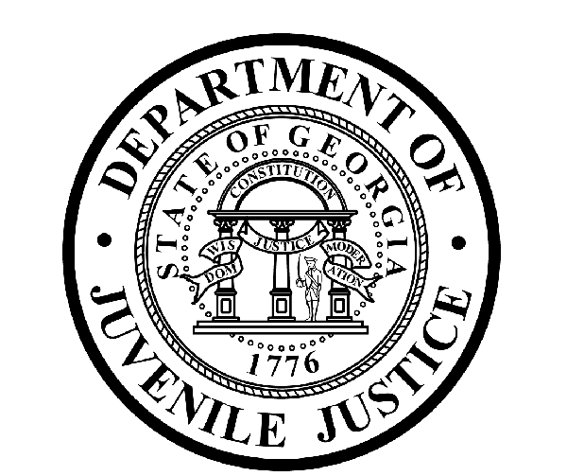

Avery D. Niles, CommissionerDepartment of Juvenile Justice

Jim Shuler, Director3408 Covington Highway ▪ Decatur, Georgia ▪ 30032-1513
Office of CommunicationsTelephone: (404) 508-7147 ▪ Fax: (404) 508-7341
FOR IMMEDIATE RELEASE CONTACT:
Jim Shuler, Director
June 6, 2014 DJJ Communications
(404) 508-7238
JimShuler@djj.state.ga.us

Commissioner Brings in Top Victim Advocacy Experts for DJJ Training

(ATLANTA - GA) Commissioner Avery D. Niles is pleased to announce the Department of Juvenile Justice is working with a Washington, DC-based criminal justice “think tank” to provide agency guidance on Victim Impact and Advocacy issues. The Moss Group consulting firm is known for their expertise in the adult and juvenile corrections fields. Their specialists conducted special leadership training sessions at the request of Commissioner Niles for his entire Executive Team and Management Staff.

Leadership is the cornerstone of The Moss Group approach to Victim Advocacy issues. Their instruction was designed to help remodel DJJ’s current management culture and help the DJJ Executive Team understand the devastating impact of Victimization on overall decision-making practices at the agency.

To accomplish that, Moss Group facilitators lead training and “round table” discussions to explore the challenges faced by victims of juvenile crime who try to function normally after experiencing violent traumas. The training is also designed to teach DJJ management to be more aware of young people in custody who may also be young crime victims detained in the juvenile justice system.

At DJJ’s Division of Operations and Compliance, Deputy Commissioner Sarah Draper coordinated the special Executive Team Victim Impact training. “We understand the traumatic impact of crime on its victims,” Deputy Commissioner Draper said.

“Commissioner Niles not only sees a duty for DJJ to support and assist crime victims, he also wants to ensure a safe environment in our secure facilities while Georgia’s juvenile offenders are in our care,” Deputy Commissioner Draper said.

The Moss Group’s Victim Impact and Advocacy Training was conducted by special request from Commissioner Niles, who as a veteran corrections facility administrator, recognizes the impact of victimization and the need for increased awareness for all vulnerable youth populations, including those in detention at DJJ.

The Moss Group was founded by former DOC Assistant Deputy Commissioner Andie Moss after her work as program manager with the National Institute of Corrections. Since leaving Georgia’s Department of Corrections, Moss has provided on-site consultations with more than 60 correctional facilities and published in two textbooks and several professional periodicals.

(PAGE TWO TWO TWO)

Due to its high profile correctional work, The Moss Group was awarded a multi-year agreement to assist a division of the U.S. Justice Department with implementation of the 2003 federal Prison Rape Elimination Act called PREA. The special leadership training at DJJ was developed through a partnership between The Moss Group and victim impact consultant Anne Seymour and juvenile justice subject matter expert Cherie Townsend.

As Co-founder and Senior Advisor of the Washington, D.C.-based Justice Solutions group, consultant Anne Seymour is known as a leading national and international advocate for crime victims’ rights. Her work covers correctional sexual abuse victims and survivors, program development for realigning organizational cultures, and building leadership capabilities. She has contributed to numerous victim rights studies and reports, and authored or contributed to more than 30 manuals or published texts. She is the recipient of the 1992 "Outstanding Service to Crime Victims" award from President Bush.

Consultant Cherie Townsend is a former Executive Director for the Texas Youth Commission and is well respected in juvenile justice fields for her expertise with federal PREA enforcement. Townsend’s experience with Victim Advocacy and sensitive correctional management issues includes work Commercial Sexual Exploitation of Children referred to as “C-SEC”, and other gender responsive issues such as assessing sexual abuse concerns in correctional settings and implementing gender-responsive management strategies.

Together, this team of national subject matter experts also discussed vulnerable populations and ways for DJJ to prepare an agency response. When The Moss Group concludes their assessment of DJJ Victim Advocacy practices, the consultant team will recommend actions and solutions unique to this agency’s culture and needs.

“That means, as we do a better job of tracking the interwoven cycles of juvenile crime, we begin to better understand that many young offenders may also be juvenile crime victims, as well as juvenile offenders,” said DJJ Commissioner Avery Niles.

The first Executive Training Session conducted at Georgia’s Department of Juvenile Justice was followed by a second day of instruction focused on DJJ management needs for dealing with victim issues in the field. Department Managers may face real victim challenges at secure facilities and court service offices on a daily basis.

“All of this training represents another DJJ breakthrough juvenile justice reform partnership with some of the foremost leaders in Victim Impact and Advocacy programs,” said Commissioner Avery Niles. “The expertise of these respected advisors from the Moss Group will greatly enhance our abilities in these critical areas to fully provide the vital services we have envisioned as part of DJJ’s ongoing agency growth and restructuring under the juvenile justice reform act,” Commissioner Niles said.

For more information about special juvenile justice reform projects at DJJ, visit us on the web at http://www.djjnewsandviews.org/juvenilejusticereform/ .

(END RELEASE)

PHOTOS BELOW ARE FROM THE DJJ VICTIM IMPACT AND ADVOCACY TRAINING SESSIONS. PHOTO ONE SHOWS MOSS GROUP CONSULTANT ANDIE MOSS (CENTER) ADDRESSING DJJ EXECUTIVE STAFF AT CENTRAL OFFICE IN DECATUR. PHOTO TWO DEPICTS (LEFT TO RIGHT) VICTIM ADVOCACY CONSULTANT CHERIE TOWNSEND, DJJ DEPUTY COMMISSIONER SARAH DRAPER, AND CONSULTANT ANNE SEYMOUR DURING A LEADERSHIP TRAINING SESSION WITH DJJ EXECUTIVE STAFF. PHOTOS MAY BE USED BY NEWS PUBLICATIONS WHEN ACCOMPANIED BY PHOTO CREDIT, “Courtesy Georgia DJJ”.

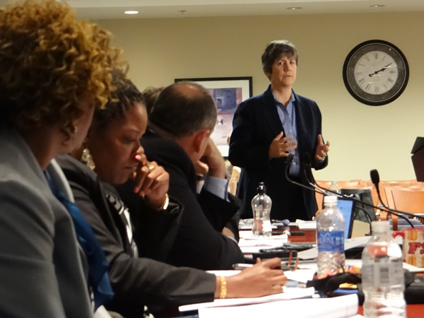

PHOTO CREDIT: Courtesy Georgia DJJ DJJ Victim Impact and Advocacy Training
Moss Group Consultant Andie Moss (CENTER) Addresses DJJ Executive Staff at Central Office in Decatur.

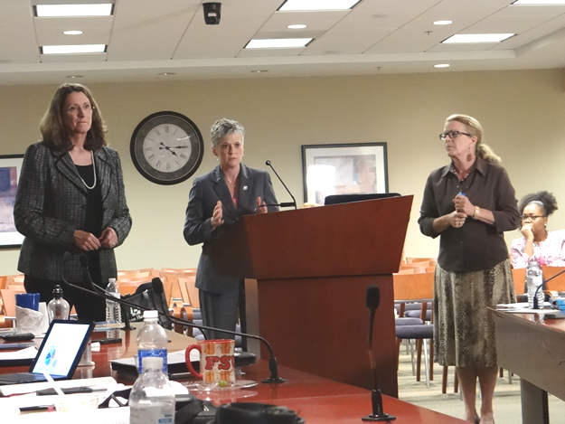

PHOTO CREDIT: Courtesy Georgia DJJ DJJ Victim Impact and Advocacy Training
(Left To Right) Victim Advocacy Consultant Cherie Townsend, DJJ Deputy Commissioner Sarah Draper, and Victim Advocacy Consultant Anne Seymour during executive leadership training.

