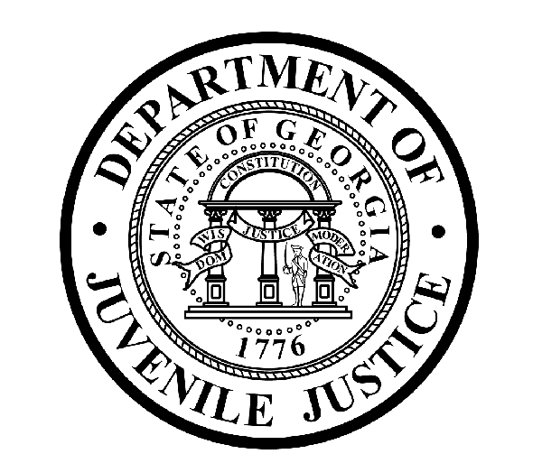

Avery D. Niles, CommissionerDepartment of Juvenile Justice

Scott Mall3408 Covington Highway ▪ Decatur, Georgia ▪ 30032-1513
Office of CommunicationsTelephone: (404) 508-7147 ▪ Fax: (404) 508-7341
FOR IMMEDIATE RELEASE CONTACT:
Jim Shuler
January 27, 2017 DJJ Communications
(404) 508-7147
JimShuler@djj.state.ga.us

Department of Juvenile Justice Recruiting in January!

(SPECIAL for ATLANTA, GA) The Department of Juvenile Justice (DJJ) is offering full-time employment in one of Georgia’s most challenging criminal justice career areas. DJJ is looking for qualified candidates to fill professional positions for Juvenile Corrections Officers (JCOs) at the Metro Regional Youth Detention Center (RYDC) in Atlanta, Georgia.

Commissioner Avery D. Niles says agency recruiters will be in Atlanta on January 31st for a special career fair to seek mature, responsible applicants who want the kind of juvenile correctional work that will make a real difference in their lives and their communities.

“We offer complete state health and benefit packages and we’re always looking for applicants who can apply their knowledge and experience in corrections, the military or law enforcement to work in a structured juvenile justice system environment,” the Commissioner said.

*Please note career fair locations and times may change OR additional career fair dates may be added to the DJJ recruiting schedule. Applicants should check the DJJ website for late-breaking schedule changes at www.djjcareers.org BEFORE visiting a DJJ job fair.

Date: Tuesday, January 31, 2017 – OPEN to GENERAL PUBLIC
Location: Metro Regional Youth Detention Center (RYDC)
1300 Constitution Rd
Atlanta, GA
Time: 10:00 a.m. - 2:00 p.m.
Contact: Elanda Trice (404) 624- 2552

Applicants for Juvenile Corrections Officer positions should bring copies of these important documents to the interview process:

(more)

(page two)

- Compass Scores (Reading: 70 Writing: 32)** Accuplacer (Reading: 55 Writing: 60 Numerical: 34) **
- SAT Scores (Verbal: 430 Math: 400) or ACT Scores (Verbal: 18 Math: 16)**
- Valid Driver’s License
- Birth Certificate
- High School Diploma or GED
- DD214 Long Form with discharge indicated
- Naturalization Forms if Non-US Citizen
- If P.O.S.T. Certified, please bring two (2) forms of Government issued ID & P.O.S.T. Profile **

**Applicants with a 4-year degree from an accredited college are exempt from taking the Compass test or providing proof of acceptable ACT or SAT scores.

Commissioner Niles said, “We want jobseekers with the drive it takes to help young offenders through their personal challenges while they’re in state custody. DJJ is searching for special candidates to become part of our dedicated team of professionals.”

Interested job seekers can click on www.djjcareers.org for more information about career opportunities in juvenile corrections. DJJ is ‘Veteran-Friendly.’ Former military service members with Honorable Discharges should also click on www.djjcareers.org to learn about DJJ's one-time Military Salary Increase Incentive on eligible job titles at “DJJ Careers for Veterans.”

**Please note that career fair times and locations may change and additional career fair dates may be added to our recruiting schedule at any time. Applicants should check the DJJ website for late-breaking schedule changes at http://www.djjnewsandviews.org/djjcareers/ before visiting a job fair.

###

“DJJ is a great place to make your work count.”
Avery D. Niles, Commissioner
Georgia Department of Juvenile Justice

The Georgia Department of Juvenile Justice (DJJ) is a multi-faceted agency that serves the needs of this state`s young offenders up to the age of 21. The Department employs more than 4,000 men and women at 26 secure facilities and 97 community services offices throughout the state to effect justice and redirect the young lives in the agency`s care.

Including those who are placed on probation, more than 50,000 youths are diverted each year to evidence-based community programs, sentenced to short-term incarceration or committed to the Department`s long-term custody by the Juvenile Courts. It is the duty of DJJ’s professional corrections staff to preserve public safety and safeguard the citizens of Georgia, as well as protect the victims of crimes so that they can rebuild their lives.

At the same time, DJJ holds juvenile offenders accountable for their delinquent conduct so that they can take responsibility for their actions through probation, supervision and secure detention. The youth are provided with medical and psychological treatment, as well as specialized education and programs designed to equip them with the social, intellectual and emotional tools needed to achieve their successful reentry and reintegration into community, workplace and neighborhood settings as more productive and law-abiding citizens.

