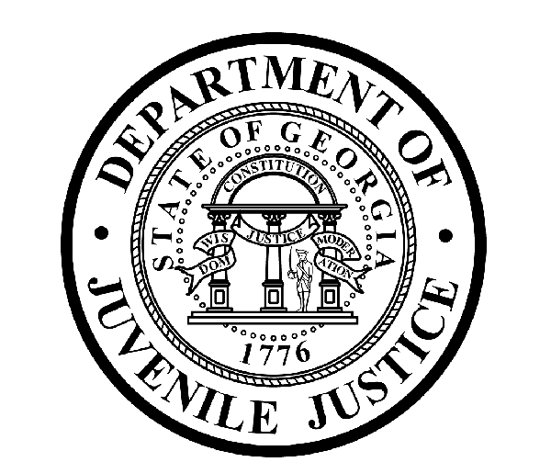

Avery D. Niles, CommissionerDepartment of Juvenile Justice

Jim Shuler, Director3408 Covington Highway ▪ Decatur, Georgia ▪ 30032-1513
Office of CommunicationsTelephone: (404) 508-7147 ▪ Fax: (404) 508-7341
FOR IMMEDIATE RELEASE CONTACT:
Jim Shuler, Director
September 3, 2015 DJJ Communications
(404) 508-7238
JimShuler@djj.state.ga.us

COMMITTED to CLASSROOM SUCCESS
DJJ’s Georgia’s Preparatory Academy

(DECATUR – GA) At the beginning of August, just under 1400 students reported to class at the second largest school system in Georgia without causing a single traffic snarl. Professional educators had readied detailed preparations for opening week, pleased with the knowledge they would be working with some of the most up-to-date teaching tools available to students in any private or public classroom.

As those students followed lessons from the overhead Smart Boards or assigned readings from their Kindles, classroom visitors might not otherwise have known that it was the first week of class for Georgia’s juvenile offenders. But the orderly lines of students in DJJ jumpsuits revealed the Fall Session at Georgia’s 181st school district was officially underway at the Department of Juvenile Justice.

“Smart Boards have revolutionized the educator’s tool box available to our teachers,” said DJJ Commissioner Avery D. Niles. “Our students are no longer constrained by single text books or paper handouts that previously limited innovative approaches by our educators. Now, DJJ Education is on the move with instructional material presented in an interactive medium that gets our students personally involved in their classes,” Commissioner Niles said.

Many parents are surprised to learn the state juvenile justice system conducts a regular school-year schedule of classes at the newly named Georgia Preparatory Academy (GPA). Just like pupils at Georgia schools outside DJJ’s security fences, students here receive 330 minutes of regular or special education every school day. Each curriculum taught at DJJ meets the same quality education standards prepared by the Georgia Department of Education.

“Our Preparatory Academy is now in full implementation of the statewide Georgia Performance Standards education curriculum for language arts and mathematics,” said DJJ Associate School Superintendent Audrey Armistad. “These standards are rigorous benchmarks all teachers use to guide instruction. Georgia Preparatory Academy is also administering the new Georgia Milestones Assessments. DJJ’s professional educators and administrators will continually become better equipped to support the elevation of their students toward higher levels of success,” Dr. Armistad said.

(MORE MORE MORE)
(PAGE TWO TWO TWO)
As the Department progresses into the third year of Georgia Juvenile Justice Reform, DJJ continues to employ and recruit professionally certified, highly qualified and motivated teachers to ensure the Department is operating in compliance with those reforms. Georgia Preparatory Academy is distinguished by its dual accreditations through the Southern Association of Colleges and Schools (SACS) and Correctional Education Association (CEA). It builds positive new learning experiences and provides educational platforms for all youth committed to juvenile secure confinement.

These opportunities are steadily helping Georgia youth achieve their educational goals. Teachers at the Georgia Preparatory Academy are hearing more Education Success Stories: Like the student at DJJ’s Regional Youth Detention Center in Gainesville who recently completed his G.E.D. through DJJ’s ‘Transition to Success’ program. However, this determined student wouldn’t stop there and he’s currently beginning courses at Lanier Technical College.

Another Education Success Story: The first DJJ student to enroll in DJJ’s ‘eCore’ online college program completed six college courses and earned an “A” in each one. Before he was released from Sumter Youth Development Campus this summer, that student completed a total of 18 college credits. Today he’s playing baseball for a private Georgia college where he started classes last month.

Now DJJ has three more students enrolled in the ‘eCore’ online college program. Each will be taking two college courses online and DJJ will continue adding more students to this successful program.

To make more Education Success Stories possible, the Department of Juvenile Justice embraces other state-of-the-art educational opportunities to help make student “Reentry” into their community seamless. This means providing vocational education linked to meaningful employment opportunities while students are still earning their diploma or GED at DJJ.

Georgia Preparatory Academy has developed relationships with local Georgia technical colleges teaching auto and collision repair, welding, certified construction work, landscape and design (horticulture) to help administer technical programs and certifications. To promote job-readiness, Georgia Preparatory Academy students participate in job readiness classes that teach soft skills such as dressing for success and proper interviewing skills.

During summer 2015, eight DJJ students passed the ‘ServSafe’ exam administered at DJJ’s Youth Development Campus in Atlanta. This five-year certification from the National Restaurant Association is a Vocational Education Success Story that will enable those students to obtain a job in the food industry once released. More than thirty students have passed the ServSafe exam since DJJ began conducting the certifications just a year and a half ago.

While teaching students how to use the latest classroom technology, DJJ educators are also tapping into the potential of low-tech partnerships among parents, schools, and communities. Educators observe that every-day parental involvement, especially in juvenile detention education settings, can ultimately lead to significant gains across the board in student achievement. Two newly-hired DJJ Parental Involvement Coordinators have the responsibility of encouraging parents to be actively involved to ensure a positive impact on their child’s academic learning, to be included in school advisory committees and beneficial decision making, and to help facilitate regular communication about other school activities.

DJJ is also collaborating with local public school systems to expand school-based supervision using on-site probation officers assigned to provide alternative consequences to student suspensions. Youth who are no longer able to pursue their education in traditional public school settings after being suspended or expelled, will be able to enroll in one of DJJ’s newly established Community-based Education Transitional Centers (ETC) which will be located in Richmond, Fulton, Muscogee, Bibb and Chatham counties. These new Education Transitional Centers provide youth under DJJ community supervision with opportunities to continue their education and earn course credit outside of their public school settings.

Finally, DJJ has implemented the ‘Infinite Campus’ student information system for the electronic transfer of student schedules, record keeping and information exchange between the Georgia Preparatory Academy and other school districts throughout the state. Electronic records transfer decreases the transition period between the time when a youth is released from custody and re-enrollment into their schools back home.
(MORE MORE MORE)
(PAGE THREE THREE THREE)

But the true test of the Preparatory Academy’s commitment to providing quality Education for Georgia’s young offenders is the level of excitement experienced by reenergized students who thought they would never realize the achievement of a high school diploma or G.E.D. As the number of High School and G.E.D. graduates at DJJ has increased, Commissioner Niles began gathering graduates from across the state to a central secure facility for their opportunity to cross the stage in caps and gowns together.

“We wanted these students to experience the genuine excitement of commencement ceremonies with a large group of their classmates,” Commissioner Niles said. “We wanted our students to know the wonderful feeling of accomplishment that goes with standing up to be recognized for your personal academic achievement.”

During the 2014-15 school year, 119 juveniles from DJJ secured facilities and community supervision received high school diplomas or G.E.D.’s. Associate Superintendent Armistad praised her students for their success: “Getting a high school diploma or G.E.D. provides these students with a tool that is needed for them to become successful and productive citizens. We are proud of their accomplishments,” Armistad said.

At every DJJ commencement ceremony Commissioner Avery Niles tells those attending the ceremony, “the goal of the agency is to ensure that each student is in a better place with their education than they were when they arrived at the Department of Juvenile Justice.”

Commissioner Niles says, “DJJ is proud of the number of advancements we’ve been able to make in the operation of the Education Division and the number of youth whose lives we have positively influenced. These graduations are a tangible representation of the success of Juvenile Justice Reform in the State of Georgia.”

(END RELEASE)
The photos posted below are available for publication with the story. If used, please credit the photos to the Georgia Department of Juvenile Justice.
