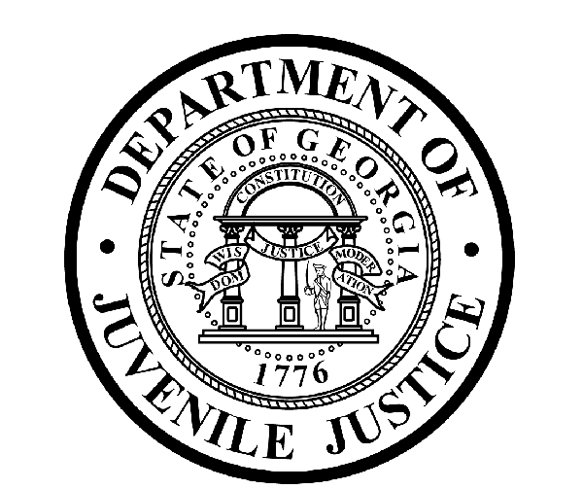

Avery D. Niles, CommissionerDepartment of Juvenile Justice

Scott Mall3408 Covington Highway ▪ Decatur, Georgia ▪ 30032-1513
Office of CommunicationsTelephone: (404) 508-7147 ▪ Fax: (404) 508-7341
FOR IMMEDIATE RELEASE CONTACT:
Jim Shuler
February 1, 2017 DJJ Communications
(404) 508-7238
JimShuler@djj.state.ga.us

DJJ FOCUS ON EDUCATION:
DJJ Graduates Senior Class
Commissioner Encourages More Grads in 2017

(Forsyth – GA) With goals set for continued scholastic success at the state’s 181st school district, Department of Juvenile Justice (DJJ) Commissioner Avery D. Niles congratulated graduates of the Georgia Preparatory Academy (GPA) at the Tift College campus in Forsyth during the winter graduation. Combined senior classes from Department of Juvenile Justice (DJJ) secure facilities around the state crossed the stage at Roberts Chapel together in their caps and gowns and closed out the 2016 school year with their inspiring commencement ceremonies.

Commissioner Niles shook their hands and said, “You have managed to overcome many personal, family and social adversities to get here today.” The Commissioner awarded 26 GEDs, 14 High School Diplomas and 18 Vocational Technical Certificates of Credit.

A capacity crowd of families, dignitaries, DJJ educators and media participated in community recognition for the young offenders who distinguished themselves with their hard work and academic accomplishments while committed to state custody. In addition, 25 GPA students completed ACT testing modules for college admission requirements.

“It’s one of the great rewards of my job to witness the excitement of our students when we conduct these Georgia Preparatory Academy commencement exercises,” Commissioner Niles said. “And now their further success depends on them realizing this is the time to make positive changes,” Niles said.

Graduates attended from 12 Georgia Preparatory Academies at Youth Development Campuses (YDCs) in Atlanta, Augusta, Eastman, Macon, Muscogee and Sumter; Regional Youth Detention Centers (RYDCs) in Gainesville, Muscogee, Rome and Sandersville; the Intensive Treatment Unit (ITU) in Milledgeville; and from the Chatham Education Transitional Center in Savannah.
(-more-)

(Page 2)

Students at DJJ are held to the same scholastic standards for earning their diplomas as pupils in Georgia’s traditional state schools. Students receive 330 minutes of regular or special education inside DJJ’s security barriers every school day. GPA curriculum also meets the same quality education standards set by the Georgia Department of Education for all public schools. The Georgia Preparatory Academy is a dually accredited state school district.

The graduates were saluted by the keynote speaker, Principal Dawn Parker from the Alonzo Crim Open Campus High School in DeKalb County. Principal Parker effectively doubled the graduation rate at her campus from 6.9 percent to 12.7 percent in the 2014-2015 school terms. Parker congratulated the GPA graduates for their resilience in accomplishing this major milestone, despite the many times they may have experienced humiliation, discrimination, frustration and failure. She encouraged the graduates to continue believing in themselves and to never forget the people who did not stop loving and supporting them.

“Don’t forget to repay those you love by giving back to others in need,” Principal Parker said. She advised the graduates to pay forward the debt for their success by preventing others from making wrong decisions in their lives. “If you can keep one person from making a wrong decision or redirect them from making the wrong choice, then you are fulfilling our greatest mission in life,” Parker said.

Commissioner Niles presented Principal Parker with a special projects check for $300.00, which was raised by the DJJ Executive Staff to honor her steady progress with graduation rates at the Alonzo Crim Open Campus High School.

In another special presentation, Arisha Dancy–Mattox, an English Language Arts teacher at Aaron Cohn RYDC, was named DJJ’s 2016 Teacher of the Year. Dancy-Mattox has been an educator for 11 years. She told presenters her personal philosophy is that “the best teachers teach from the heart, not from the book.”

Additional honors for Teacher of the Year finalists went to Joann Canady, a Math teacher at Macon RYDC; Charlotte Hall, Lead teacher at Claxton RYDC; Damien Northern, a Social Studies teacher at Metro YDC; and Janice Zeigler, an English Language Arts teacher at Macon YDC. Commissioner Niles and Dr. Richard Behrens, GPA Associate Superintendent of Schools, congratulated all the finalists for their dedication and professionalism.

Other special graduation guests included DJJ Board Members Willie Bolton, Julia Neighbors and Penny Penn. The Department of Juvenile Justice SMRT Team delivered the Presentation of Colors and Ms. Tina Thames performed the National Anthem.

Photos of DJJ’s graduation ceremonies are posted on the agency’s “News & Views” webpage at http://www.djjnewsandviews.org/2016gpadecembergraduation/ .

(###)

The Georgia Preparatory Academy is Georgia’s 181st School District and has dual accreditation from the Southern Association of Colleges and Schools (SACS) and from the Correctional Educational Association (CEA). The mission of the Georgia Preparatory Academy is to provide a comprehensive educational program which will facilitate the successful integration of each student into the community and workplace.

(-more-)

(Page 3)

ABOUT DJJ
The Georgia Department of Juvenile Justice (DJJ) is a multi-faceted agency that serves the needs of this state`s young offenders up to the age of 21. The Department employs more than 4,000 men and women at 26 secure facilities and 97 community services offices throughout the state to effect justice and redirect the young lives in the agency`s care.

Including those who are placed on probation, more than 50,000 youths are diverted each year to evidence-based community programs, sentenced to short-term incarceration or committed to the Department`s long-term custody by the Juvenile Courts. It is the duty of DJJ’s professional corrections staff to preserve public safety and safeguard the citizens of Georgia, as well as protect the victims of crimes so that they can rebuild their lives.

At the same time, DJJ holds juvenile offenders accountable for their delinquent conduct so that they can take responsibility for their actions through probation, supervision and secure detention. The youth are provided with medical and psychological treatment, as well as specialized education and programs designed to equip them with the social, intellectual and emotional tools needed to achieve their successful reentry and reintegration into community, workplace and neighborhood settings as more productive and law-abiding citizens.

