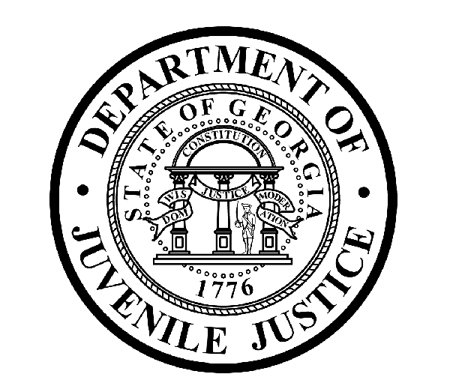

Avery D. Niles, CommissionerDepartment of Juvenile Justice

Jim Shuler, Director3408 Covington Highway ▪ Decatur, Georgia ▪ 30032-1513
Office of CommunicationsTelephone: (404) 508-7147 ▪ Fax: (404) 508-7341
FOR IMMEDIATE RELEASE CONTACT:
Jim Shuler, Director
MARCH 10, 2016 DJJ Communications
(404) 508-7238
JimShuler@djj.state.ga.us

Commissioner Niles Honors Hall, Dawson & NE GA Staff Members
DJJ Employee Recognition Program Highlights Outstanding Teams

(STATEWIDE - GA) Georgia’s Juvenile Justice Commissioner Avery D. Niles is pleased to announce the Office of Human Resources (OHR) brought several accomplished staff members before the recent DJJ Board meeting for special acknowledgement, including honorees from Hall and Dawson Counties. OHR Personnel Analysis Section Manager Harold Cooper described the DJJ Employee Recognition Program as one of the Department’s special efforts to show appreciation to deserving employees for their commendable performance on the job.

The DJJ Customer Service Award was presented to JPPS Star-Jabrea Farrington at the Hall-Dawson County Community Service Office in Gainesville. The nomination for this award says ‘Starr has found her calling at DJJ’. She maintains relations with other agencies and has spent many miles on the road to ensure that the youth under her supervision know she supports them. She is known for singing in the office to bring ‘a joyful noise and happiness to the workplace’ but also knows when to sit back and listen when a youth needs attention. Mr. Cooper said, “Star truly has a passion for working with youth and she does not know what 5pm checkout means.”

JPPS II Tonya Hagins received the DJJ Extra Mile Award for her work at the Hall-Dawson County Community Service Office (CSO) in Gainesville. Mrs. Hagins interned for nine months at the CSO and continued to do volunteer work there through the summer. She was later hired as a JPPS. Mr. Cooper said Mrs. Hagins has orchestrated after-school programs; nature trail and food pantry community service projects for DJJ youth; and helped organize volunteer projects with focus on Hall County’s Hispanic population. Mrs. Hagins also posted a ‘wall of fame’ at the CSO to celebrate local youth who have made their successful reentry into the community. Her nomination calls her, “a wise soul and free spirit who is infectious to her youth and to her peers.” Mr. Cooper said Mrs. Hagins brings high energy and a loving nature with enthusiasm to see DJJ youth succeed.
(MORE MORE MORE)
(PAGE TWO TWO TWO)

Mr. Cooper presented the DJJ Safety Award to Savannah RYDC control room officer Luisa Calderon who was monitoring closed circuit security cameras and defused a potentially volatile situation by simply talking with some unruly youth. Mr. Cooper said Officer Calderon performed above and beyond the regular duties of control room officer, using innovative initiatives and approaches to protect and ensure the health and safety of DJJ employees and youth in agency care. Her actions were recognized as a great reflection on herself, her shift, her facility and the Department.

The District 2 JPMs were the recipients of the DJJ Customer Service Team Award “for their commitment to the youth and families of the State of Georgia.. and to each other.” The award was presented to Sidney Michael Johnson, Cathy Sells, Donna Anderson-Lowe, Jonathan McMichael, Crystal Teasley, Ryan Phagan, Amber Miller Bryd, Christopher Ayers and Denise Haney for their team approach to public service and problem solving. District 2 Director Todd Bentley’s nomination recognized his team for providing invaluable support for DJJ youth and more.

Director Bentley wrote, “It is an honor to with a group of JPMs that sacrifice daily to serve the youth and families of the State of Georgia but also one another in a time of need.” The official nomination said the District 2 Team regularly impresses their supervisor with their synergistic approach to handling cases, hearings, summits and sharing other important responsibilities. “They consider their teammate’s needs above their own,” Bentley wrote. “They consistently amaze me as their supervisor by the way they support their fellow JPMs and are always eager to assist in any manner possible.”

Department of Juvenile Justice Commissioner Avery D. Niles told Board members he was thankful for the dedication and commitment of all DJJ employees who have a passion to serve the youth and citizens of the State of Georgia.
(END RELEASE)

“DJJ is a great place to make your work count.”
Avery D. Niles, Commissioner
Georgia Department of Juvenile Justice

