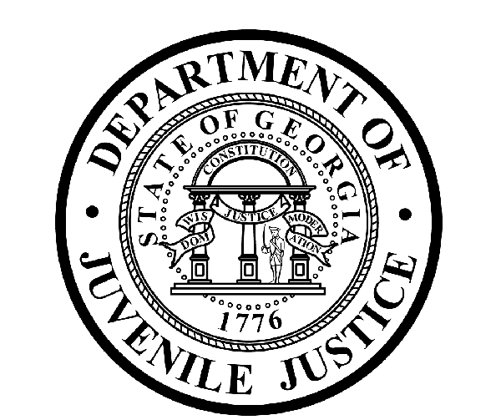
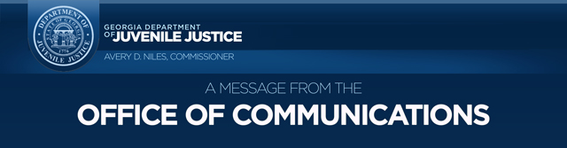
Avery D. Niles, CommissionerDepartment of Juvenile Justice

Scott Mall3408 Covington Highway ▪ Decatur, Georgia ▪ 30032-1513
Office of CommunicationsTelephone: (404) 508-7147 ▪ Fax: (404) 508-7341
For immediate release Office of Communications September 8, 2016 Scott Mall
(404) 508-5119
Scott.mall@djj.state.ga.us
scott.mall@djj.state.ga.us

DJJ Enthusiastically Supports Governor Deal’s Law Enforcement Pay & Training Package

(Atlanta, GA) – Georgia Governor Nathan Deal announced a law enforcement pay and training reform package today that includes a 20 percent pay raise for more than 3,300 state law enforcement officers and a multi-phase overhaul of officer training and certification courses. The pay increase is effective January 1, 2017, and represents more than $78 million in state funding in the amended FY17 budget and the FY18 budget.

“Since our founding, one of government’s primary roles is the protection of its people,” said Deal. “While the responsibility to provide for the public’s safety has not changed over the course of time, the demands of fulfilling this fundamental obligation have changed and grown. We ask our law enforcement personnel of all levels and ranks to do a very difficult job, one that requires great skill, long suffering and dedication of purpose. It is incumbent upon the government to recruit and retain the best and brightest, while equipping them with the training and resources they require. They deserve our unwavering commitment and support.”

Governor Deal continued, “To that end, I’ve crafted a law enforcement proposal consisting of two major components: more pay for our state officers who risk their lives every day, and changes to how we train both state and local authorities who have the power to make arrests. In crafting these reforms, I sought recommendations and input from the Georgia Public Safety Training Center and the Peace Officer Standards and Training Center. I’m thankful for their efforts and those of our public safety agencies and boards as these changes are implemented.”

Avery D. Niles, Commissioner of the Department of Juvenile Justice (DJJ), stated, “On behalf of the 135 DJJ law enforcement staff positively impacted by this package, we are very grateful to Governor Deal and the Georgia General Assembly. Like law enforcement officers in other areas of state government, DJJ law enforcement personnel perform difficult and dangerous tasks daily, and this pay increase helps recognize their outstanding work.”

###

