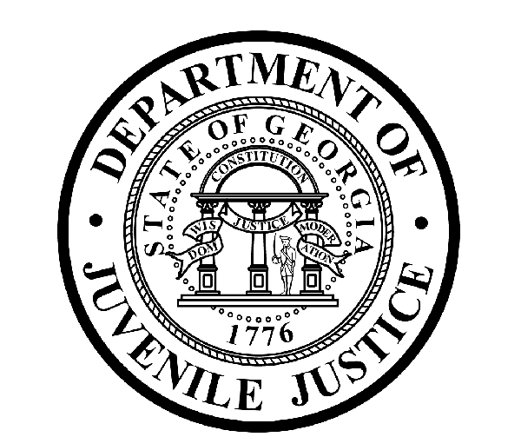

Avery D. Niles, CommissionerDepartment of Juvenile Justice

Scott Mall3408 Covington Highway ▪ Decatur, Georgia ▪ 30032-1513
Office of CommunicationsTelephone: (404) 508-7147 ▪ Fax: (404) 508-7341
FOR IMMEDIATE RELEASE CONTACT:
Jim Shuler
April 2, 2017 DJJ Communications
(404) 508-7147
JimShuler@djj.state.ga.us

Department of Juvenile Justice Recruiting Around Georgia in April!
Albany, College Park, Decatur, Dublin, Duluth, Hinesville, Statesboro, Swainsboro, Vidalia

(STATEWIDE-GA) The Department of Juvenile Justice (DJJ) is recruiting full-time employees for one of Georgia’s most challenging and rewarding criminal justice career areas. Commissioner Avery D. Niles has authorized agency recruiters to find qualified candidates for Juvenile Corrections Officer (JCO) positions at 26 secure facilities throughout the state.

“We’re recruiting across Georgia to find motivated applicants who can accept the personal challenge of helping juvenile offenders through their troubled life transitions while committed to secure state custody,” Commissioner Niles explained.

DJJ recruiters are seeking mature, responsible candidates who want to embrace careers in corrections to make a positive difference in the lives of Georgia’s young offenders and help prepare them to return to build successful lives in their communities.

“We’re always looking for applicants who can apply their knowledge and experience from previous employment in corrections, the military or law enforcement to new functions in a structured juvenile justice environment,” Commissioner Niles said. “DJJ is searching for special candidates to become part of our dedicated team of professionals. At DJJ we didn’t invent caring for young offenders, but as professionals we practice it here with them every day,” the Commissioner said.

DJJ runs its own certified state academy where it provides a vigorous training program for new recruits. The agency offers complete state health and benefit packages with competitive compensation for new JCOs.

Interested job seekers can click on www.djjcareers.org for more information about career opportunities in juvenile corrections. Former military service members with Honorable Discharges should also click on www.djjcareers.org to learn about DJJ's one-time Military Salary Increase Incentive on eligible job titles at “DJJ Careers for Veterans.”
(more)
(page two)
There is no charge for participation at juvenile corrections career fairs. DJJ recruiters are authorized to interview qualified candidates on-the-spot for new correctional officer opportunities. Applicants should bring their resumes and come dressed for job interviews.

*Please note career fair locations and times may change OR additional career fair dates may be added to the DJJ recruiting schedule. Applicants should check the DJJ website for late-breaking schedule changes at www.djjcareers.org BEFORE visiting a DJJ job fair.

Date: Wednesday, April 5 – OPEN to GENERAL PUBLIC
Location: 1332 Southern Dr. Carroll Building
Statesboro, GA
Time: 11:00 a.m. – 1:00 p.m.
Contact: Ms. Courtney Dyer, 912-478-5197

Date: Tuesday, April 11 – OPEN to GENERAL PUBLIC
Location: 2050 Sugarloaf Circle
Duluth, GA
Time: 10:00 a.m. - 2:00 p.m.
Contact: Osvaldo Montalvo, 770-209-3086

Date: Wednesday, April 12 – OPEN to GENERAL PUBLIC
Location: 100 Technology Drive
Hinesville, GA
Time: 11:00 a.m. – 1:00 p.m.
Contact: Ms. Sylvia Perry, 912-443-5880

Date: Wednesday, April 12– OPEN to GENERAL PUBLIC
Location: One Joseph E. Kennedy Blvd
Statesboro, GA
Time: 9:00 a.m. – 12:30 p.m.
Contact: Mr. Larry Bowen, 912-871-1620

Date: Thursday, April 13 – OPEN to GENERAL PUBLIC
Location: 910 N. Jefferson St.
Dublin, GA
Time: 9:00 a.m. – 3:00 p.m.
Contact: Ms. Patsy Carr, 478-275-6525

Date: Tuesday, April 18 – OPEN to GENERAL PUBLIC
Location: 4650 Flat Shoals Pkwy
Decatur, GA
Time: 10:00 a.m. – 1:00 p.m.
Contact: Kenneth Dinkins, 404-486-8008

Date: Tuesday, April 18 – OPEN to GENERAL PUBLIC
Location: 346 Kite Road
Swainsboro, GA
Time: 9:00 a.m. – 12:00 p.m.
Contact: Mr. Lance Helms, 912-538-3207

Date: Thursday, April 20 – OPEN to GENERAL PUBLIC
Location: 1704 S. Slappey Blvd, Kirkland Conference Center
Albany, GA
Time: 9:00 a.m. - 12:00 p.m.
Contact: Ms. Judy Jimmerson, 229-430-3514
(more)

(page three)

Date: Thursday, April 20 – OPEN to GENERAL PUBLIC
Location: 3001 E. First Street
Vidalia, GA
Time: 9:00 a.m. – 12:00 p.m.
Contact: Mr. Lance Helms, 912-538-3207

Date: Friday, April 28 – OPEN to GENERAL PUBLIC
Location: 2000 Convention Center Concourse
College Park, GA
Time: 10:00 a.m. – 3:00 p.m.
Contact: Issac DoDoo, 770-432-5405

Applicants for Juvenile Corrections Officer positions must bring copies of these important documents to the interview process:

- Compass Scores (Reading: 70 Writing: 32)** Accuplacer (Reading: 55 Writing: 60 Numerical: 34) **
- SAT Scores (Verbal: 430 Math: 400) or ACT Scores (Verbal: 18 Math: 16)**
- Valid Driver’s License
- Birth Certificate
- High School Diploma or GED
- DD214 Long Form with discharge indicated
- Naturalization Forms if Non-US Citizen
- If P.O.S.T. Certified, please bring two (2) forms of Government issued ID & P.O.S.T. Profile **

**Applicants with a 4-year degree from an accredited college are exempt from taking the Compass test or providing proof of acceptable ACT or SAT scores.

###

“DJJ is a great place to make your work count.”
Avery D. Niles, Commissioner
Georgia Department of Juvenile Justice

ABOUT DJJ
The Georgia Department of Juvenile Justice (DJJ) is a multi-faceted agency that serves the needs of this state`s young offenders up to the age of 21. The Department employs more than 4,300 men and women at 26 secure facilities and 97 community services offices throughout the state to effect justice and redirect the young lives in the agency`s care.

Including those who are placed on probation, more than 50,000 youths are diverted each year to evidence-based community programs, sentenced to short-term incarceration or committed to the Department`s long-term custody by the Juvenile Courts. It is the duty of DJJ’s professional corrections staff to preserve public safety and safeguard the citizens of Georgia, as well as protect the victims of crimes so that they can rebuild their lives.

At the same time, DJJ holds juvenile offenders accountable for their delinquent conduct so that they can take responsibility for their actions through probation, supervision and secure detention. The youth are provided with medical and psychological treatment, as well as specialized education and programs designed to equip them with the social, intellectual and emotional tools needed to achieve their successful reentry and reintegration into community, workplace and neighborhood settings as more productive and law-abiding citizens.

