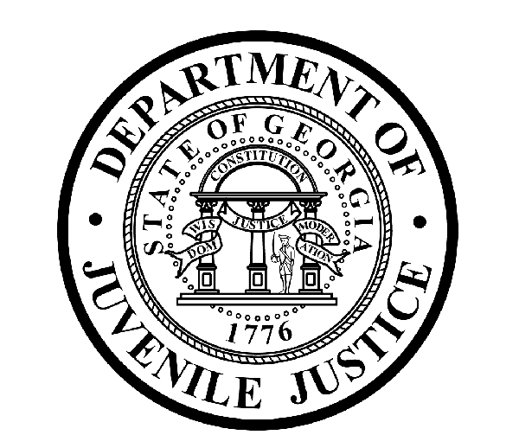

Avery D. Niles, CommissionerDepartment of Juvenile Justice

Jim Shuler, Director3408 Covington Highway ▪ Decatur, Georgia ▪ 30032-1513
Office of CommunicationsTelephone: (404) 508-7147 ▪ Fax: (404) 508-7341
FOR IMMEDIATE RELEASE CONTACT:
Jim Shuler, Director
March 21, 2013 DJJ Communications
(404) 508-7238
JimShuler@djj.state.ga.us

GEORGIA LAW ENFORCEMENT ‘ON LOOK-OUT’ FOR VETERANS
AGENCIES ACTIVELY RECRUITING MILITARY RETURNING HOME FROM DUTY

(GLENNVILLE - GA) Georgia military personnel returning from duty are in big demand here as Georgia law enforcement agencies have more than 800 jobs waiting for them to apply. A vanguard of state H-R departments is reaching out this spring to veterans who are looking for work.

State of Georgia agency recruiters are hosting a job fair for returning veterans at the National Guard Armory in Glennville, Georgia. It’s scheduled soon from 10:00am to 2:00pm on April 17th and it’s free to veterans who register on line.

Why are veterans such a sought after commodity in the Georgia job market? “Because from deployment to employment, veterans are typically candidates who can distinguish themselves in any job description,” says Commissioner Avery D. Niles at the Georgia Department of Juvenile Justice.

“Veterans bring discipline, maturity, experience and leadership skills to your work place,” said Commissioner Niles. “That makes them the kind of candidate we’re seeking most for positions involving responsibility and trust.”

Commissioner Niles is in a position to know. He recently hired Lt. Colonel Mark Sexton, U.S. Army Retired, for the Commissioner’s top executive staff spot at DJJ Central Office. Now as DJJ’s new Assistant Commissioner, Sexton is drawing on more than 20 years of experience as a commissioned officer in key military posts around the world to help restructure DJJ’s Central Office operations.

“As an integral element of my military background I was expected to direct specialized work forces, streamline organizations, increase productivity and produce outstanding safety records,” says Assistant Commissioner Sexton.

(MORE MORE MORE)
(PAGE TWO)

“This special skill set now carries over into my new career with the State of Georgia as I am assigned the task of change management for the Department of Juvenile Justice,” said Sexton. “The State of Georgia is an excellent career destination.”

DJJ provides a unique opportunity for service members to apply their discipline, deployment experience, and leadership skills to establish a positive influence on the lives of Georgia youth under their care.

“We support Governor Nathan Deal’s ‘Hire a Georgia Veteran campaign,” said Commissioner Avery Niles. “We proudly signed the Governor’s pledge to provide enhanced hiring opportunities for veterans. Assistant Commissioner Sexton served his country as a Lt. Colonel and now we look forward to working together with him on the DJJ Team serving the State of Georgia.”

DJJ offers a one-time Military Salary Increase Incentive to current and former military service members on eligible job titles, who have served on active duty. To be eligible, service members must have an Honorable Discharge. The one-time incentive will be based upon the current number of active duty years served. Governor Deal has said that ensuring that these heroes find meaningful employment as they return home is one of Georgia’s top priorities.

The April 17th job fair at the National Guard Armory in Glennville, Georgia is one of several upcoming statewide initiatives designed to help a wave of 80-thousand Georgia veterans who are expected to enter the state’s workforce by 2016. In September 2012, the Department of Corrections hosted a similar veterans’ job fair at the DOC offices in Forsyth, Georgia and more than 220 veterans registered for the event.

The Glennville job fair will be hosted again by the Georgia Department of Corrections, the state Department of Defense and the National Guard. The Department of Public Safety, Department of Natural Resources and DJJ will all have personnel on hand to answer questions from candidates.

Recruiters are looking for qualified candidates to hire for a wide range of career positions including administration, transportation, communications, probation, I-T, engineering, counseling, maintenance, and state patrol and correctional officers.

“Veterans understand discipline and take pride in their work,” said Commissioner Niles. “The Department of Juvenile Justice is proud to offer new opportunities to these men and women who have served their country. All of Georgia’s state agencies are privileged to open new career paths to our U.S. veterans.”

The Department of Juvenile Justice has career opportunities available for Administrative positions, Corrections and Transportation Officers, Security Emergency Response Teams, Probation and Parole Specialists, Registered Nurses and Physicians, Professional Social Workers, Special Education Teachers and more. Candidates who don’t want to miss an opportunity to begin a career in State law Enforcement should register at https://www.surveymonkey.com/s/MilitaryJobFair.

For more information about the Department of Juvenile Justice job fair schedule in April click on http://www.djjnewsandviews.org/whatsnewatdjj/viewnews.asp?newsID=92 .

For more information about careers at DJJ click on http://www.djjnewsandviews.org/djjcareers/.

(END RELEASE)

